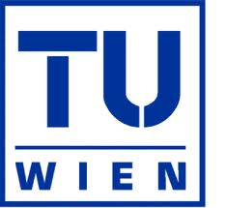
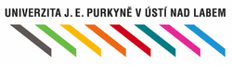

Radioactive Waste Management
in Austria an Czech Republic

Martin Hejhal & Thomas Horvath

Co-operating Universities
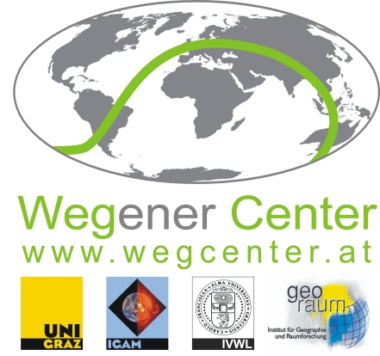


Financial support by

Prague and Vienna, 2014
TABEL OF CONTENT:

1. Introduction and General information 3
2. Abstract 3
3. Radioactive waste 3
Principle of radioactive waste disposal 3
Radioactive waste classification 4
Options for radioactive waste disposal 5
3. Czech Republic 7
Major legislation 7
Key players 8
Producers of radioactive waste 9
Funding of waste management 10
Decommissioning funding 10
4. Austria 12
Main legislation 12
Description of waste management 13
Funding 15
5. Conclusions 16
References (Literature) 18
Figure Index 18

1. Introduction and General information

The usage of radioactivity is very wide – it is used for defectoscopy in material engineering, for sterilization of food and medical instruments, for medical purposes (nuclear medicine) or for power generation. So the radioactive waste is a result of wide spectrum of human activities. Very often is the problem of radioactive waste management highlighted in connection with Nuclear Power Plants.

2. Abstract
Radioactive waste disposal represents a commitment for a long period of time. This waste is produced not only in Nuclear Power Plants, but also in hospitals or as a result of industrial activity. The usage of radioactivity is very wide – it is used for defectoscopy in material engineering, for sterilization of food and medical instruments, for medical purposes (nuclear medicine) or for power generation. So the radioactive waste is a result of wide spectrum of human activities. Our aim is to look at the possibilities of radioactive waste management and compare the approach of two completely different countries, “nuclear” Czech Republic and “non-nuclear” Austria, what are the differences between various types of radioactive waste and their handling, how can be each type stored or deposited, and how it is financed.

3. Radioactive waste

Radioactive waste management plays an important role in a nuclear safety. As with any source of radioactivity, radioactive waste is potentially hazardous to health and to environment. Good waste management begins before the waste is generated: avoiding or reducing waste generation at its source also minimizes the quantity of radioactive waste requiring disposal.

Principle of radioactive waste disposal
Radioactivity naturally decays over time, so the basic principle of radioactive waste disposal is the isolation from biosphere for a sufficient period of time. The amount of time needed for decrease of radioactivity depends on the radioisotopic content – particularly on the (radioactive) half-life of contained isotopes. The half-life for a given radioisotope is the time for half the radioactive nuclei in any sample to undergo radioactive decay. Eventually all radioactive isotopes decays into stable, non-radioactive isotopes.
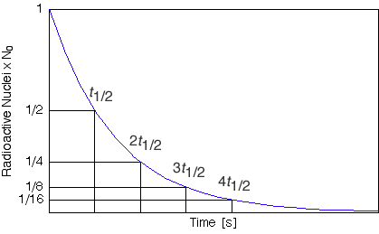

Fig. 1. Half-life of a Radioactive Nucleid

Radioactive waste classification
There are different types of radioactive waste based on its properties. Waste classification is needed for appropriate handling and disposal. According to IAEA (2009) the basic classification is usually based on radioactive content and half-life:
- Low Level Waste (LLW) – Waste that is above clearance levels, but with limited amounts of long lived radionuclides. Such waste requires robust isolation and containment for periods of up to a few hundred years and is suitable for disposal in engineered near surface facilities. This class covers a very broad range of waste.
- Intermediate level waste (ILW) – Waste that requires a greater degree of containment and isolation than that provided by near surface disposal. ILW may contain long lived radionuclides that will not decay to a level of activity concentration acceptable for near surface disposal during the time for which institutional controls can be relied upon, typically for thousands to tens of thousands of years. Therefore, waste in this class requires disposal at greater depths, of the order of tens of metres to a few hundred metres.
- High Level Waste (HLW) – Waste with levels of activity concentration high enough to generate significant quantities of heat by the radioactive decay – mainly Spent Fuel. These wastes must be isolated from the biosphere for hundreds of thousands of years. Disposal in deep, stable geological formations usually several hundred metres or more below the surface is the generally recognized option for disposal of HLW.

Some countries, such as France, have finer classification according to the half-life along with the radioisotopical content. LLW and ILW categories are then divided into Short-Lived (half-life ≤ 31 years) and Long-Lived (half-life > 31 years) subcategories (LLW-SL, LLW-LL, ILW-SL and ILW-LL). For disposal purposes there is very slight difference between Short-Lived LLW and ILW in this case and usually is used the term Short-Lived Low- and Intermediate Level Waste (LILW-SL).

Very special waste is that with half-life shorter than 100 days – Very Short Lived Low Level Waste (VSLLW). This waste is for economical reasons stored until the radioactivity decays naturally under the clearance levels, which takes about 1-6 months, and then the waste is treated as conventional waste (IAEA, 2009).

Options for radioactive waste disposal
There are a few options how radioactive waste can be disposed. World-wide accepted radioactive waste management (IAEA, 2006) strategy is disposal in geological repositories. It means that the waste is packed into suitable containers and entombed in underground. The design of such a repository must reflect the type of waste, which is intended to be disposed in it (as mentioned above).

Shallow repository
The simplest repository is a shallow repository. It is suitable for VLLW-SL waste. The disposal of this type of waste is very simple. The waste is placed either in crates or polyethylene bags, these are covered with sand and a layer of special impervious substance, and then with natural soil. The waste disposed of in this way no longer poses danger to humans and the environment.

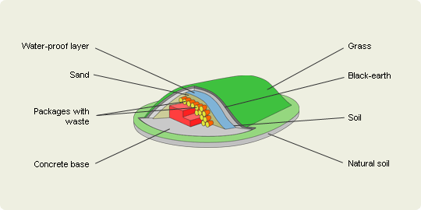

Fig. 2. Shallow Repository (VAE, 2013)

Near-surface repository
Second option, which is suitable for LILW-SL waste, is the near-surface repository. This kind of repository consists of reinforced concrete vaults established on the earth surface. Radioactive waste packages are placed into the vaults and covered with a multi-layer shelter resistant to atmospheric effects. This method is universally accepted and has been used in many countries. Before disposal, waste is managed and packaged.
The alternative to the engineered near-surface repository is emplacement in suitable mines or cavities.
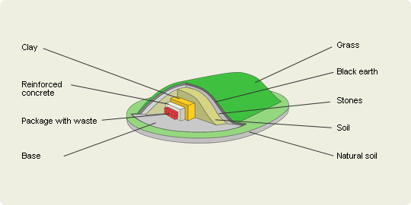

FIg. 3. Near Surface Repository (VAE, 2013)

Deep geological repository
The third option is disposal in deep geological repository. This kind of repository is suitable for HLW and LILW-LL wastes. Crystalline basement used for final disposal of spent nuclear fuel and long-lived radioactive waste is the most examined geological medium in the world. An additional advantage of this medium is that this geological formation may be found at lower or higher depths everywhere. With the use of the state-of-the-art technologies, it is possible to construct shafts in rocks of crystalline basement and to bore 150-500 meters long tunnels at a depth of some 500 meters in which containers with spent fuel may be placed. All gaps between the copper containers with fuel and the rocks would be loaded by special impervious clay (bentonite).
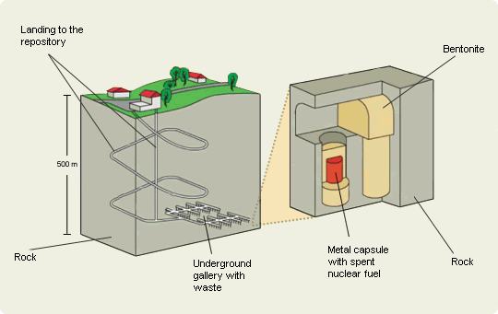

Fig. 4. Deep Geological Repository (VAE, 2013)

3. Czech Republic
Czech Republic is a nuclear country. There are two nuclear power plants consisting of six reactor units.

Major legislation
Act No. 18/1997 Coll., on Peaceful Utilization of Nuclear Energy and Ionizing Radiation (the Atomic Act) and on Amendments and Additions to Related Acts, regulates (Czech Republic, 1997):
- the method of utilising nuclear energy and ionising radiation, and conditions for the performance of practices related to nuclear energy utilisation and radiation activities;
- the system for protection of people and the environment from undesirable effects of ionising radiation;
- obligations during preparation for and implementation of intervention intended to reduce exposures to natural sources and exposures due to radiation accidents;
- specific requirements for civil liability in the case of nuclear damage,
- conditions for safe management of radioactive waste;
- performance of State administration and supervision within nuclear energy utilisation, within radiation activities and over nuclear items.

Policy of Radioactive Waste Management and Nuclear Spent Fuel Management, adopted by the Czech Government on May 15, 2002 (Government Resolution No. 487/2002), is a fundamental document which defines the radioactive waste and spent fuel management strategies of the Government and its agencies approximately by 2025, with an outlook to the end of the 21st century (Czech Republic, 2002).
The Government Ordinance No. 416/2002 Coll., on the amount and terms of payments to the nuclear account by radioactive waste producers and the annual subsidy to the communities and the rules for its payment (Czech Republic, 2002, B)

Key players
The Radioactive Waste Repository Authority (RAWRA or SÚRAO) was established by the Ministry of Industry and Trade on 1 June 1997 according to the Atomic Act. RAWRA has been a fully state-controlled organisation since 2000 in compliance with Act 219/2000, Article 51. Its main tasks and activities are (Czech Republic, 1997; RAWRA, 2013):
- ensuring the safe management of radioactive waste;
- providing the preparation, construction, commissioning, operation and closure of radioactive waste repositories and the monitoring of the impact of such repositories on the surrounding environment;
- ensuring the reprocessing of spent or irradiated nuclear fuel so as to transform it into a form suitable for disposal and/or subsequent re-use;
- maintaining records of accepted radioactive waste and its producers;
- administering payments made by radioactive waste producers to the Nuclear Account;
- preparing proposals for the determination of the scale of charges to be paid by radioactive waste producers to the Nuclear Account;
- ensuring and coordinating research and development relating to radioactive waste management;
- monitoring the creation of financial reserves by licence holders for the future decommissioning of their nuclear facilities;
- managing radioactive waste which was historically transported to the Czech Republic from abroad and which cannot be returned;
- ensuring the interim management of radioactive waste which has been transferred, for whatever reason, into State ownership.

The State Office for Nuclear Safety (SONS or SÚJB) is a governmental regulatory body responsible for governmental administration and supervision in the fields of uses of nuclear energy and radiation and of radiation protection. The responsibilities of the SONS, stipulated by Atomic Act, include in connection with radioactive waste management (Czech Republic, 1997):
- licensing of activities as specified by Act. No. 18/1997, e.g. for the siting and operation of nuclear facilities and workplaces handling very significant ionizing radiation sources, for handling ionizing radiation sources and radioactive wastes, transportation of nuclear materials and radionuclide emitters;
- monitoring the status of exposure of the public and personnel handling ionizing radiation sources;
- providing relevant radioactive waste management information to municipalities and district administration bodies and to the Government of the Czech Republic.

Producers of radioactive waste
ČEZ, a.s. is as an operator of two NNPs the most important radioactive waste producer.
NPP Dukovany consists of four pressurized water reactor (PWR) units with installed capacity 4 x 510MW electric. First unit was commissioned in 1985 with estimated lifetime of 30 years. There are many projects running at this plant to improve the safety of this plant, so the plant’s operator can get an extension for its license. Recently the expected lifetime of the Dukovany NPP is 50-60 years based on the international research.
NNP Temelin consists of two pressurized water reactor (PWR) units with installed capacity 2 x 1020MW electric. First unit was commissioned in 2002 with estimated lifetime of 40 years. Recently the expected lifetime of Temelin NPP is also about 50-60 years.

Institutional producer of waste is common designation for other producers than nuclear power generation. It consists of hospitals, industry, research reactors and small sources of radiation.

Estimated volumes of radioactive waste are presented in tables Tab. 1 and 2.
Source of waste | LLW - operation  (m³) | LLW - decommissioning  (m³) | average per year  (m³)
NPP Dukovany (1985-2025) | 10 250 | -- | 256
NPP Dukovany (2025-2035) | -- | 3 640 | 364
NPP Dukovany (2085-2094) | -- | 2 385 | 239
NPP Temelin (2000-2042) | 12 000 | -- | 285
NPP Temelin (2040-2047) | -- | 620 | 78
NPP Temelin (2090-2095) | -- | 4 012 | 669
TOTAL NPP waste | 32 907
Institutions (1958-2000) | 2 800 |  | 67
Institutions (2000-2095) | 5 700 |  | 60
TOTAL institutional waste | 8 500
Tab. 1: Estimated volumes of LLW (Czech Republic, 2001)

Source of waste | HLW - operation  (m³) | HLW - decommissioning  (m³) | SF  (t)
NPP Dukovany (1985-2025) | 50 | -- | 1 937
NPP Dukovany (2085-2094) | -- | 2 000 | --
NPP Temelin (2000-2042) | 50 | -- | 1 787
NPP Temelin (2090-2095) | -- | 624 | --
TOTAL NPP waste | 2724 |  | 3 724
Institutions (1958-2000) | 80 | 5 | 0,2
Institutions (2000-2095) | 150 | 50 | 0,3
TOTAL institutional waste | 285 |  | 0,5
Tab. 2: Estimated volumes of HLW and SF (Czech Republic, 2001)

Funding of waste management
Operational LLW and ILW waste from NNPs is deposited at the Dukovany near-surface repository.
Spent (Nuclear) Fuel (SF or SNF) is after removal from the reactor stored for several years in the spent fuel cooling pools, and then it is placed in dry storage containers. Dry storage is controlled, long established and virtually waste-free technology. Until the commissioning of a deep geological repository will SNF from nuclear power plants be stored in the transport and storage containers placed in warehouses for SNF in NPPs. Reprocessing of SNF is not considered due to economical aspects (Wuppertal Institut für Klima, Umwelt, Energie GmbH, 2007).
Part of the waste from decommissioning can be deposited Richard repository, and the waste that does not meet the criteria for depositing in this repository will be put into deep geological repository along with HLW and SNF (RAWRA, 2013).
In case of operational waste and SNF management the operator of NPP is obliged to pay a fee for radioactive waste disposal. This fee for NPP operator is based on electricity production and amounts to 50 CZK/MWh_{e} (1,83 €/MWh_{e}). For research reactor with thermal output higher than 0,1 MWh the fee is calculated according to the thermal energy output and the fee amounts to 15 CZK/MWh_{th} (0,55 €/MWh_{th}) (Czech Republic, 2002)
For small volume producers of radioactive waste the fee is set as single payment per barrel after the receipt of their radioactive waste by SURAO for disposal. The fee for disposal in year 2014 amounts 29 158 CZK/200l barrel (1 064,2 €) and grows 6% p.a.
Funds needed for operational waste and SNF disposal are collected on Nuclear Account established at Czech National Bank by the Ministry of Finance since 1997. RAWRA activities are financed from this account. The funds are invested into safe investments specified in Atomic Energy Act (e.g. Czech Republic Government Bonds) to cover inflation effects and to achieve some real interest. ČEZ contributed in 2012 over 1.516 billion CZK (57 million €) to the Nuclear Account in regular monthly instalments. A total of 18.5 billion CZK (675 million €) was deposited in the Nuclear Account as at the end of 2012.

Decommissioning funding
Operators of nuclear facilities are obliged to make provisions for decommissioning if the estimated cost of decommissioning exceeds 300 000 CZK (10 950 €) according to the Atomic Act. If the costs exceed 1 billion CZK (36,4 million €), the financial resources are deposited on the blocked bank account. The provisions are made on annual basis:
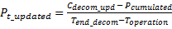 (1)
where P_{t_updated} is the annual contribution to the account in year t, C_{decom_upd} updated estimated cost of decommissioning, P_{cumulated} already cumulated financial resources on blocked account, T_{end_decom} number of years from operation start to the end of decommissioning, T_{operation} number of years from start of operation to the year of update of decommissioning cost estimation (Czech Republic, 2002, A).
The plan of decommissioning along with cost estimation shall be updated every 5 years and must be approved by State Office for Nuclear Safety (technical aspects) and by RAWRA (economical aspects). The most recent cost estimates related to Czech NPPs are in Tab. 1:
Nuclear facility | Year of estimation | Estimated cost of decommissioning
NPP Dukovany | 2012 | 22 355 million CZK(2012) / 815 million €(2012)
NPP Temelín | 2009 | 14 579 million CZK(2010) / 532 million €(2010)
Tab. 3. Estimated costs of decommissioning Czech NPPs (European Commission, 2013)

Financial resources from the blocked account can be used only for the decommissioning purposes. Therefore, withdrawal from this account must be approved by RAWRA. A total of 9.932 billion CZK (362,5 million €) was deposited in the blocked account of CEZ as at the end of 2012.
Currently valid strategy for decommissioning of both NPPs is the deferred decommissioning with 35-50 years of safe enclosure period after the removal of spent fuel.

4. Austria
Austria is a NNP free country therefore all radioactive waste comes from industry, medicine or research facilities.

Main legislation
The constitutional law for a nuclear free Austria (Budesverfassungsgesetz für ein atomfreies Österreich) is the main law that neither allows the use of nuclear energy nor the construction of such facilities.
Its origin goes back to a national referendum in 1978 against the activation of the already finished NPP in Zwentendorf. After this referendum, in December of 1978, Austria introduced the “Atomsperrgesetz (Verbot der Nutzung der Kernspaltung für die Energieversorgung in Österreich)”, a law prohibiting the use of fissionable material for energy production as a normal law.
In 1999, after the popular petition for a nuclear power free Austria (Volksbegehren für ein Atomfreies Österreich) in 1997, the Atomsperrgesetz was made a constitutional law by an unanimously decision of the Austrian Parlament.

The constitutional law for a nuclear free Austria consists of five major paragraphs:

- In Austria it’s not allowed to produce, store, transport, test or use of nuclear weapons. Also the deployment of nuclear weapons is not allowed.
- The construction of facilities for the energy production through nuclear fission is forbidden. If already constructed its not allowed to activates such facilities.
- The transport of fissional material on Austrian territory is prohibited, except if opposed to international law. Excluded from this the transport for a peaceful aim, but not for the purpose of energy production through fission or disposal. Furthermore not exceptional permissions will be made.
- By law it has to make sure, that any damage on Austria territory caused by nuclear accidents are decently compensated, also by foreign at-fault parties.
- The execution of this constitutional law is made by the Austrian parliament.
(Klestil ,T. und Klima, V. 1999)

The Austrian legislation in Radioactive Waste Management is influenced by international treaties such as EURATOM, IAEA, OECD/NEA and ICRP. Therefore, the Austrian legal framework is in compliance with internationally accepted safety principles as specified in the Joint Convention on the Safety of Spent Fuel Management and on the Safety of Radioactive Waste Management. (OECD. 2012)

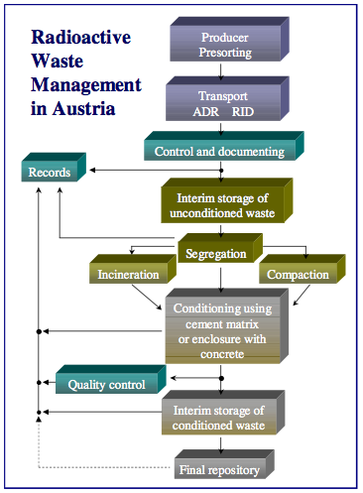
Description of waste management
All the radioactive waste that is produced in Austria, low and intermediate level, has to be brought to the NES (Nuclear Engeneering Seibersdorf), located in Seibersdorf, Lower Austria about 20km southern of Vienna for treatment and storage. Base on a trilateral contract between the Republic of Austria, the community of Seibersdorf and the NES, Nuclear Engeneering Seibersdorf operates as a radioactive waste management and interim storage facility in the name of Austria’s Federal Ministry of Agriculture, Forestry, Environment and Water Management (Lebensministerium).
The NES acts as pre-disposal facility, including treatment, conditioning and interim storage of all the low and intermediate waste in Austria, since high-level waste does not arise. Waste from the few facilities operating with highly radioactive material, are only allowed to import these materials if granted that all waste is sent back to the country of origin. E.g. currently, Austria operates one research reactor at the Institute of Atomic and Subatomic Physics, which is administered by the Vienna University of Technology. Spent nuclear fuel from the research reactor is stored at site and will be repatriated to the USA.

Fig. 5: Radioactive Waste Management in Austria (IAEA. 2011)

Handling radioactive material is only allowed with official permission and therefore Austria has an official register for radiation sources to prevent illegal disposal of radioactive waste.

Depending on the type of waste several treatment techniques are applied:
• Combustible waste is incinerated. In the past, the resulting incinerator ash has homogeneously been cemented. Since 2007 ash is stored in 100-litre-drums, which are placed into custom made of stainless steel cartridges. These cartridges are purged with nitrogen, shut by welding and placed into 200-litre-drums. Volume reduction: > 40:1.
• Non-combustible compactable waste is super compacted; the pellets are loaded into 200-litre-drums made of steel for interim storage, volume reduction: ~4:1.
• Aqueous liquids are treated by neutralization and evaporation to dryness, usually after mixing with sludge from the waste water treatment plant. The resulting powder is super compacted; volume reduction: >30:1.
• Filters are super compacted; the pellets are loaded into 200-litre-drums for interim storage.
• Conditioned 200-litre-drums are dried in the 32-drum-dryer to minimize the risk of corrosion effects and chemical reactions inside the drums.
• Graphite blocks formerly used in the ASTRA research reactor core are stored in a Konrad Type II container.
• Higher active waste originating from ASTRA research reactor decommissioning (near core construction material and in core experimental equipment) has been cut into smaller pieces and placed into appropriately shielded Mosaik and Konrad Type II containers.
• Radioactive sealed sources are segregated according to their half-life, i.e. 60Co, 137 Cs, 241Am. They are enclosed in stainless steel cartridges and/or lead shielding and retrievably stored in 200-litre-drums.
• Radium sources are encapsulated by welding them into stainless steel capsules; they are retrievably stored in lead shielding. Other sources are collected in small steel containers and stored in shielded drums. (IAEA. 2011)

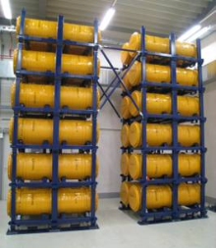
Right now, there are about 11000 barrels, containing about 2000m³ low and intermediate level waste stored above ground in a controllable environment, see picture. The total activity of the waste is approximately 10¹⁶ Bq. Every year 15t of radioactive waste is produced by medical, industrial and research facilities. (Karg, V. 2011)
Furthermore, Austria is obligated to remove all stored radwaste from the NES to a final repository until the 31st of December 2045 (was 2030), according to the Joint Agreement on the Management of Radioactive Waste by the Republic of Austria (Federal Ministry of Agriculture, Forestry, Environment and Water Management), the municipality of Seibersdorf and the NES.

Fig. 6. NES storage hall (IAEA. 2011)

A new storage concept for the 200-litre-drums was already implemented in storage facility no.13: All drums are stored horizontally in a way that will enable individual drum inspection during the whole time of storage. After erection of new storage facility (no.14) for approx. 10.000 200-litre-drums the existing storage facilities no.12 and 12A will be refurbished in the same way as no. 13 and no.14. Storing the drums following the new concept (with possibility for individual inspection of each drum) will require more space compared to today’s storing-practise. The future storage capacity at Nuclear Engineering Seibersdorf will be:
- storage facilities no.12 and 12A: totally 4.600 drums
- storage facility no.13: 2.900 drums
- storage facility no.14: 10.000 drums
in total: 17.500 drums (IAEA, 2011)

Funding
Since 2003, the Austrian radwaste management follows a polluter-pays-principle.

Equipment and Infrastructure
All infrastructure and equipment of the Austrian Waste Management facility for a state-of-the-art treatment is guaranteed by the Austrian State.

Treatment
When delivering radioactive waste to the NES polluters have to pay for the interim storage a charge (Vorsorgeentgeld) and a risk premium (Risikozuschlag), furthermore the polluter has to contribute to a special fund which is separate and specially dedicated to finance a final repository.
All the salary of the employees and smaller maintenance cost have to be covered by the polluters, since the NES is a non-profit contractor acting in the name of the Austrian Republic.

Final Repository
Even tough no concrete plans for a final repository are not yet made, all cost for a final repository should be covered by a special fund, as mentioned above. But should the state-of-art estimation prove to be insufficient at a late period of time, the Republic of Austria covers the difference. (OECD. 2012)
Furthermore Austria is part of the ERDO (European Repository Development Organisation) working group, an organization of European countries that are looking for a common solutions for all their radioactive waste.

5. Conclusions
Radioactive waste management is by now well organized in both countries – the Czech Republic and Austria.
The comparison of nuclear and non nuclear country shows one big difference – and that is the cost of radioactive waste treatment and management. In nuclear country are the volumes of radioactive waste bigger than in non nuclear country. But the repository for the final disposal of such waste has a high ratio of fixed costs. For example the deep geological repository for intermediate level waste, which is considered to be one of the most suitable solution for this kind of radioactive waste, has high cost for research and development, site exploration, construction of entrance tunnel to the caverns. The costs for construction of additional caverns and containers for disposal are not very significant, so with increasing volume of waste the average cost for the polluter is decreasing. In the Czech Republic the volumes of waste arising from NPP operation is in case of LLW four times bigger than from institutions, in case of HLW the difference is 10 times. So the major part of costs of radioactive waste management is carried by NPP operators. The benefit is the lower price for hospitals or research facilities, and with lower price comes lower probability that someone will try to avoid to pay for correct disposal and will dump radioactive waste in conventional waste disposal.
For non nuclear country could be interesting from the economical point of view the cooperation with other non nuclear country (or even with nuclear country), which allows the countries to benefit from sharing the costs of repository construction and decreasing the price for the polluter (like in the case of nuclear country described above). On the other hand there are international conventions and national laws that prohibit the export or import of radioactive waste for disposal. And there are also social issues – like in which country should be the repository constructed.

References (Literature)

IAEA. (2006). Radioactive Waste Management. 3rd ed. Vienna: IAEA.
IAEA. (2009). Classification of Radioactive Waste. Vienna: IAEA.
VAE. (2012). Management And Final Disposal of Radioactive Waste. [Online] Vilnius: Lietuvos energija. Available at: http://www.vae.lt/en/pages/management_and_final_disposal_of_radioactive_waste [20.2.2014]
Wuppertal Institut für Klima, Umwelt, Energie GmbH. (2007). Comparison among different decommissioning funds methodologies for nuclear installations - Country Report Czech Republic. [Online] Available at: http://epub.wupperinst.org/frontdoor/index/index/docId/2608 [22.10.2013]
RAWRA. (2013). Annual Report 2012. Prague: RAWRA.
European Commission. (2013). Commission Staff Working Document "EU Decommissioning Funding Data". Brussels.
Czech Republic. (1997) Act No. 18/1997 Coll., on Peaceful Utilisation of Nuclear Energy and Ionising Radiation (the Atomic Act) and on Amendments and Additions to Related Acts. Prague.
Czech Republic. (2001). Policy of Radioactive Waste and Nuclear Spent Fuel Management in the Czech Republic. Prague.
Czech Republic. (2002). (A) Notice of Ministry of Industry and Trade 360/2002 on Financial Provision for Decommissioning of Nuclear Installation or Category III or IV Workplace. Prague.
Czech Republic. (2002). (B) The Government Ordinance No. 416/2002 Coll., On The Amount And Terms Of Payments To The Nuclear Account By Radioactive Waste Producers And The Annual Subsidy To The Communities And The Rules For Its Payment
Klestil, T. und Klima V. (1999). Bundesgesetzblatt für die Republik Österreich
IAEA. (2012). Forth National Report Austria
Karg, V. (2011). 2. Wiener Nuklearsymposium Entsorgung Radioaktiver Abfälle in Österreich
OECD. (2012). The control of safety of radioactive waste management and decommissioning in Austria

Figure Index

Fig. 1. Half-life of a Radioactive Nucleid 4
Fig. 2. Shalow Repository 5
FIg. 3. Near Surface Repository 6
Fig. 4. Deep Geological Repository 7
Fig. 5: Radioactive Waste Management in Austria 13
Fig. 6. NES storage hall 14

A/ 12
B/19
C/15

