How could Germany reorganize their electricity production if nuclear power plants were shut down?

Martin Kratchovil
Lukas Schwalt

Co-operating Universities





Financial support by

Prague and Vienna, 2013

Content
How could Germany reorganize their electricity production if nuclear power plants were shut down? 1
Content 2
1. Abstract 2
2. Introduction 3
3. Current situation 6
4. Method → Comparison of the Effect of the Co2- Prices out of our Scenarios for the three listed States and Europe in total. 7
5. Result → What can Germany do for producing the Electricity which is missing after the NPP shutdown 8
6. Discussion 9
7. Recapitulation 10

Abstract
Our purpose for this seminar paper is the summarization and evaluation of the plan of shutting down all the nuclear power plants in Germany. The paper should give an overview about the actual electricity power plant structure in Germany and also give an outlook over the future Electricity production after the Nuclear Power plant shutdown. As main question we are going to analyze how future prices for a ton of emitted CO₂ will affect on the power plant structure in the country and out of that then especially what would be the best solution by comparison: reactivating old coal fired power plants or use and build more gas fired- and combined cycled gas power plants?
We are going to analyze how different prices for CO₂ per ton will affect on the future electricity price and also on the future power plant structure, by using different scenarios. We divided the whole considered period in two parts: at first we focus on short term changes then the changes over long term. In both sub-chapters we will analyze what would be the best technical solution to get back to the electricity production from nowadays and even higher.
Finally, we will discuss the possibilities of future research in this field and try to tell, what would be the best way for Germany after the shutdown from our point of view.

Introduction
How can Germany reorganize their electricity production if nuclear power plants where shut down?
The shutdown of all nuclear power plants in Germany is now already in discussion since 1998 (http://www.grin.com/de/e-book/176330/der-atomausstieg-in-deutschland) after the election in this year. The new federal government was build by different parties, which all wanted the nuclear phase out. Since then every federal government tried to get to an end in this discussion but till today no one has spoken out a concrete date for the phase out.
The following table should show all the existing power plants in Germany:
Paste the pp list from the “Bundesnetzagentur”.
In total Germany now has an installed capacity of 175,3GW whereof 75,5GW are produced by Renewable energy sources.
http://www.bundesnetzagentur.de/DE/Sachgebiete/ElektrizitaetGas/Sonderthemen/Kraftwerksliste/VeroeffKraftwerksliste_node.html
Summ of Net- Capacity (elec.) in MW | Status of the Power Station
Energieträger | Operating state | Cold reserve | Special case | Definitly inoperative 2012 | Definitly inoperative 31.12.2011 | Reserve-power station | Total
Geothermal | 12 |  |  |  |  |  | 12
Sewer Gas | 90 |  |  |  |  |  | 90
Mine Gas | 254 |  |  |  |  |  | 254
Landfil Gas | 262 |  |  |  |  |  | 262
Offshore Windpower | 268 |  |  |  |  |  | 268
Waste | 1.100 | 52 | 12 | 6 |  |  | 1.169
Other Energysources | 1.147 |  |  |  |  |  | 1.147
Dammed Water (w/o pump storeage) | 1.309 |  |  |  |  |  | 1.309
Mineral oil products | 3.713 | 29 |  | 30 |  |  | 3.772
Running Water | 3.798 |  |  |  |  |  | 3.798
Biomass | 5.569 |  |  |  |  |  | 5.569
Pump storeage | 8.939 |  | 290 |  |  |  | 9.229
Nuclear power | 12.068 |  |  |  |  |  | 12.068
Several energy sources | 14.517 | 335 | 28 | 133 |  | 415 | 15.428
Natural Gas | 16.823 | 1.250 | 199 | 64 |  | 1.117 | 19.454
Brown coal | 17.793 | 260 |  | 1.321 | 383 |  | 19.757
Stone coal | 19.159 | 566 | 249 | 386 |  | 203 | 20.562
Onshore Windpower | 30.016 |  |  |  |  |  | 30.016
Solar radiant energy | 33.409 |  |  |  |  |  | 33.409
Total | 170.246 | 2.492 | 778 | 1.940 | 383 | 1.735 | 177.574

The upper table shows a diversion of the electricity production by energy resources. In this table are only power plants with a net capacity over 10MW registered. Net Imports of electricity from Luxemburg, Austria, France and Switzerland are also included. Also power plants, with a net capacity under 10MW are listed, if they have an improved capability. In the year 2012 Germany has consumed 594 TWh electricity.

  - How are prices for CO2/ton effecting on the power plant structure in Germany over long term, especially if we reactivate coal or build gas engines?

First of all we have to take a look on the CO₂- Emissions of the different production technologies:
CO2- comparsion of Different generating plants | CO2-Emission
Bio Gas-Block heating works | - 409 g per kwh
Wind power Offshore | 23 g per kwh
Wind power Onshore | 24 g per kwh
Solar energy import from Spain | 27 g per kwh
Nuclear power | 32 g per kwh
Water power plant | 40 g per kwh
Multicristalline Solarcell | 101 g per kwh
Natural Gas-GuD-Heating plant | 428 g per kwh
Import stonecoal- power plant | 949 g per kwh
Browncoal-power plant | 1153 g per kwh

Source: http://www.co2-emissionen-vergleichen.de/Stromerzeugung/CO2-Vergleich-Stromerzeugung.html (29.03.2013)

If we take a closely look at the table, we see that between the emissions of a Natural Gas powered generating plant and a stone coal fired power plant is a difference of more than 50%. And in comparison of Gas and Brown coal is a difference of more than 75% for its CO₂- Emissions

  - Which further CO2- Emissions/Prices will occur because of the shutdown of nuclear PP and the new creation of RES or/and reactivation of old structures/build new?
  - Research question (how are CO2 prices effecting on the power plant structure over long term, especially if we reactivate coal or build gas?)

Current situation
  - Energy demand in Germany
  - Price developments of CO2 (historical prices and likely development according to energy demand and regulations)
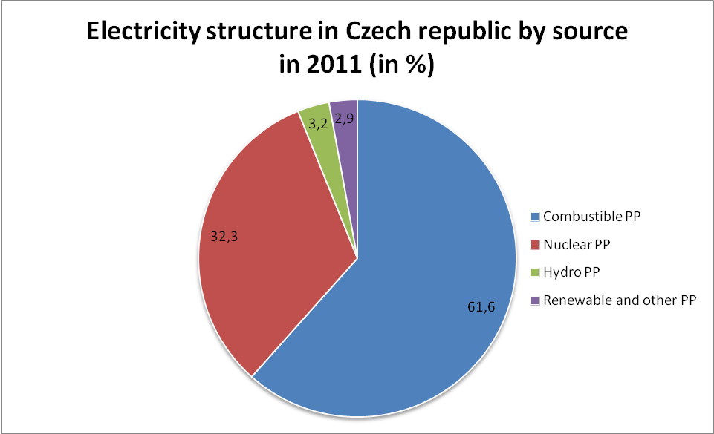
  - Present situation of power plant structure in Germany
  - In comparison: power plant structure in Austria and Czech republic

Graph 1.1 (Source: own calculation, energostat.cz)

Composition of power plant structure in Austria and Czech Republic is absolutely different. As you can see in Graph 1.1 main source of electricity in the Czech Republic are Combustible PP’s. On the other in Austria is main source Hydro PP’s, as you can see in Graph 1.2. The major reason for this difference is geographic profile. Considerable part of Austria is covered by the Alps. Total production of electricity in the Czech Republic was 87 561 GWh in 2011. In Austria this number is 63 412 GWh.
In the Czech Republic is the second largest source of electricity Nuclear PP’s. Nuclear PP’s produced 25 512,6 GWh in 2011. Even though both countries are from Central Europe, we can see absolutely different energy policy. From this point of view, we can assume, impacts caused by shutting down Nuclear PP’s in Germany will be more significant for the Czech Republic.
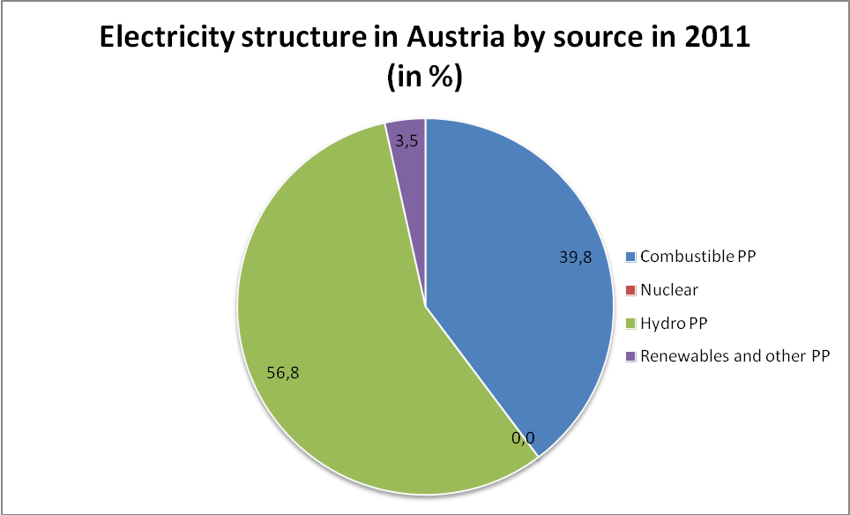
Graph 1.2 (Source: own calculation, iea.org)
  - Regulations (EU’s and German’s authorities)
  - Building scenarios by using numbers out of different Emission- Price- Plans (EU, UN, Germany and so on.))

Method → Comparison of the Effect of the Co2- Prices out of our Scenarios for the three listed States and Europe in total.
  - Future Electricity Prices and the part of CO2- Emission Prices (EU- Certificates )in Germany
  - Czech
  - Austria
  - Europe

Result → What can Germany do for producing the Electricity which is missing after the NPP shutdown
  - Short term: reactivate of old coal PP or use all of the Gas PP and CCGPP, Import? (How can Germany profit from the regions around the State
    - How much could they Import from Czech, Austria and which would be the better partner if we take a view on the CO2 Emission- Prices (EU Certificate Prices)out of our scenarios?
  - Long term: Build new Plant of RES, get better Import- Infrastructures, Restructure old Coal, Gas PP, and build in CO2 storage.
  - What is the most probable situation according to CO2 prices and regulations

Discussion
  - Possibilities of further research
  - Our opinion on future effecting on the power plant structure

Recapitulation
  - Summarization of our research
- Sources
- International Energy Agency. [online]. [cit. 2013-03-31]. Dostupné z: http://www.iea.org/stats/surveys/mes.pdf
- Energostat. [online]. [cit. 2013-03-31]. Dostupné z: http://energostat.cz/elektrina.html

Energostat. [online]. [cit. 2013-03-31]. Dostupné z: http://energostat.cz/elektrina.html
International Energy Agency. [online]. [cit. 2013-03-31]. Dostupné z: http://www.iea.org/stats/surveys/mes.pdf
Energostat. [online]. [cit. 2013-03-31]. Dostupné z: http://energostat.cz/elektrina.html

