


Czech-Austrian Winter and Summer School
On the path of achieving EU goals by 2020:
Policy Option for Austria & the Czech Republic

Uswatun Hasanah (University of Wien)
Vit Mraz (VSE)

Co-operating Universities



Financial support by

Prague and Vienna, 2013

Content
Content 2
ABSTRACT 3
PAPER 3
Motivation 3
Problem statement 3
Approach.. 4
Results….. 7
Conclusions 18
References (Literature) 18

ABSTRACT
The EU agenda by 2020-the reduction of GHG emission by 20%, the use of renewable energy by 20%, and the increase of energy efficiency by 20%- have enforced EU members to direct their national policy in order to achieve the intended target. However, EU members have different existing condition so that ‘the story’ to achieve the EU target may be different. In addition the EU goals may rise ‘the trade-off’ between their policy objectives, particularly the reduction of GHG emission and energy efficiency, in the short run and long run. Further, we present the potential trade-off through three different scheme of policy mix by using emission price as instrument. This paper try to present the current condition on energy efficiency and emission action in Austria and the Czech Republic and in order to track whether their policies are on the path or not. Because the different existing condition between Austria and the Czech Republic, this paper does not be intended to compare both countries. We apply statistics descriptive in order to get a view how the progress on energy efficiency and emission action look like. The brief finding are Austria has second highest energy efficiency among EU countries while the Czech Republic has to make a significant improvement on energy efficiency. In addition, both countries have a positive and an increase trend on their environmental revenue in order to protect their environment. Further, in terms of emission action, the Czech Republic has already initiated emission trading on its coal industry.

PAPER

Motivation
The EU policy goals by 2020, 20% reduction in greenhouse gas (GHG) emission, 20% of energy from renewable sources and 20% reduction in energy use, has always been a crucial agenda among EU members. This agenda has directed any policy in all EU members such that policy on GHG emission abatement, renewable energy and energy efficiency are always ‘on the track’. However, a few conflicting agenda may rise in order to achieve the goals, particularly GHG emission reduction and energy efficiency. It should be noted that terminology ‘energy efficiency’ and ‘energy saving’ is different (Oikonomou et al, 2009). But in this context, EU refers energy efficiency as energy saving that is achieved by the reduction of energy use.
GHG emission has been one of ‘commercial’ good that has a ‘selling point’ in the global economy. As commercial good, GHG emission has ‘value’ that make it trade-able. As consequence, producing more or less emission has financial impact for the industry or emitter. Then, it makes the agenda on both GHG emission abatement and allocation have been continuously growing.
Some literature have examined the relation between energy consumption and emission, for example, Schipper and Hass (1997) argued the relation between energy use and emission. Because the need of suitable indicator was so important, they recommended that it should be developed properly. Further, Arouri et al (2012) presented the link between energy consumption and macroeconomic indicator such as economic growth and CO₂ emissions in Middle East and North African countries. They found that real GDP exhibited a quadratic relationship with CO₂ emissions. In transportation sector, M.J. Bradley & Associates (2007) presented the comparison between energy use and CO₂ emissions by using different transportation modes. They found that in average the highest emission comes from ferry boat by 878 CO₂ g/pass-mi and in the second rank is a car that is occupied by 1 person by 371 CO₂ g/pass-mi while transit bus took the third rank by 299 CO₂ g/pass-mi and domestic air flight was the fourth position by 243 CO₂ g/pass-mi. The full table of transportation mode and its pollution can be seen in Appendix 1.
In terms of energy efficiency, Bleischwitz and Andersen (2009) presented the informational barriers to energy efficiency and proposed the development of measures base remuneration on energy performance, the development on the information on technologies and the education of consumers and installer on energy efficiency. Previously EU has also conducted the research on the private cost effectiveness on energy efficiency and suggested an independent evaluation of building energy efficiency standards and recommended how that local governments behaved: by stick on the standard and not making any variations in these standards (Energy Efficiency Productivity Commission, 2005). While in residential sector, Haas and Schipper (1997) presented the residential energy demand in OECD-countries and the role of irreversible efficiency improvements. They found briefly that price elasticity is different so that implying low rebound-effect, technical efficiency is an important parameter on forecasting energy demand, and the effect of technological efficiency on income elasticity.
In terms of regulation, there are some Directive in EU level as legal basis for energy efficiency and emission abatement in the national level, for example EC establishing a scheme for greenhouse gas emission allowance trading within the Community, EC restructuring the Community framework for the taxation of energy products and electricity and EC improving and extending the trading of greenhouse gas in the Community.
In addition EC set the limit for industrial emissions (integrated pollution prevention and control) and introduced the measurement for energy end-use efficiency and energy services. The details of the Directive is in Appendix-2
In this decade, there has been many effort to reduce GHG emission through several instrument like emission trading. Regardless there are many parties that have high concern to put emission abatement as national and global agenda, there is a few parties that disagree with some kind of activities like emission trading and call for the global climate action (EU, March 2013).

Problem statement
In this paper, we try to examine whether the policy on energy efficiency and GHG emission reduction in Austria and the Czech Republic ‘on the track or not’ by aligning the policy agenda in the national and EU level and in the SR and LR. It raises two research question:
- How the energy/environmental policy in Austria-the Czech Republic respond EU goals by 2020?
- How Austria-the Czech Republic participate on emission trading?
We put regulation in EU level as legal basis of policy in the national level without making further assessment or examining each regulation in energy or environmental per se.

Approach
This paper examines how both countries make an effort to achieve the set of EU goals by 2020 particularly energy efficiency and GHG emission reduction. It raises two research question:
- How the energy/environmental policy in Austria-the Czech Republic respond EU goals by 2020?
- How Austria-the Czech Republic participate on emission trading?
In this paper, we examine the data on energy efficiency and emission abatement instead of looking at each regulation per se in energy or environmental policy in order to track whether both countries in line with EU goals. However, we put regulation in EU level as legal basis of policy in the national level without making further assessment.
3.1 (Potential) Trade-off of Policy Objectives
According to EU commission on climate change (2012), by aligning the short-term and long-term of EU goals will help us to understand the potential (conflicting) problem between the option on energy saving policy and the reduction of GHG emission policy. Refer to their assessment, the 20% reduction on GHG is on the track, so does the goals of 20% energy use from renewable sources. But, the target of 20% reduction on energy use will be conflicting.
The EU energy policy goal, particularly GHG emission in the SR and LR is described by figure 3.1. The SR target is the 20% GHG emission reduction by 2020 while the LR target is the 80-95% GHG emission reduction by 2050. The issue is about the amount of GHG that have to be reduced on the period of time. The failure of the intended target in the SR imply the bigger amount of GHG that have to be reduced in the following year.

Figure 3.1 Energy Policy Goals
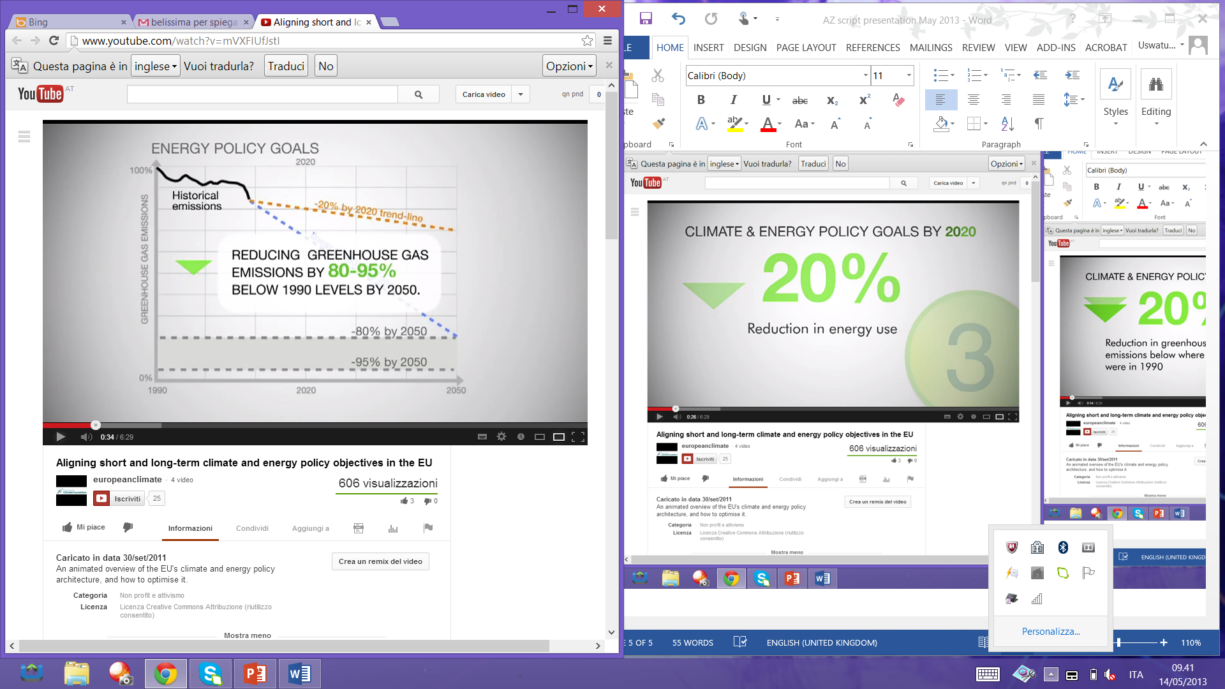
Source: EC on climate change
Moreover the most critical issue is about the cost of mitigation in order to achieve the intended GHG emission reduction. The cost of mitigation in the SR and LR depend on the policy option. It may make the cost of mitigation will be lower in the SR and higher in the LR or in the reverse direction. The most ideal scenario is we can manage the medium cost in the SR and the lower cost in the LR by combining the ideal policy mix between energy efficiency and GHG reduction by powering the ‘low carbon investment’.
However, the conflicting agenda between energy efficiency and GHG reduction can be explained by figure 3.2. Briefly, EU applies energy saving as indicator of energy efficiency. So the achievement of energy efficiency depends on how much we can save the energy. By reducing energy use, the emission also reduce followed by the reduction of emission demand. As consequent, the drop on demand will push the price of emission lower. As consequence, the very low price of emission will discourage ‘the low carbon investment’ in the SR and LR. This dilemma attract any effort to achieve the target of energy saving without undermining the price of emission.
Figure 3.2 The dilemma between energy efficiency and the GHG reduction target
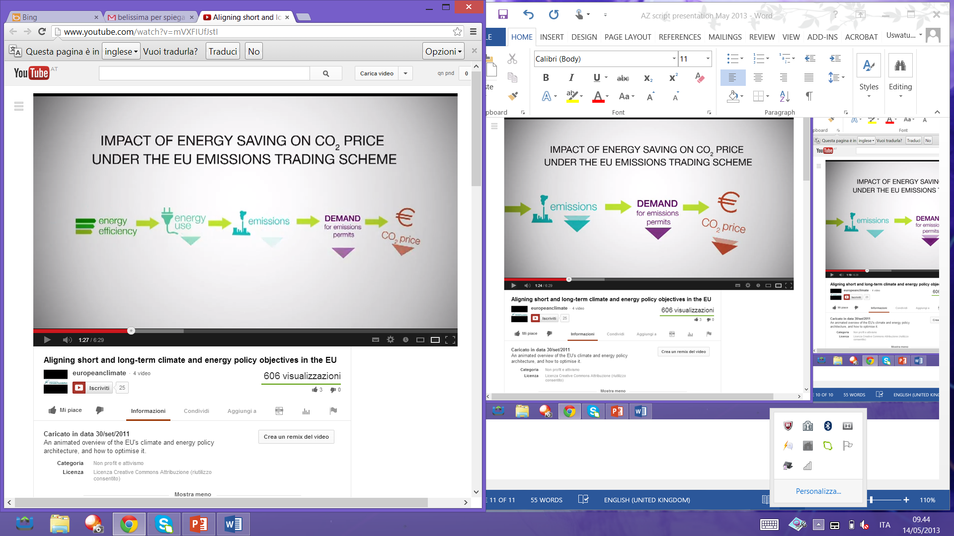
Source: EC on climate change

3.2 The Scenario of Policy Option
The dilemma of two policy goals can be examined by presenting the policy target, the instrument and the outcomes. The policy targets are 20% increase on energy efficiency and 20% decrease on GHG emission. The instrument is the price of emission and the outcomes are the short run (SR) and the long run (LR) economy cost. It is defined that the time frame of SR is achieving the policy target by 2020 and the LR is by 2050.
There are three scheme:
- Business as usual (BUS)
- Achieving the existing target
- Achieving the efficiency target + higher GHG target
The detail scheme is as follows.
Business as usual
Under the business as usual (BUS) scenario, the efficiency will be 10% and the GHG emission will be 20%. By choosing this policy, it keeps the price of emission stable within the interval Euro 15- Euro 30 per ton that is needed to encourage ‘low carbon investment’. And the cost of mitigation in order to achieve 20% GHG reduction is medium in the SR while the efficiency target is also tapped. But in the LR the cost of emission mitigation will be high because the rest of the target (around 60%) has to be achieved after 2020.

Achieving the existing target
In the second scenario, we assume that both targets is being met, the 20% decrease on GHG emission and the 20% increase on energy efficiency. Under this scheme, it pushes the price of emission down below the current price and almost collapsing. The cost of emission mitigation is low in the SR because it is achieved through the cost effective energy saving. But the cost of emission mitigation in the LR is so high because with current level of price emission, it makes any effort for ‘low carbon investment’ becomes not attractive anymore.
This scenario may rise a serious problem, carbon lock-in investment, because little short term incentives for low carbon investment.

Achieving the efficiency target + higher GHG target
The third scenario is the most ambitious one. In this scenario, the 20% target of energy efficiency is achieved and the target of GHG reduction is increased from 20% to 30%. In this scenario, the emission price remains stable and within an acceptable range. The cost of emission mitigation is medium because it is offset by the cost effectiveness on energy efficiency. And in the LR, the cost of emission mitigation is also low because it is not only offset by cost effective energy efficiency but also the emission target after 2020 is lower.

According to those three scenario, the first scenario causes high cost emission mitigation in the LR while the second scenario fails to generate stable and acceptable emission price. In this case, the policy mix can be proposed refer to the third scenario because it maintains stable emission price while the mitigation cost is medium in the SR and low in the LR. Under this scenario, the 20% energy saving target must be achieved and at least 25% emission reduction must be achieved.

Results
According to the historical data of energy efficiency, taxing/fees on emission or environmental purpose both in Austria and The Czech Republic, we can examine whether both countries are on the track or not in order to achieve EU goals. At first, we present the statistic descriptive and then we make a simple analysis to where the policy should be directed.

4.1 Energy Efficiency
According to figure 4.1 Austria had efficiency improvement by around 65% in 2010 in comparison with 2005, but The Czech Republic experienced efficiency loss by comparing both years. The interesting phenomena is efficiency loss also took place in a more powerful economies like Norway, Finland, Sweden, Germany, and France. But we should note that Norway, Finland and Sweden have already had very high efficiency. Though they experienced efficiency loss, their degree of efficiency was still higher than other EU countries.
Figure 4.1 Efficiency (electricity and heat) production from conventional thermal plants in 2005 and 2010
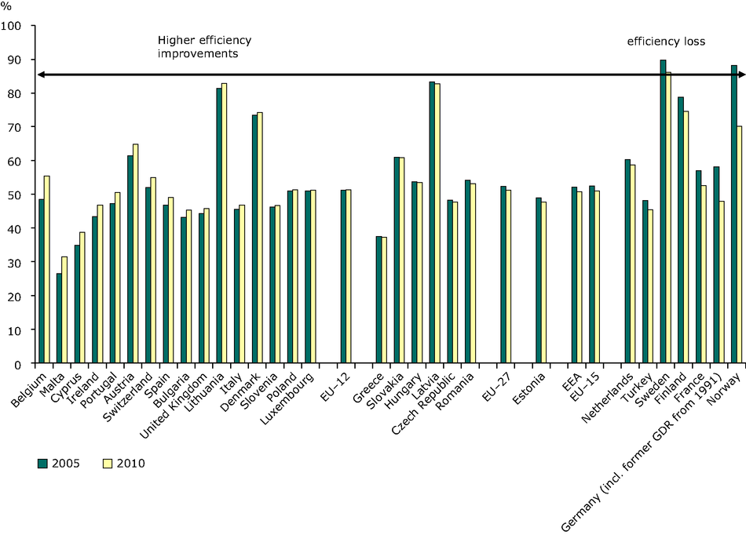
Source: www.eea.europa.eu
Figure 4.2 Efficiency (electricity and heat) production from conventional thermal plants, 1990, 2010
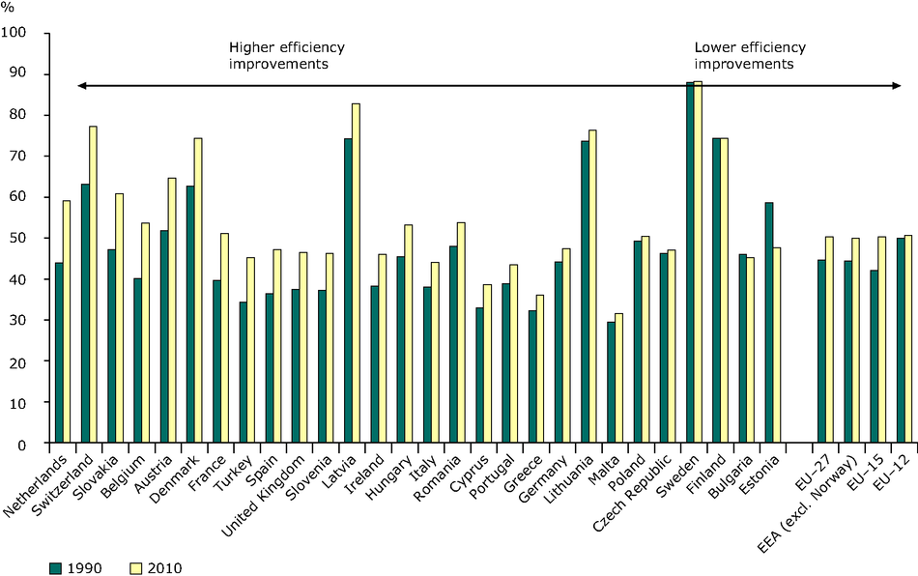
Source: www.eea.europa.eu
Similar to figure 4.1, figure 4.2 depicted efficiency on electricity and heat, but the difference is figure 4.1 using efficiency level in 2005 as comparison and figure 4.2 using efficiency level in 1990. In By using 1990 as comparison level, Austria had significant efficiency improvement while The Czech Republic still experienced efficiency loss. By using efficiency in 1990, many EU countries experienced higher efficiency improvement than using 2005 as base level.
In terms of space heating per m², figure 4.3 presents the decrease on energy consumption in many EU countries when we compare two periods of energy consumption: 1990-2010 and 2000-2010. Austria showed the decrease on the rate of its energy consumption while The Czech Republic presented the significant increase on the rate of its energy consumption on those period.
Figure 4.3 Trends in household energy consumption for space heating per m² (climate corrected)
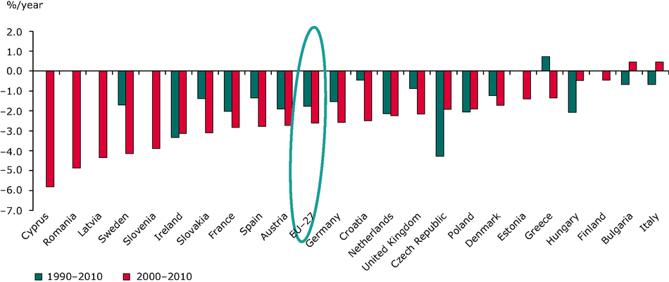
Source: ww.eea.europa.eu
Figure 4.4 Trends in electricity consumption per capita (1990-2010)
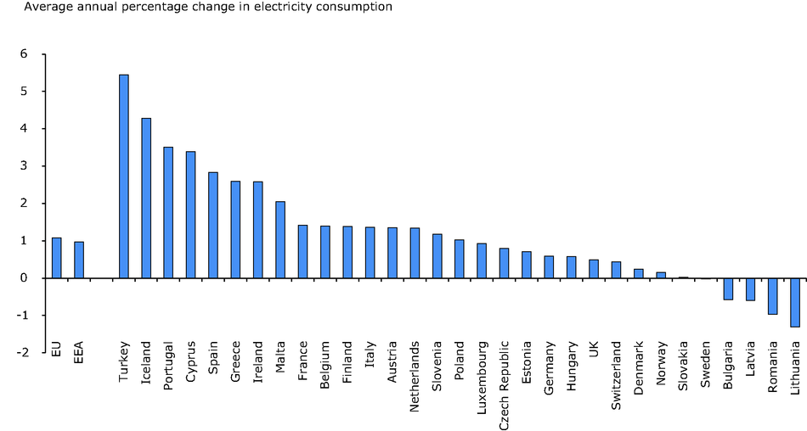
Source: www.eea.europa.eu
In terms of electricity consumption per capita, figure 4.4 presented the average annual percentage change in electricity consumption. We can see that electricity consumption in Austria and The Czech Republic were relatively moderate in comparison with other EU countries.
Contribution of energy efficiency by each sectors is presented by figure-5. There was not big difference on average efficiency of the electric sector among EU countries except Norway. And Austria took the second after Norway but The Czech Republic the second last position.
Figure 4.5 Average efficiency of the electric sector (2010)
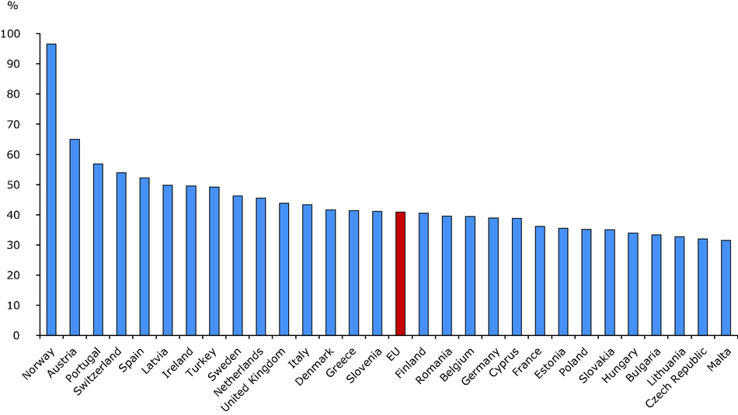
Source: www.eea.europa.eu

  - Emission Abatement Policy
In terms of emission abatement policy, we present the available statistics on environmental purpose, for example emission abatement and energy tax. The name of statistics in The Czech Republic is probably not the same in Austria but the goals is the same: to protect environment. Each country has different feature so we divide emission abatement policy into two sections: Austria and The Czech Republic.
In Austria, there are several environmental taxes and statistics on emission but there is no data about emission trading while in the Czech Republic, the data is quite complete that covers emission trading and the price of emission.

4.2.1 Austria
The legal basis to impose environment (or eco) taxes is regulation (EU) No 691/2011 of the European Parliament and of the Council of 6 July 2011 on European environmental economic accounts and five years contract with the Federal Ministry of Agriculture and Forestry, Environment and Water Management.
In order to protect the environment, the government imposes several taxes that include eco-taxes, energy taxes, ecologically relevant payment, transport taxes, resource taxes and the pollution taxes.
According to figure 4.6 we can show that the trend of resource taxes increased in the period 1995-2011 while pollution taxes quite decreased. The highest revenue from pollution taxes took place in 2003 (Euro 97 million) and suddenly decreased almost half in 2005 (Euro 46 million); a bit increased in 2006-2007 then smoothly decreased in the following period. On the other hand, the resources taxes were smoothly increase year by year.
Figure 4.6 Resource taxes and pollution taxes
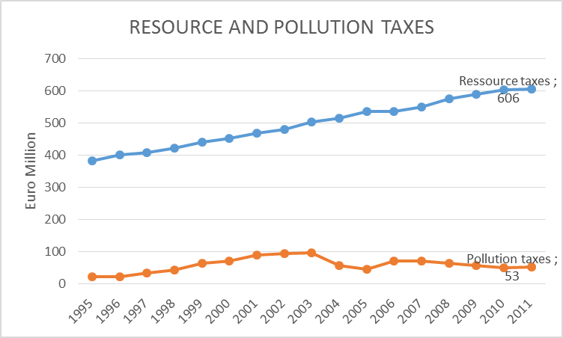
Source: www.statistics.at
According to figure 4.7 all type of taxes that cover eco-taxes, energy taxes, ecologically relevant payment and transport taxes have positive and increase trend. The highest revenue came from eco-taxes followed by energy taxes.
In this case, we do not make further analysis how the relation between the environmental revenue and the environmental performance both in Austria and the Czech Republic.

Figure 4.7 Environmental (eco) taxes and environmental (eco) fees
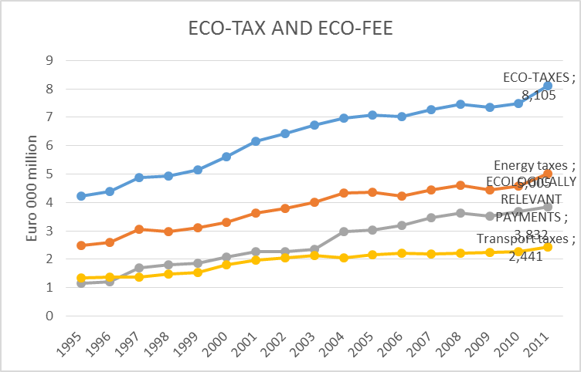
Source: www.statistics.at

4.2.2 The Czech Republic
Expenditure on Environmental Protection
Refer to figure 4.8 in 2011 investments in environmental protection was CZK 24.8 billion, which was an increase of almost 10% over the previous year. At the same time the graph clearly shows the distribution of investments by the guidelines of focus - Air and climate protection, wastewater treatment, waste management and other investments.
In 2011, capital expenditure on air and climate protection was CZK 4.8 billion (compared with the previous year, this represents an increase of nearly one-third), the Wastewater was CZK 9.6 billion (remain at the same level as in the previous year), and the waste was CZK 3.6 billion (also remain at the same level as the previous year). Looking at the situation in the longer term, we see that in the early years of monitoring, the volume of funds spent on investment in environmental protection wasn´t too high and dominated by investments to protect water.

Figure 4.8 Investment in Environmental Protection period 1986-2011
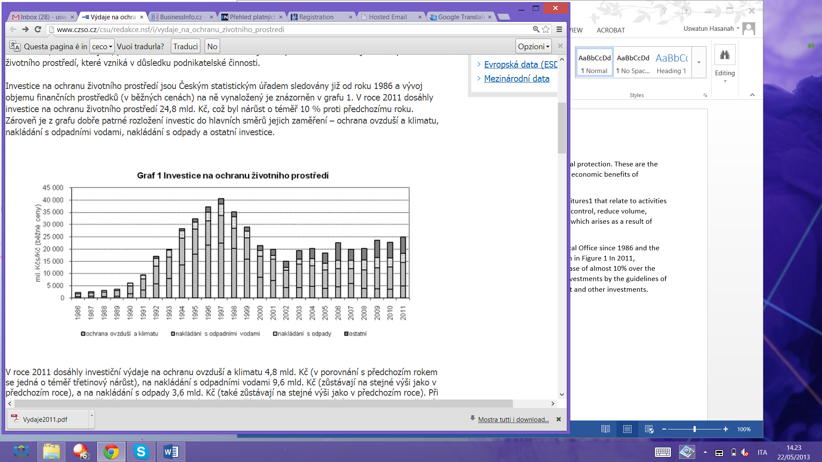
Source: www.czso.cz
Figure 4.9 Investment Cost in Environmental Protection period 1995 2011
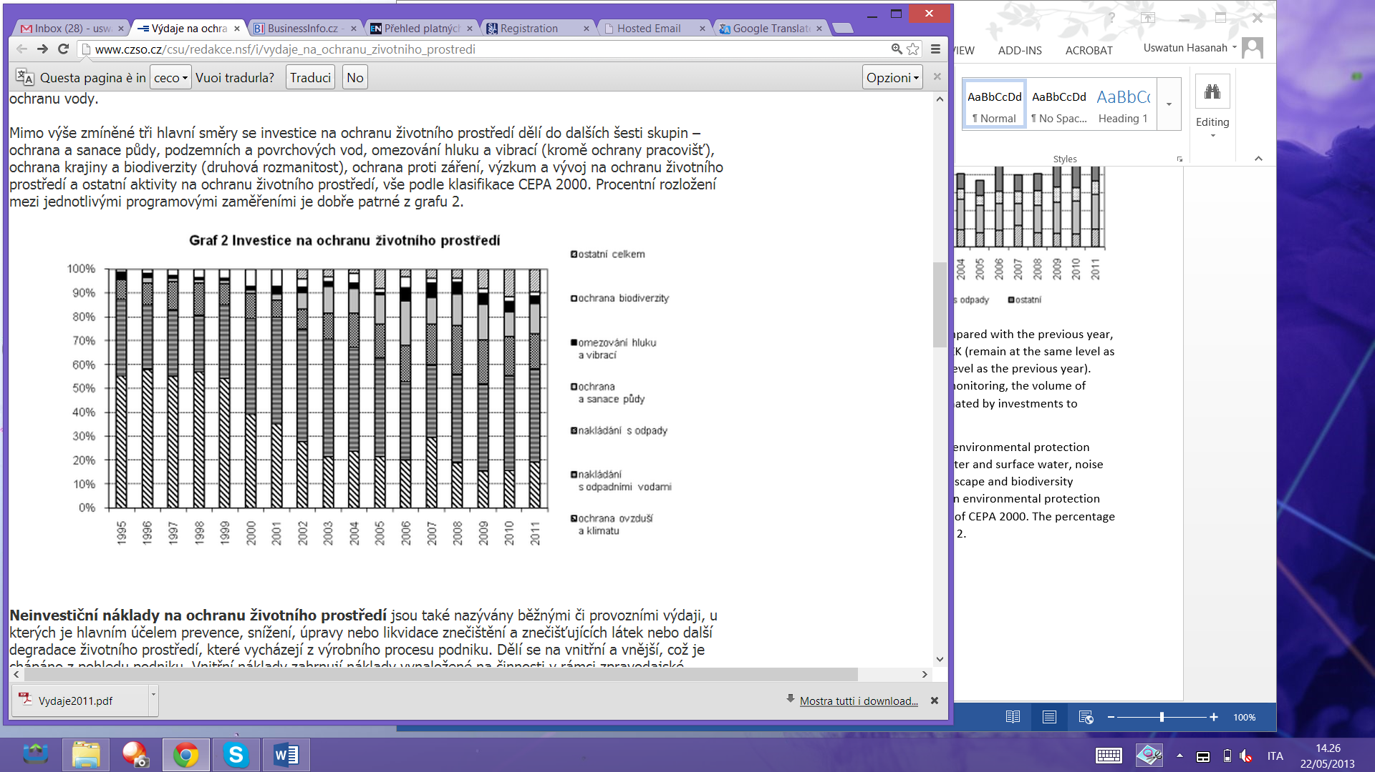
Source: www.czso.cz
Non-investment costs of environmental protection are also called conventional or operational expenditure, which is the main purpose of prevention, reduction, modification or disposal of pollutants and pollution or other environmental degradation, based on the process of production. It is divided into internal and external, which is seen from a business perspective. Internal costs include costs incurred for activities within a reporting unit. They include labour costs, payments for material and energy consumption, for repairs and maintenance, etc. External non-capital expenses mean payments for work done by a contractor (like purchase of services).

Figure 4.10 Non Investment Cost in Environmental Protection
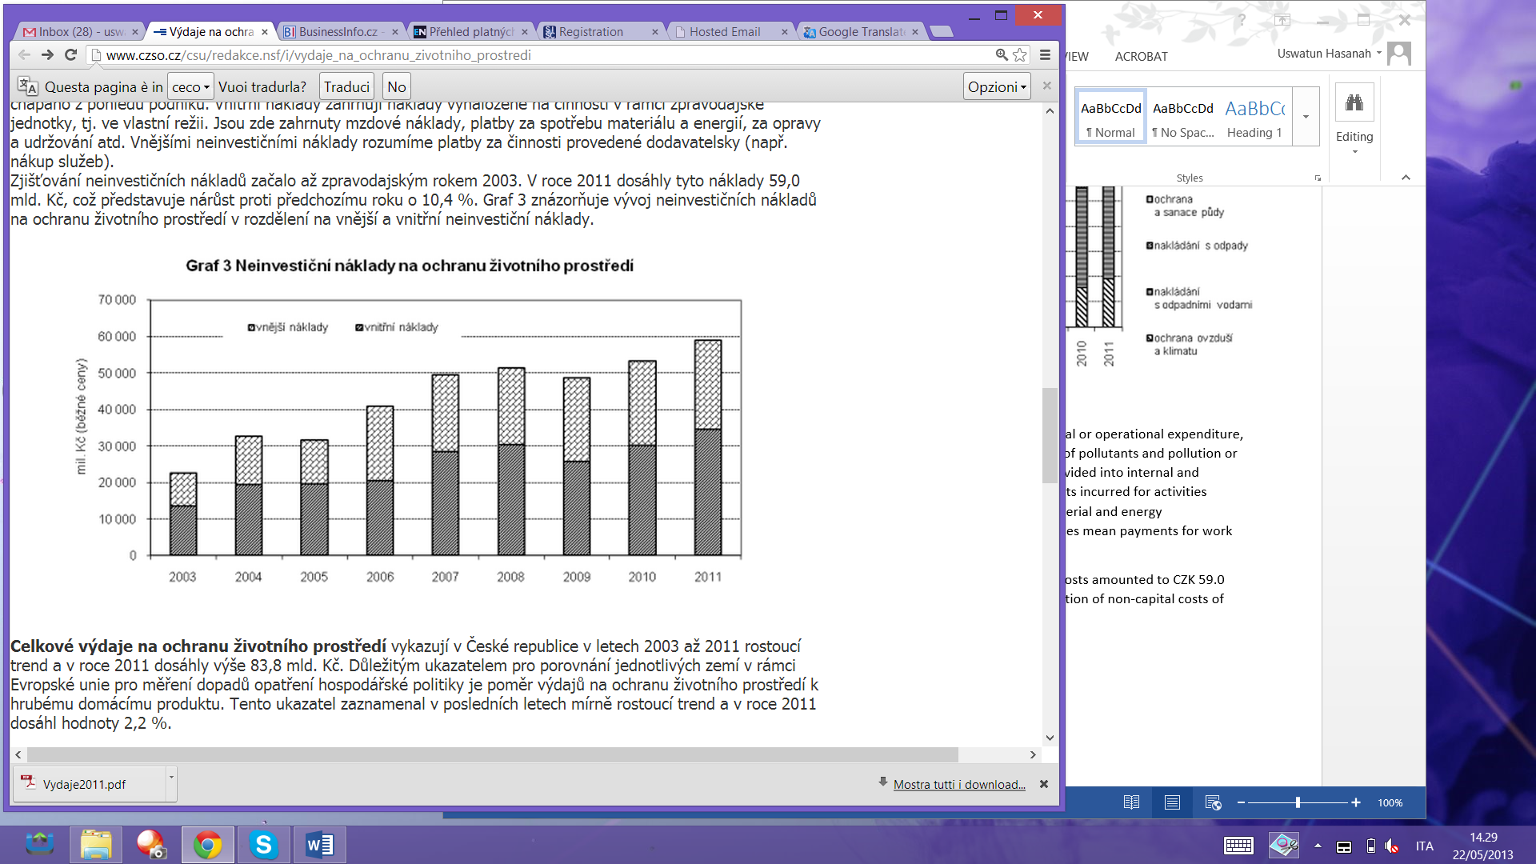
Source: www.czso.cz
Detection of non-capital costs only started reporting in 2003. In 2011, these costs amounted to CZK 59.0 billion, an increase over the previous year by 10.4%. Figure 3 shows the evolution of non-capital costs of environmental protection division of the external and internal expenditures.
Figure 4.11 The comparison of total expenditure on environmental to GDP
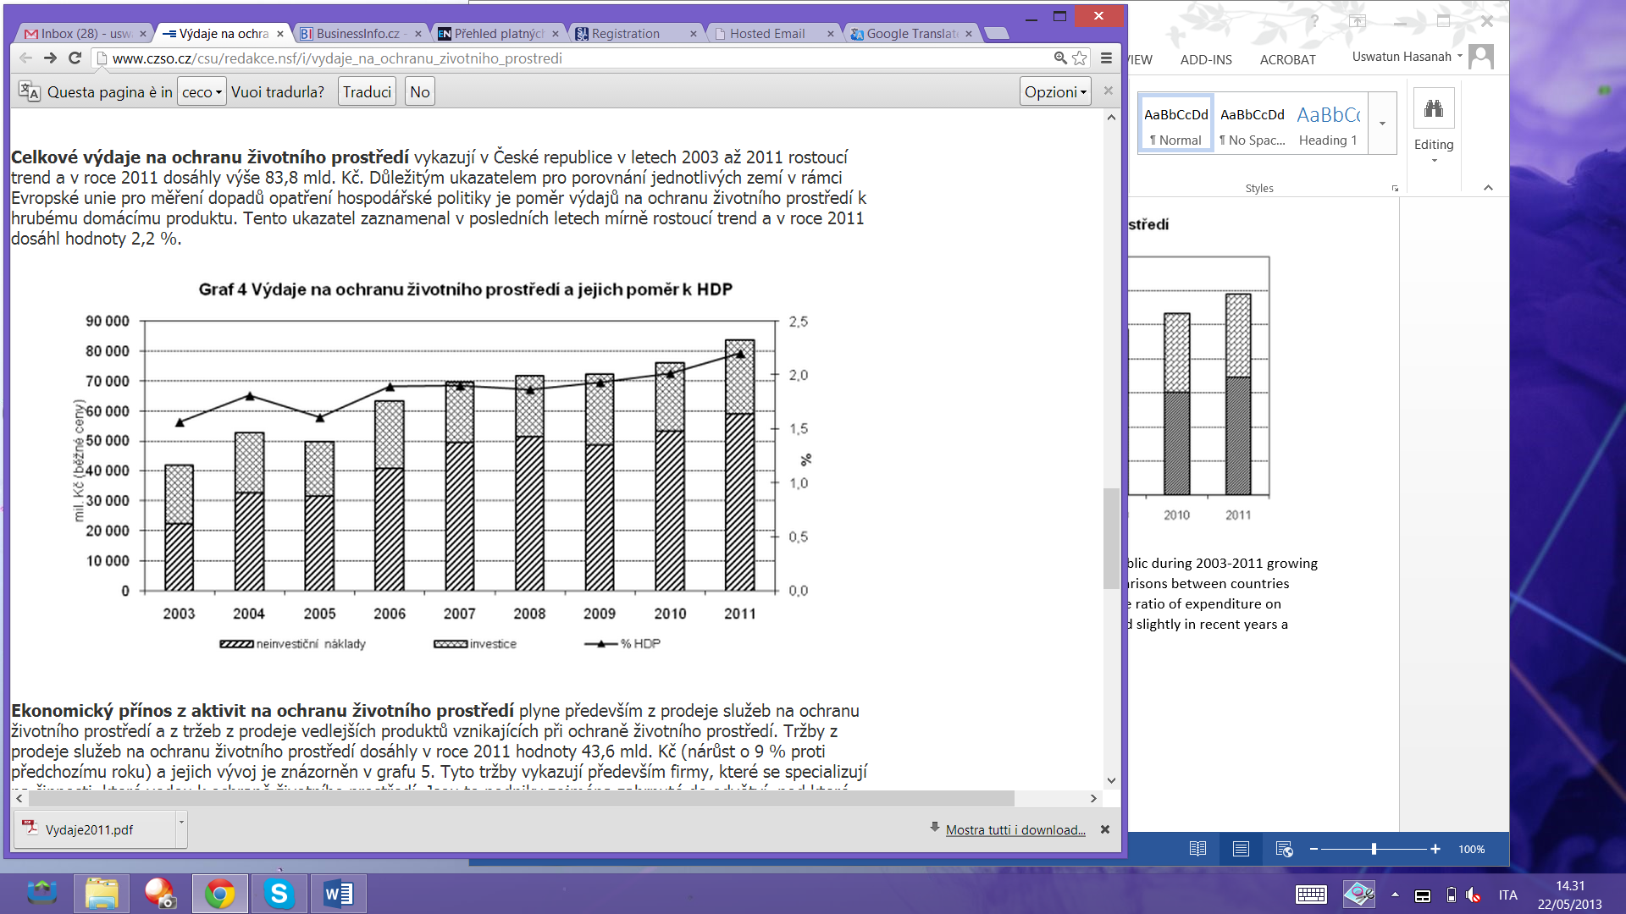
Source: www.czso.cz
Total expenditure on environmental protection recognized in the Czech Republic during 2003-2011 growing trend in 2011 amounted to CZK 83.8 billion. An important indicator for comparisons between countries within the European Union for measuring the impact of policy measures is the ratio of expenditure on environmental protection to the gross domestic product. This indicator scored slightly in recent years a growing trend, and in 2011 reached 2.2%. Expenditure on environmental protection is currently one of the priority areas of the strategy of environmental accounting, which is closely related to the sustainable development strategies. The aim of the Czech Republic Statistical Office is therefore continue to identify and refine these indicators and thereby contribute to the development of environmental accounting in the Czech Republic.
Table 4.1 Energy Taxes in the Czech Republic
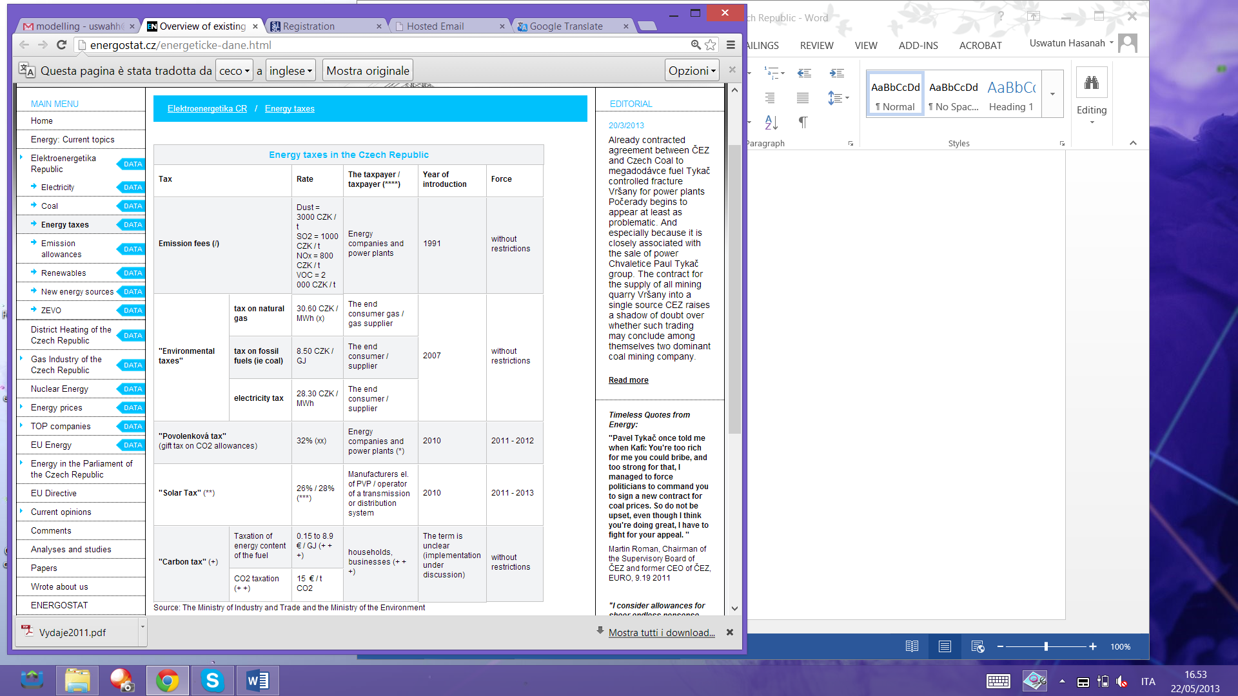
Emission Allowances
Already contracted agreement between ČEZ and the Czech Republic Coal begins to appear at least as problematic. Especially because it is closely associated with the sale of power plant Chvaletice owned by Paul Tykač group. The contract for the supply of all mining quarry ‘Vršany’ into a single source ČEZ raises a shadow of doubt over whether such trading may conclude among themselves two dominant coal mining company.
Here is the current development in the market for brown coal in the Czech Republic in the context of energy transaction in 2013.

Table 4.2 Price emission allowances EUA 13-20 to Burt (EUR)
Price emission allowances EUA 13-20 to Burt (EUR)
January 7, 2013 | January 17, 2013 | January 29, 2013 | February 7, 2013 | February 18, 2013 | February 28, 2013 | March 7, 2013 | March 18, 2013
6.18 | 5.36 | 3.88 | 4.24 | 5.14 | 4.38 | 4.12 | 3.47
Source: EEX

Table 4.3 The average price of emission allowances (CZK, methodology ERO)
The average price of emission allowances (CZK, methodology ERO)
4Q 2012 | 3Q 2012 | 2Q 2012 | 1Q 2012 | 1-4Q 2012 | 1-4Q 2011 | 1-4Q 2010 | 1-4Q 2009
185.9 | 189.0 | 174.0 | 196.9 | 186.5 | 322.6 | 355.7 | 332.2
Source: BlueNext, CNB
Note:
It is a weighted average of the prices of emission allowances for each trading day in the period, where the weight is the quantity traded for the day. Conversion to CZK using the average rate for the period by the CNB. A similar methodology used in determining the price of allowances and ERUs.

Figure 4.12 The difference between the allocation and actual emission (EU-ETS, t)
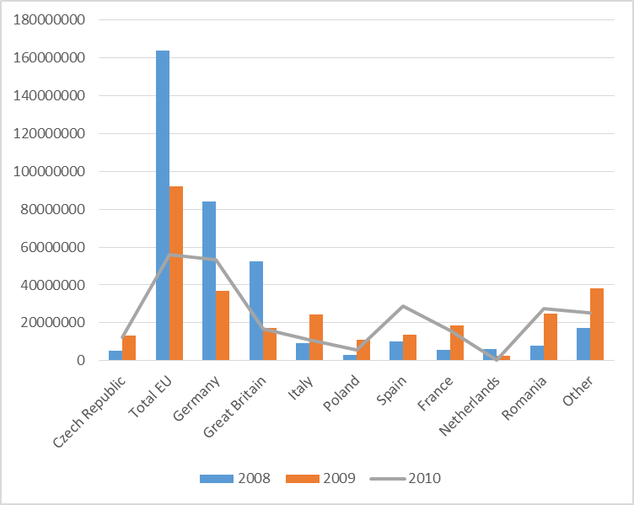
Source: EU

According to figure 4.2, it shows the difference between the allocation and actual emission (EU-ETS, t) in the Czech Republic in comparison with EU and selected EU countries. The positive number refers to ‘surplus’, it means they still have opportunity to sell their right to emit pollution. In comparison to 2008,

In terms of ecological tax reform, The Czech Republic has been making significant progress. In addition to the unified rate should generate new directive also add to the emissions trading scheme and a tool to support achievement of the strategy by 2020.
In the Czech Republic, government's draft medium-term expenditure frameworks for the years 2013 - 2015 is planned carbon tax in the amount of 15 EUR / t CO2. According to the legislative plan should be a bill submitted to the Government in October 2013.

Conclusions
This paper try to present the current condition on energy efficiency and emission action in Austria and the Czech Republic and to where the policy should be directed. And it should be noted that this paper does not be intended to compare both countries because the existing condition between Austria and the Czech Republic is different. Austria has been a stable country for so many years while the Czech Republic was experiencing political conflict until being an independent country as the Czech Republic since January 1st 1993.

This paper emphasizes how both countries respond the policy goals in EU level and whether they are on the track or not. However, this paper only review the policy on energy efficiency and pollution abatement and has not intended to evaluate or make assessment of the policy.
According to the historical data of energy efficiency, taxing/fees on emission or environmental purpose both in Austria and The Czech Republic, we can show that both countries are on the track in order to achieve EU goals. Austria took the second rank on energy efficiency among EU countries while the Czech Republic initiate emission trading on its coal industry. In terms of environmental (eco-) taxes/fees, both countries have a positive and an increase trend on their environmental revenue. Moreover, the Czech Republic has been continuously initiating any kind of fees to protect environment.

References (Literature)
_____, (2005) The private cost effectiveness of improving energy efficiency Productivity Commission, EU.
Arouri et al (2012), Energy consumption, economic growth and CO₂ emissions in Middle East and North African countries, IZA Discussion Series Paper No. 6412.
Bleischwitz and Andersen (2009), Informational barriers to energy efficiency-Theory and European Policies, MPRA Paper, No. 19937
Haas and Schipper (1997), Residential energy demand in OECD-countries and the role of irreversible efficiency improvements, Energy Economics, Vol. 20, Issue 4, pp. 421–442.
M.J. Bradley & Associates (2007), Comparison of energy use & CO₂ emissions from different transportation modes, submitted to American Bus Association (ABA), Washington, DC.
Oikonomou et. al. (2009), Energy saving and energy efficiency concepts for policy making, Energy Policy, Vol. 37, Issue 11, pp. 4787–4796
Schipper and Hass (1997), The political relevance of energy and CO₂ indicators-an introduction, Energy Policy, Vol. 25, Issues 7-9, pp. 639-649.
Statistics the Czech Republic:
Energy taxes http://energostat.cz/energeticke-dane.html
Ecological taxes http://www.businessinfo.cz/cs/clanky/ekologicke-dane-3532.html#predmet
Government spending http://www.czso.cz/csu/redakce.nsf/i/vydaje_na_ochranu_zivotniho_prostredi
NAMEA http://vdb.czso.cz/vdbvo/en/tabdetail.jsp?cislotab=ENE4130UC&kapitola_id=34
http://vdb.czso.cz/vdbvo/tabparam.jsp?cislotab=ENE5030UC&&kapitola_id=34&voa=tabulka

Aligning Short Term and Long Term EU Policy Objectives
http://www.youtube.com/watch?v=mVXFIUfJstI
EU Energy Policy-Pro and Contra
http://www.youtube.com/watch?v=nyTzGsWz_6o

By definition, investments in environmental protection all investment expenditures1 that relate to activities to protect the environment, whose main goal is to collect, treat, monitor and control, reduce volume, prevent or eliminate pollutants and pollution or damage to the environment, which arises as a result of business activities
(/) ... currently preparing an extensive amendment to the Clean Air Act; adjustment will also affect the amount of emissions charges and their time shallowness, more details in the special issue , which is devoted to this topic (X) ... tax rate is actually ranges from 0 - 264.80 CZK / MWh by use of gas, the tax base is the amount of gas in MWh heat of combustion, that rate 30.60 / MWh, for example, refers to gas for heat (Xx) ... the price of emission allowances (*) ... Act (Amendment z.č.180/2005 in the organization from 2010) introducing gift tax allowances to specify the payer / taxpayers of this "povolenkové taxes", the other legal regulations, however, that it is all of the operator, that emit greenhouse gases (ie all companies covered by the Act No. 695/2004 on conditions for trading in greenhouse gas emissions) (**) ... Official name: "levy on electricity from sunlight" (***) ... Rate refers to the amount the producer receives for electricity produced from PV; rate of 26% was applied in the case of payment by means of the purchase price; rate of 28% in the case of payment by means of green bonus; (****) ... taxpayer actually pays tax to the payer provides payment of taxes to the state (+) ... Still in the design stage of the Government (10 April 2012) is based on Directive 2003/96/EC ; folder "carbon tax" tax the energy content of the fuel has The Czech Republic equivalent title (+ +) ... in a press statement the Government defined this part of the "carbon tax" as the emission component of excise duty on fuel oil, solid fuel taxes and taxes on natural gas and other gases (+ + +) ... Under different energy content of the fuel (+ + + +) ... Component CO2 tax will not apply to entities with the obligation to purchase emission allowances

