

**Single European Electricity Market - the Role of RES-E**

**Czech-Austrian Winter and Summer School**

**Petr Spodniak**

**Beata Garšicová**

**Wolfgang Pichler**

Co-operating Universities

   

Financial support by

 

**Prague and Graz, 2012**

Table of Contents

Abstract 3

Motivation 3

Problem statement 3

Approach 4

Results 5

European Union 5

Electricity market 5

Renewable energy 6

Finland 8

Electricity market 8

Renewable energy 9

Czech Republic 10

Electricity market 10

Renewable energy 13

Austria 14

Electricity market 14

Renewable energy 16

Discussion 16

Technology vs. governance 16

Finland 17

Czech Republic 18

Austria 18

Conclusions 19

Bibliography 20

Appendix 22

# Abstract

The European Union plans to achieve fully liberalized internal electricity markets by 2014. Achieving this ambitious goal is strongly dependent on two factors: national energy policies and transmission networks. The current work focuses on the national policies of three EU states across three electricity market regions (Central-East, Central-South, and Nordic) and assesses their compliance against the objective of common European electricity market. To achieve our objective two approaches are utilized. First, we review the development of electricity markets in the sampled countries and focus on renewable energy policy. This approach enables understanding of national markets’ differences in respect of electricity generation mix, electricity supply and demand structures, and various support mechanisms for conventional and RES electricity generation technologies. Second, we classify each of the countries’ electricity market according to two dimensions (Finon, et al., 2004) - governance dimension (competition/coordination) and technology dimensions (large scale centralized/small scale decentralized systems). The results show how the national energy policies create different market conditions for RES-E generators which may in consequence hinder the process of achieving the pan-European electricity market.

# Motivation

The European electricity markets have been in constant change since early 1990s when the process of market liberalization and deregulation commenced. The major driver for electricity market opening is enhanced competition, which leads to efficient allocation of resources, lower prices for end customer and new services (European Commission, 2009; Berg Insight, 2010). The challenging task of restructuring traditionally vertically integrated market is borne by the national governments which are further guided by the common European energy strategy. The task of integrating and harmonizing historically independent electricity markets is immense. In this paper we analyze the development path towards the integrated electricity market in Europe with a focus on the role of renewable energy support mechanisms.

# Problem statement

Directive 2009/72/EC concerning common rules for the internal market in electricity, in force since March 2011, points out multiple challenges of the internal electricity market, namely: obstacles to the sale of electricity, nondiscriminatory network access, and an equally effective level of regulatory supervision in each Member State. A particular role is played by diversified sources of energy, especially renewables which serve to enhance security of energy supply. However, the lack of regulatory harmonization across Member States, in particular concerning renewable energy support schemes, is introducing new challenges to competitive electricity markets. The topicality of the subject is confirmed by European Energy Regulators’ recent consultation (CEER, 2011) on market effects of non-harmonized RES support schemes in Europe. As expected, the lack of harmonization has an effect on investment decisions and market functioning (Lord Mogg, 2012). The current paper identifies and points out the regulatory differences in a sample of EU countries and discusses the effects on national and European electricity markets.

# Approach

In the current work we embrace approaches of mainly two works. First, Finon et al. (2004) classify national electricity markets according to governance dimension (competition/coordination) and technology dimensions (large scale centralized/small scale decentralized systems). We try to apply this classficiation to the country sample. Second, specifically for the analysis of renewable enrgy policy, Sawin (2003 p. 2) mentions the following:

“Governments have a number of options that they can use to promote renewables. The first is to support the use of voluntary measures, particularly through education and information dissemination. This option has varying and limited effects. Second are environmental standards or energy taxes. The third option is to promote renewable energies through direct support, which is the focus of this report. The combination of policies needed depends on the costs of the technology used, location and conditions.

Sawin further presents five major categories of RES policy mechanisms, which we take into account:

* Regulations that govern capacity access to the market/electric grid and production or purchase obligations
* Financial incentives
* Industry standards, permitting and building codes
* Education and information dissemination
* Stakeholder involvement

Furthermore, Council of European Energy Regulators (CEER, 2011) presents RES financial support schemes according to four categories:

* general taxes
* specific non-tax levies in electricity bills
* possible pass-through to end-users of costs borne by the Distributor/Supplier via a specific surcharge in bills
* Possible pass-through into the wholesale electricity price of costs borne by the Generator or the Supplier without a specific surcharge in bills

The main support instruments considered by CEER were feed-in tariffs, feed-in premiums, quota obligations (Green Certificates), and others, as presented in the table below.

Table 1 Overview of ways of financing RES electricity support schemes, 2009 (CEER, 2011 p. 8)

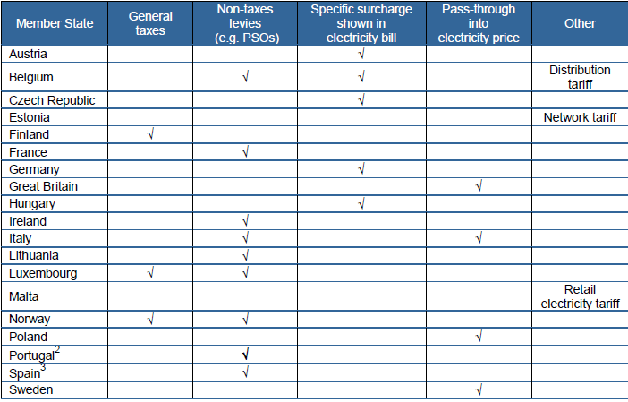

# Results

The aim of this chapter is to present the main regulatory frameworks of electricity markets in general and renewable energy in particular. The discussion starts with European markets and renewable energy policies, and further moves into the country-specific debate. Topics discussed deal with wholesale and retail electricity markets, competition and regulation frameworks, and transmission and distribution networks. However, the major focus is given to renewable energy policy, due to their significant role in the common electricity market.

## European Union

### Electricity market

Electricity market in Europe has already been liberalized but on the other hand, there is still a long way before the market will be fully integrated. Let’s now focus on the main milestones that affected the whole liberalization process and steps that still need to be done to fulfill the ambitious target of the EU, to create a common electricity market.

First of all there are important laws of the European Union from which the idea about the creation of common market in general arose. From those it is necessary to mention the Treaty on European Union and the Treaty on the functioning of European Union. After that there were many agreements that focused directly on electricity markets. We can see some legal regulations issued by the European Commission before the EU creation as well.

The European Commission directive 90/547 issued in 1990 dealt with the international transmission of electricity, the directive 90/377 that followed regulated the prices of electricity for final consumers. The Maastricht Treaty and the creation of the European Union started the common market creation process, but the final decision was done in 1996 in 1996/92/EC directive.

The first phase of the market opening should have been done by 1999. Although there were some delays and some members opened their market only partially, this goal was finally achieved. Scandinavian countries, Spain, Netherlands and the Great Britain opened their markets completely. There were some countries with formal attitude, such as Germany, that opened their markets for all customers but not for the foreign competition. Countries like France firstly refused to open their market, as the electricity played role of a public good, and the access to their grid was very limited.

The new directive was introduced in 2004 which specified the conditions and details about market liberalization and the introduction to new adherents to EU. The market was fully liberalized in 2006.

Since 2008 we can see the trend in the creation of small integrated European markets, these regions are displayed in the figure below. From these integrations we can mention: Northern region (Sweden, Finland, Norway and western part of Denmark), CWE countries (France, Netherlands, Germany, Belgium and Denmark), Central European region (the Czech Republic, Slovakia and Hungary), etc.

However this idea is well planned and the preparation process is running, the goal of the common electricity market doesn’t seem to be achieved by 2014, as projected.

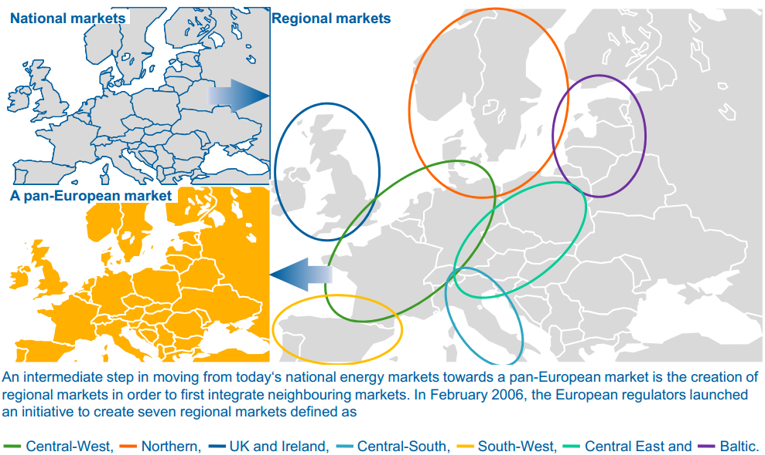

Figure 1 Electricity markets in the EU[1]

### Renewable energy

The main EU directive for renewables is the Renewable Energy Directive (2009/28/EC) which among others requires all member states to issue legally binding National Renewable Energy Action Plans (NREAP). By and large, the 3rd Energy Package introduced a new institutional framework, which among deregulation, unbundling, establishment of joined agencies ACER and ENTSO-E, and the 20-20-20 energy goals, significantly reduced barriers for new entrants. The strategy beyond the 2020 energy goals is illustrated in the Energy Roadmap 2050 (European Commission, 2011) by three different scenario analyses. First, the reference scenario relies on 1,7% GDP growth p.a., achievement of EU 20-20-20 energy goals, and compliance with the emission trading scheme. Second, current policy scenarios take into consideration the Energy Efficiency Plan and the new Energy Taxation Directive. Third, decarbonisation scenarios model scenarios with high RES penetration, low nuclear power, delayed CCS commercialization, significant energy efficiency, and diversified technologies. Importantly, under all scenarios electricity will play an ever increasing role in the final energy demand expected to reach 36-39% in 2050. The increasing role of RES in energy consumption is illustrated in the figure below. Under the high RES scenario wind power is the largest source of electricity by 2050.

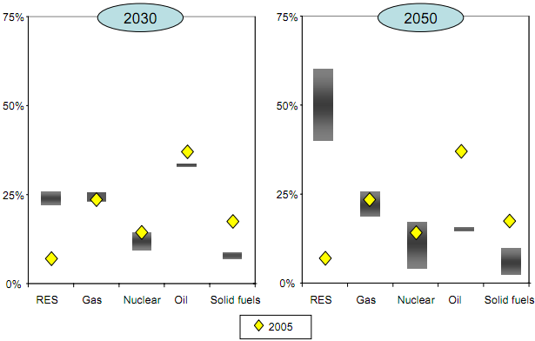

Figure 2 EU Decarbonisation scenarios - 2030 and 2050 range of fuel shares in primary energy consumption compared with 2005 outcome (in %)[2]

In addition, the revised Energy Taxation Directive, which is to come into effect in 2013 and replace Directive 2003/96/EC, introduces two new elements. First, energy efficient sources of energy are rewarded due to taxation based on the energy content (€/GJ) instead of volume. Second, all sectors, excluding renewable energy sources, not covered by the EU ETS are subject to minimum CO2 emission tax of 20€/t CO2. Such a two-element energy tax system, employed in Finland since 2011, has the benefit of non-discriminating renewable sources with lower energy content but higher environmental benefits.

The instrument which reduces negative externalities of industrial production and usage is the Emission Trading Directive (2009/29EC). Currently, the scheme covers period up to 2020 and the major change from the previous trading periods is the compulsory auctioning of the emission allowances starting from 2013. Again, instead of the free allocation system practiced earlier, power generators and other participants will have to buy and trade allowances which introduce yet another competition factor.

## Finland

### Electricity market

Finland, together with Sweden, Norway, Denmark, and Estonia, constitute the Nordic electricity market. Electricity Market Act (1995) is the founding document of Finnish electricity markets, which enabled separation of electricity supply and generation from distribution and transmission. The retail markets are fully open to all customers from 1998 and currently there are approximately 70 electricity retail companies. Average customer switching rate is between 7-8 percent (EMV, 2011 p. 4). Even though the Finnish electricity sector is characterized by large number of generating companies (120) and power plants (550), the majority of production is controlled by two players: Fortum (40%) and Pohjolan Voima (25%). The electrical grid is operated by 91 distribution system operators (DSO) and national transmission system operator (TSO, Fingrid), all operating as natural monopolies with regional (DSO) and national (TSO) scope of authority. Fingrid performs multiple significant roles enacted in the Electricity Market Act (2004), namely grid’s technical operation, maintenance and development, reliability, national balance, and grid connections, for example.

The Nordic electricity marketplace is facilitated by the first and largest electricity power exchange Nord Pool. More specifically, the market enables physical power trades through Nord Pool Spot (day-ahead and intraday markets), and financial power trades via Nasdaq OMX Commodities (futures, forwards, options, and CfD) and OTC traders (bilateral trade). Nord Pool also clears the contracts traded on the Nordic power exchange. In 2009, 72 % of electricity has been traded through Nordic spot market while the rest is based on bilateral transactions (Fingrid, 2009). Specifically, the share of power bought from the power exchange in relation to the consumption in Finland equaled to 55.9% in 2010 (EMV, 2011 p. 4).

Concerning the electricity price in Finland, it comprises of two commodities: 1. Sale of electrical energy, which is subject to competition and customers’ choice, and 2. Distribution of electricity, which belongs exclusively to local network companies (EMV, 2012). Energy tax on electricity in Finland is based on the output (consumption) of electricity, which is divided according to two rates: lower rate (0.69 euro cents/kWh) for industry and greenhouse cultivation, and higher rate (1.69 euro cents/kWh) for households, agriculture and services (Ministry of the Environment, 2011). Since 2008, RES-E received fiscal subsidies equaling to 0.69 euro cents/kWh with minimum eligible refund of 100MWh per 6 months (Ministry of the Environment, 2008), which significantly reduced the tax-burden for RES-E. In addition, all customers under the two tax rates described are eligible to pay strategic stockpile fees (0,013 euro cents/kWh). Value Added Tax on electricity has been in effect in Finland since August 1986. The current rate is 22 % and is recoverable by industrial customers.

Finland is an energy deficit country in which demand surpasses the national production capacities and the imbalance is imported from the Nordic market and Russia. In 2010, the peak load equaled to 14588 MW and the estimated generation capacity is 13360 MW (EMV, 2011 p. 4). During this period, power generation was approximately 11640MW and import to Finland was 2950 MW. In 2012, the total import capacity of electricity to Finland from neighboring countries was 4650 MW.

### Renewable energy

The Long-term Climate and Energy Strategy (Finnish Government, 2008) is the founding document of Finnish energy strategy until 2020 with sketches of policy directions up to 2050. Among the main objectives is to increase the share of renewable energy to 38 % of total final energy consumption until 2020.

Another long-term strategy document is the national renewable energy action plan (Ministry of Employment and the Economy, 2010) for promoting energy from renewable sources, to comply with the renewable energy Directive (2009/28/EC). The main goal of the action plan, which covers the period 2010-2020, is to halt and reverse the growth in the final energy consumption. However, already in 2010 the final energy consumption rose by 10% (Statistics Finland, 2011) and the energy demand increased by 8 % to 87 TWh in comparison to the previous year. National energy efficiency plan (NEEP-2, 2011) is another strategic document introducing long term energy efficiency measures which are to save 37 TWh of energy end-use by 2020. The document complies with the Energy Services Directive (32/2006/EC).

For the medium-term, concrete implementation rules are defined in the Act on Production Subsidy for Electricity Produced from Renewable Energy Sources (1396/2010), which defines two RES support mechanisms: feed-in tariff and fixed production subsidy. Under both schemes, the Energy Market Authority is the main supervisor, guided by general management of Ministry of Employment and the Economy.

One of the critical decisions affecting RES-E projects in the early stage of planning is the environmental impact assessment (EIA). The decision-making process is guided by the amended Act on Environmental Impact Assessment Procedure (468/1994). The EIA involves multiple actors and spans across wide areas, such as road traffic (TraFi), air traffic (Finavia), building and land permits (ELY), noise abatement (Ministry of Environment), and national defense (Finnish Defense Forces). The Act enacts Centers for Economic Development, Transport and the Environment (ELY) as the coordination authority with the right of appeal (veto) against inadequate EIAs. Despite the complex requirements of EIA, there are no official evaluation documents guiding the decision-making process of ELY which may increase the investment risk of developer who solely bears the EIA costs. At present, the results of ministerial working group (Ministry of the Environment, 2011) serve as process guidelines addressing issues of wind farm construction, impact assessment, and approval procedures.

Finally, in addition to RES it is noteworthy to mention the government’s stance to nuclear energy in Finland. During the last nine year the Finnish government has made three positive Decisions in Principle which subsequently lead to construction of the same number of new nuclear power plants. Olkiluoto 3 is to start operation in 2014, Olkiluoto 4 and Pyhäjoki in 2020 with the total yearly expected output of approximately 36 TWh (Fennovoima, 2009; Pohjalan Voima, 2011). In comparison to the year 2010 where 25% of yearly national electricity demand was served by 21,89 TWh of nuclear power, the year 2020 will deliver more than double the amount. Such trend does not seem to follow the European decarbonisation scenarios discussed above which illustrate a decreasing trend of nuclear power in primary energy consumption in the long-run. However, nuclear energy is perceived by the government as the mean to fill the national supply gap by large scale, non-intermittent, and cheap (if built on schedule) energy.

## Czech Republic

### Electricity market

#### Regulation

The regulation process in the Czech Republic is divided into three periods: the first took place from 1st January 2002 till 31st December 2004, the following period was effective till 31st December 2009 and the current regulation phase is also supposed to last 5 years (1st January 2010-31st December 2014). The main changes that were implemented during the regulation periods are mentioned in following paragraphs, some of them are described more precisely in next chapters, because we consider them as the key criteria in the creation of the common electricity market.

**1st regulation phase**

During the first period the new type of price regulation was introduced. The RPI-X method, which is based on the companies’ performance, was quite common for other European regulators but opposite to cost based method previously typical for the Czech Republic. The regulator set up the ‘revenue-cap’ which is every year adjusted for inflation and the productivity growth of the industry.

**2nd regulation phase**

The goal of the second regulation phase was to guarantee the price stability of electricity for final consumers and conserve the profitability for investors. The accent is put also on investments. The important regulatory change influenced by the European directive 1228/2003 hampers the taxes or fees on electricity exported. In the same time it allows the profits from cross-border transactions being regulated. The regulator includes this income into maximum allowed revenues and the price for final consumers is therefore lower. Financial supports for production of electricity from RES and cogeneration production were introduced during the second regulation phase.

1st January 2006 the market was fully liberalised.

**3rd regulation phase**

The system of calculation of allowed revenues, introduced during second phase, was specified and factors taken into account in formulas were precisely defined.

The third regulation phase defines also the prices for local distributor which can be higher or lower than the one of the main distributor. The regulation of the Market Operator was modified as well. The price of the settlement of imbalances is settled as a combination of revenue-cap and cost-plus method. New rules in a creation of price of a supply of last resort were applied, as the price can be set up by the providers of that service (it was determined by the regulator before).

#### Legal environment

Liberalized electricity market means not only the technical possibilities how to trade electricity throughout Europe, but also the fair and competitive legal environment. In this chapter we will examine the most important legal documents that manage the whole electro-energetic industry and may have impact on the creation of the common electricity market.

The essential document that regulates the electro-energetic industry in the Czech Republic is the Energy law (458/2000 Sb.) accompanied by directives issued by the Czech Ministry of Industry and Trade and Energy Regulatory Office. The Energy Regulatory Office is an independent institution responsible for the right functioning of the electricity market. The Ministry of Industry and Trade is the key institution for implementing the EU directives. The National Energetic Inspection (which is subordinated to the Ministry) plays also important role, as it controls and gives sanctions if the law about renewable energy policy is not fulfilled.

The entrepreneurship in the electro-energetic sector is conditioned by a license issued by the Energy Regulatory Office. These licenses are usually granted for 25 years, in case of traders with electricity for 5 years only. There is a specific obligation connected with licenses on electricity distribution, the holders of these licenses are not only allowed but also obliged to run their business as the continuous distribution process. The entrepreneurship of other members of EU is allowed, but the license issued abroad must be accepted by the local regulator. According to European directive implemented in Czech Energy law, the electricity transmission system is conditioned also by the certificate of independency which aim to prove the real interest in providing electricity transmission and the independency of other players in electricity business (production, distribution and trading). The latter is called the unbundling, which is, in electro-energetic industry, possible only on ownership basis (the whole system needs to be physically connected). The ownership unbundling is applied also to operators in the market, which is not required by European Union (this service is for example in Slovakia executed by the transmission company SEPS, a.s.).

Concerning the price regulation there are only two sectors that have already been liberalized, electricity producers and traders are not regulated. Transmission, distribution and other related services have their sales strictly watched by the Energy Regulatory Office. The price regulation follows the method ‘Revenue cap’, which determine the maximum allowed revenues according to costs, depreciation and reasonable level of profit. This measure can be considered as an obstruction while creating the common electricity market, because the system of price regulation among members of European Union has not been harmonized yet. As we can see in figure 3, there are two main types of regulation: incentive or non incentive based. The Czech Republic uses the former one, which stimulate regulated entities in increasing their effectiveness. The Czech Republic is the only member state, which apply revenue cap method and set up efficiency factor without any benchmark. Due to a presence of many German companies in the Czech market, the benchmarking method is now being discussed.

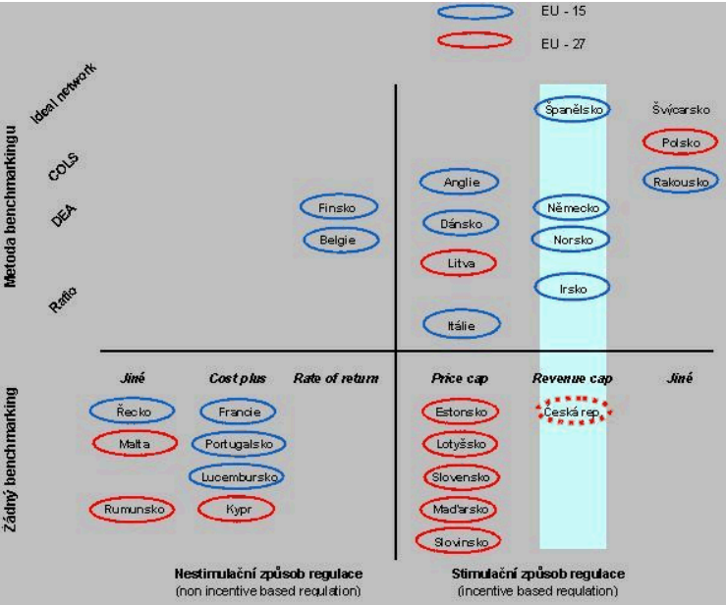

Figure 3: Methods of price regulation in Europe[3]

#### Ownership of the main players

This chapter deals with the level of competition among the companies that plays an important role on the Czech electricity market. Public or private ownership is also discussed.

Due to the high capital expenses, for every society is undesirable and impossible to have more than one transmission system, the competition can be characterized as a natural monopoly. The transmission is exercised by the publicly owned company Čeps, a.s.

There are three main distributors that rent parts of the transmission system and are responsible for supplies to final consumers. These distributors have the market regionally divided, the competition can be therefore characterised as a cartel agreement between oligopolies. This division is determined by the regulator and consumers cannot change their distributor. The companies are following: ČEZ, PRE and EON. They are partially publicly owned- 70% of ČEZ is held by state, part of PRE is municipally owned.

There are many suppliers, pure traders with electricity. Opposite to the distributors, it is possible to change the electricity supplier. The environment is very competitive and this was even strengthened by the new non-traditional energy suppliers entering the market. Private ownership is typical as the sector is liberalised.

There is only one Market Operator that is in charge of organization of the short term market and responsible for settlement of imbalances of the subjects of settlement. It is a publicly owned administrative monopoly.

### Renewable energy

Renewable energy policy in the Czech Republic is determined by the Law about supported sources of energy (180/2005 Sb.) and complies with the European directive (2009/28/ES).

There are two types of possible financial supports to green energy sources. These supports apply only to the electricity produced within the Czech Republic and connected to the grid, moreover the minimum installed capacity must be 20MWe. Producers may chose to be able to sell their electricity for the fix price which is set up by the Energy Regulatory Office and differs according to the source of energy and the year the plant started its production. There are also different tariffs for the electricity sold in or off peak. If they decide to sell the electricity on stock exchange or by OTC contract for market prices, they can apply for a green bonus which also differs according to the type of RES and the time the electricity is sold. If the electricity supported is produced together with the electricity from non-renewable energy sources, the producer is allowed only to apply for a green bonus.

There is a new law going to be introduced in near future. There will be strict rules about production efficiency and the supplier of last resort will be responsible for obligatory energy buyouts.

The trend in the support of renewable energy sources in the Czech Republic is unfortunately developing in opposite direction than general attitude in other, especially western members of the European Union. Alena Vitásková, the head of the Energy Regulatory Office, declared that the Czech Republic will decrease all the financial supports of green energy by 2014. She wants to keep only the small solar panels for households and biogas stations for farmers. The reason is that electricity becomes too expensive for final consumers and it reduces the competitiveness of the whole economy.

The actual share of RES on electricity production is 8,3% which means that the Czech Republic fulfilled the European criteria of minimum of 8%. This share should be increased to at least 13% by the year 2020, as the EU could meet the common criteria of 20%. According to National Action Plan this share is planned to achieve 13,5% by 2020. Alena Vitásková announced that this target will be met even if there are these significant decreases in financial supports.

Taxes are not only a source of governments’ revenues, but the aim is also the motivation of consumers to behave more ecologically. These so called ecological taxes have been introduced in EU in 2003 (2003/96/ES directive) and should be implemented into national tax codes by the year 2020.

Different tax conditions may hamper the creation of the common electricity market, as there will be a problem with competitiveness in the international trade with electricity. The harmonization process was introduced 1st January 2008 in the law about stabilization of public deficit (261/2007) as an ecological tax reform.

The minimum amount of tax from electricity were already implemented (minimum tax for 1MWh is 1euro), some of the possible allowances were applied in the Czech law as well. Among the exemptions from tax obligations we can mention the electricity produced from renewable energy sources or electricity production in cogeneration with heat power.

There is a new revision of the 2003/96/ES directive which will be implemented in national legislative 1st January 2013. This revision introduces the separation of a tax of an energy product and a tax from CO2 emissions. This will make the production of electricity from non-ecological sources more expensive, as well as the emission allowances that will be distributed for free only until 2020[4].

## Austria

### Electricity market

The Austrian energy market was fully opened to competition by the Energy Regulatory Authorities Act 2000 (BGLB I 121/200) beginning with the 1 October 2002. Beforehand, on the 1 October 2001, the full liberalization of the electricity sector took place, followed by the gas market in 2002. The supervision of electricity and gas market was handed over to the nationwide regulator (Energie-Control) enacted by the above mentioned act and took up its activities on 1 March 2001. Energie-Control “is entrusted with the task of monitoring, accompanying and, if necessary, regulating the liberalization of the Austrian electricity and gas markets”. It therefore establishes market rules for competition, regulates network tariffs, identifies and remedies competition violations and tracks and analyses market development (Energie-Control). Since the full opening of markets, all customers, ranging from major clients to private households, have the right to choose their electricity supplier according to their preferences (Energie-Control, 2011a S. 22).

Since the liberalization the structure of wholesale electricity markets has significantly changed. Electricity trading not only serves for the function of physical energy exchange. It has also brought up the possibility for hedging, speculation and arbitrage via the implementation of electricity exchanges. Those market places comprise electricity exchanges and OTC (over the counter) markets, whereas OTC trade covers individual, bilateral contracts besides the regulated market places (Energie-Control, 2011a S. 48-49).

The Austrian wholesale market is completely connected to German counterpart due to a lack of border congestion. This constitutes in general an arbitrage-free area of one price, in both the OTC and exchange trading. As mentioned above wholesaling takes the form of OTC trade and trading on the EPEX Spot/EEX Derivatives and the EXAA (Energy Exchange Austria) exchanges. Due to Austrian’s generator’s limited capacity the Austro-German wholesale market is usually hardly influenced by their actions. In 2009 the production capacities of the four biggest producers, EnBW, E.ON, RWE and Vattenfall (all Germany) added up to 80% of overall capacity. Studies by the Bundeskartellamt (2011) and DG Comp (2007) have shown that indicators pertaining to the degree of concentration within the German electricity sector, such as the Herfindal-Hirschmann Index (HHI) and the Residual Supply Index (RSI), have remained fairly stable over the last years. The HHI for the years 2003-2008 stayed beyond the threshold of 1800, which indicates market concentration (Energie-Control, 2011a S. 49; Energie-Control, 2010 S. 26).

On Austria’s EXAA electricity exchange, hourly products and block products consisting of a number of consecutive hours are traded, both adding up to 4.66 TWh (3.47 TWh excluding block products) in 2009, which was equivalent to 7.1 % of Austrian electricity demand. At the same time, traded volume on the EPEX Spot Germany-Austria did comprise about 17% of gross consumption (excluding block products). EXAA and EPEX spot prices were strongly correlated as a result of the common Austro-German price area, occurring divergences can be explained by differences in floor limits and the earlier close on the EXAA. Noteworthy, despite a highly liquid German EEX power exchange, the OTC traded volume was three times as high as the exchanged turnover in 2009. Criticism aroused in the past about this fact, as trading large amounts of capacity OTC keeps up prices artificially. If wholesale trading was primarily carried out on formalized markets, such as exchanges, this effect could be alleviated (Energie-Control, 2010 S. 28-29).

The Austrian retail market can roughly be broken down into a small and large consumer market, where former include households and small consumers (small and medium-sized enterprises, agricultural and interruptible consumers) with an annual consumption of up to 100,000 kWh and latter comprise industrial consumers with an annual consumption of over 100,000 kWh. In 2009 24% of electricity consumption was assigned to household consumers, small consumers accounted for 19%. Industrial consumers made up the largest market segment, with 57% of total demand.

More than 140 suppliers operate on the Austrian electricity market, but not all of them sell their energy on a nationwide basis. During the liberalization process, a tendency for joint ventures has been observed which reduced the number of competitors and has significantly increased the level of market concentration. The cumulative market share of the three largest suppliers of household customers in 2009 amounted for around 60% and that of the five largest suppliers was 70%. The cumulative share of the top three and top five suppliers of small and medium-sized enterprises was 60% and 72%, respectively. Shares of foreign suppliers in the Austrian market are negligible. The HHI for Austria as a whole were above the 1,800 threshold, which constitutes market concentration. Noteworthy, the average customer switching rate (by number of metering points) of 1.8% in 2010 is rather low (Energie-Control, 2011b).

The supply-side structures of the small and large consumer markets differ in several aspects, as different suppliers focus on different segments. In the small consumer market no foreign suppliers are active and up to 13 suppliers per grid compete in the segment. Large consumer markets attracted various foreign suppliers, serving customers with an annual demand of 10-20 GWh.

The ownership of Austrian electricity suppliers is still historically determined. Most Austrian electricity companies are owned by provincial governments or local authorities. In addition, the public ownership of the main companies is prescribed by legislation with constitutional status, for which an amending would require a two-thirds majority in Parliament. Here, the overlapping competence in regard to ownership and legislation becomes visible, as the owners of the utilities can influence the implementing legislation on unbundling (which is provincial responsibility). Apart from the high level of public ownership, cross-holdings are a feature of the Austrian electricity markets, where the majority of companies hold stakes in other suppliers (Energie-Control, 2010 S. 30-31).

### Renewable energy

The promotion of electricity produced by the means of renewable resources (RES-E) is specified by the Green Electricity Act 2012 (BGBL I 75/2011) and its corresponding regulation (BGBL II 471/2011), which determines feed-in-tariffs dependent on the primary energy source, efficiency and load of the power plant. The eligible energy sources subject to promotion comprise electricity out of photovoltaic (larger than 5 kWpeak), wind power, geothermal energy, liquid and solid biomass, as well as biogas and gas from purification plants and landfills. Average support in 2010 for above mentioned primary energy sources ranged from 7 cent/kWh (sewage to landfill gas) to 53 cent/kWh (photovoltaics). This constituted an overall average support for total small hydro and other renewables of 10 cent/kWh in 2010 making up 10.73% of green power contribution to total supply (Energie-Control, 2011b).

In addition, the law guaranties investment grants for small- and middle-size hydroelectric plants, plants using waste liquor as input and for photovoltaic plants smaller than 5kWpeak.

The promotion of RES-E is on the one hand financed by a flat tax per meter dependent on the consumer’s position in the various network levels, and on the other hand by a consumption tax per kWh of RES-E used.

According to the National Renewable Energy Action Plan (NREAP) 2010 Austria is targeting a 70,6% share of RES-E in the electricity sector by 2020 compared to 60,8% (including large hydroelectric plants) in 2005. Complying with the legally binding 2020 target[5] for the share of renewable energy in the final energy consumption would call for an ambitious 96% increase of RES-E in the electricity sector by 2020 (Federal Ministry for Economy, 2010). Noteworthy, with the federal law 676/1978 and the subsequent federal constitutional law 149/1999 Austria has committed itself not to utilize nuclear fission as an energy source.

# Discussion

## Technology vs. governance

Based on the above discussion of national electricity markets we classify the countries according to the methodology proposed by Finon et al. (2004). The idea is to classify the countries' electricity markets and specifically their policy approach to energy generation (capacity investments) according to a 2x2 matrix. Axis X represents *governance dimension* which comprises of governance through market competition, and co-ordinated governance. Co-ordinated governance is further subdivided into coordination by government and coordination by industry groups. Axis Y exhibits *technology dimension* which comprises of large scale centralized systems, and small scale decentralized systems. Summary with country classification is present in the figure below.



Figure 4 Policy approaches applied in liberalized electricity markets

Finland

The Czech Republic

Austria

## Finland

On *technology dimension*, we classify Finland as a large-scale centralized system. The reasons are structure of the generation fuel mix (generation capacity structure) and market concentration (ratio). The electricity supply by energy sources is composed mainly of nuclear (26,4%), hydro (14,6%), and thermal heat such as coal, bio fuel, and natural gas each sharing around 11% (Finnish Energy Industries, 2012). However, there are four companies with at least 5 % share of total installed capacity. Furthermore, the share of the three biggest companies (Fortum, TVO, Helsingin Energia) of the total installed capacity was estimated to be in the range of 45 – 50 per cent (EMV, 2011 p. 38).

On *governance dimension*, Finland is classified as coordinated governance by industry groups. The major reason derives from an industry-friendly business/legal environment for industrial power generators. The so-called Mankala business model is practiced mainly by the electricity generation and distribution companies across Finland. The model enables limited liability companies operate as a cooperative where the main goal is not profit-making but electricity generation at cost price for its shareholders. The electricity generated is distributed among shareholders according to type of shares which are usually specified either in the articles of association or shareholder’s agreement. The key point resides in the decision of Supreme Administration Court (KHO:1963-I-5) which exempts from taxation any dividends received from the difference between the delivery at cost and market price of electricity. On the one hand, this precedent motivates electricity generators to pool resources and create a large-scale centralized electricity generation which benefits from economies of scale. On the other hand, the trend of centralizing power generation into horizontally and vertically intertwined cooperatives reduces the market transparency as well as the number of potential competitors. Applied for both renewable and nonrenewable power generation projects, the Mankala business model implies increasing entry barriers for independent and small-scale electricity generators who lack the scalability.

## Czech Republic

The Czech Republic can be classified to the group 4 according to policy approaches matrix defined above. We consider the Czech electricity market as small-scaled decentralized from the technology dimension and as a regulated from the governance dimension.

Due to increased number of small photovoltaic sources of energy, as well as quite a large amount of previously existing power plants, the technology dimension is being developed from highly centralized system towards small decentralized power generators. This trend will be even increased in near future thanks to RES support mechanism which will focus on small PV systems and biofuel stations.

The Czech Republic possesses quite a large share of nuclear energy sources which represent stable but highly inflexible baseload. The shift towards decentralization has both pros and cons, it is a trade-off between flexibility and stability.

In order to analyze the technology dimension, it is necessary to mention the market concentration ratio as well – despite the fact that the market concentration is dominated by three main electricity suppliers (CEZ: 44,46%; E.ON: 19,62%; PRE: 11,14%), we consider the Czech market to be decentralized as these percentages are sharply decreasing with the amount of electricity suppliers’ switching.

Regarding the governance on the Czech electricity market, it can be classified as coordinated governance despite the liberalization processes. The market was liberalized in 2006 but there are still some segments, such as transmission and distribution system, under the supervision of the Energy Regulatory Office, which is an independent authority. However we can see some regulated governance also in already liberalized trading and generation sectors. The state gives the ‘’feed-in tariffs’’ for the ecological electricity producers and there are also obligatory buy-outs of “green electricity”. The cross-border trading is limited due to technical barriers and therefore has to be subjected to auctions regulated by the transmission provider.

## Austria

Analyzing the gross generation mix in 2010 may constitute a basis for categorizing the country’s condition according to the *governance* and *technology dimension*. Austria’s gross generation mix by energy source divides roughly into 58.5% hydropower (39.4% run of river and 19.6% pumped storage, resp.), 20.1% natural gas, 6.9% hard coal, 3.6% bio fuel and 2.9% renewables, with the residual 8% including various negligible sources. 98.5% of renewables is produced by wind power plants (Energie-Control, 2011b).

The EEX transparency platform gives information about the companies’ installed capacity, from which the shape of a concentrated market can be concluded. More than the half of total installed capacity is owned by one company (Verbund AG), whilst the biggest three producers control almost 80% of total installed capacity (EVN AG, Wien Energie GmbH and Verbund AG) (EEX).

According to the matrix based on Finon et al. (2004) and the above described structure, one could label the Austrian electricity market as *coordinated governance*, where a small club of power generators seek for the stabilization of system performance and smooth electricity prices.

Classifying Austria’s stance regarding the *technology dimension* might be ambiguous, as the share of small-scaled plants carries more and more weight. However, the promotion of RES-E using the instrument of feed-in-tariffs amounted for almost 300 million EUR in 2011, and another 25 million EUR where provided for photovoltaics (<5kWpeak) in 2012 (Klimafonds, 2012). Still, as listed above, the share of green electricity fed into the system accounted for less than 11% of total supply. Therefore, the structure of the electricity market can hardly be seen as *small-scale decentralized* at the moment, as large hydropower, pumped storage and thermal power plants determine the shape.

# Conclusions

To sum up we believe all the observed countries are following the European strategy in order to achieve the goal of the common electricity market. However, there are some delays in European directives’ implementation, individual countries’ interpretation or necessary adaptation to local circumstances.

The ideal matrix combination for free market seems to be the top right corner representing the governance through competition in combination with small scale decentralized dimension. None of the countries fulfill these criteria, we have therefore identified main imperfections hampering the creation of common market for each country.

The development in the Czech Republic is on the right way, there are just time delays as the liberalization process took place later then in Finland or Austria. As the main issue we consider the RES policy that creates barriers in the market unification. The potential problems are connected with the competitiveness of local RES producers against those from western part of Europe with high support mechanisms. Higher competitiveness would lead to a shift from the bottom-right to the top-right corner. Another point of view may be connected with the increased volatility resulting from the replacement of stable nuclear power plants by the energy from renewables from other member states (stable energy sources may become redundant thanks to subsidized RES).

Finland is attempting to move out of the industry-coordinated centralized-technology dimension towards the support schemes position. This has been attempted by the recently introduced feed-in tariffs for RES. However, the country’s long term energy strategy plans to further increase the nuclear power capacity by estimated 5050 MW (OL3 1600MW, OL4 1650MW, and Pyhäjoki 1800MW). Similar trend is observable in the Czech Republic which is currently drafting long term energy strategy where options of up to 50% generation capacity originating from nuclear power by 2030 are being considered. On one hand, such large scale new capacity may limit the potential market for RES-E since there will be lower need for new capacity. On the other hand, the faster time-to-market of RES-E with smaller, flexible, but intermittent generation may undermine the profitability of the less flexible large scale generators. These factors will play a significant role in shaping the single European electricity market.

Further analysis can focus on classification of EU countries based on market attractiveness for RES generators and investors, as published for example in Renewable energy country attractiveness indices by E&Y (2012). In addition, further research should focus on the role of institutions (North, 1990) behind achieving single electricity market in general, and diffusion of RES-E in particular. By institutions we mean both formal (consciously designed and articulated constrains) and informal (social norms, conventions, and moral codes) institutions. Moderating or mediating effects of institutions on RES-E, single electricity market, or their interaction should be investigated (see for example Knowles, et al., 2010).

# 

# Bibliography

**10 Jahre Energiemarkt-Liberalisierung** [Report] / auth. Energie-Control. - Wien : Energie-Control Austria, 2011a.

**Act 386/1995 on electricity market (including amendments up to 1172/2004)** [Report] / auth. Ministry of Employment and the Economy. - Helsinki : [s.n.], 1995. - http://www.finlex.fi/fi/laki/alkup/1995/19950386.

**Annual Report to the European Commission - Finland** [Report] : Annual Report / auth. EMV. - [s.l.] : Energy Market Authority, Finland, 2011.

**Application for a Decision-in-Principle Regarding Nuclear Power Plant** [Report] / auth. Fennovoima. - [s.l.] : Fennovioima, 2009.

**CEER response to the Commission consultation on the renewable energy strategy** [Report] / auth. Lord Mogg KCMG. - London : ERGEG, 2012. - http://www.energy-regulators.eu/portal/page/portal/EER_HOME/EER_PUBLICATIONS/CEER_PAPERS/Electricity/.

**Challenges when electricity markets face the investment phase** [Journal] / auth. Finon Dominique, Johnsenb Tor Arnt and Midttunb Atle. - [s.l.] : Elsevier, 2004. - Vol. 32. - pp. 1355–1362.

**Detailed information on environmentrelated taxes and charges in Finland** [Report] / auth. Ministry of the Environment. - [s.l.] : Ministry of the Environment, 2008. - Timo Parkkinen, senior economic adviser, 9.10.2008.

**Directive 2009/72/EC of the European Parliament and of the Council concerning common rules for the internal market in electricity** [Report] / auth. European Commission. - 2009.

**EEX-Transparenzplattform** [Online] / auth. EEX. - 05 25, 2012. - http://www.transparency.eex.com/de/Information/meldende_unternehmen.

**Electricity Market** [Online] / auth. Fingrid // Fingrid. - Fingrid, 2009. - April 13, 2012. - http://www.fingrid.fi/portal/in_english/electricity_market/.

**Electricity Market Act (386/1995; amendments up to 1172/2004 included)** [Report] / auth. Ministry of Trade and Industry. - [s.l.] : Ministry of Trade and Industry, Finland, 2004.

**Electricity pricing and making electricity suppliers compete** [Online] / auth. EMV // Energy Market Authority . - Energy Market Authority Finland, 2012. - April 13, 2012. - http://www.energiamarkkinavirasto.fi/data.asp?articleid=233&pgid=127.

**Energy consumption 2010** [Report] / auth. Statistics Finland. - Helsinki : Statistics Finland, 2011.

**Energy Roadmap 2050 - Communication from the Commission to the European Parliament, the Council, the European Economic and Social Committee and the Committee of the Regions** [Report] = COM(2011) 885/2 : Communication / auth. European Commission. - Brussels : European Commission, 2011.

**Energy Year 2011** [Report] / auth. Finnish Energy Industries. - [s.l.] : Energiateollisuus, 2012.

**Excise duty and strategic stockpile fee rates as of 1 January 2011** [Report] / auth. Ministry of the Environment. - [s.l.] : Ministry of the Environment, 2011. - http://www.environment.fi/default.asp?contentid=147208&lan=en.

**Finland’s Second National Energy Efficiency Action Plan** [Report] / auth. NEEP-2. - 2011.

**Finland's national action plan for promoting energy from renewable sources pursuant to Directive 2009/28/EC** [Report] / auth. Ministry of Employment and the Economy / Energy Department. - [s.l.] : Ministry of Employment and the Economy, 2010. - 30.6.2010.

**http://www.klimafonds.gv.at/** [Online] / auth. Klimafonds. - 2012. - 05 25, 2012. - http://www.klimafonds.gv.at/foerderungen/aktuelle-foerderungen/2012/photovoltaik-foerderaktion-2012/.

**Implications of Non-harmonised Renewable Support Schemes** [Report] : Public Consultation Document / auth. CEER. - Bruxelles : Council of European Energy Regulators, 2011. - http://www.cedec.com/documents/160/CEER-PC-Implication%20of%20non-harmonised%20RES%2011102011%20FINAL.pdf.

**Institutions, Institutional Change and Economic Performance** [Book] / auth. North Douglass C. - Cambridge : Cambridge University Press, 1990.

**Key Statistics 2011** [Report] / auth. Energie-Control. - Wien : [s.n.], 2011b.

**Long-term Climate and Energy Strategy** [Report] / auth. Finnish Government. - [s.l.] : Ministry of Employment and the Economy, 2008. - VNS 6/2008 vp.

**Market Report 2010 - National Report to the European Commission** [Report] / auth. Energie-Control. - Wien : [s.n.], 2010.

**National Policy Instruments: Policy Lessons for the Advancement & Diffusion of Renewable Energy** [Conference] / auth. Sawin Janet T // International Conference for Renewable Energies. - Bonn : [s.n.], 2003. - pp. 1-50.

**National Renewable Energy Action Plan** [Report] / auth. Federal Ministry for Economy Family and Youth. - Wien : [s.n.], 2010.

**Pohjolan Voima’s nuclear power shareholders unite to participate in the Olkiluoto 4 project’s bidding and engineering phase** [Online] / auth. Pohjalan Voima // Pohjalan Voima. - December 7, 2011. - January 5, 2012. - http://www.pohjolanvoima.fi/en/?id=30&selArticle=873.

**Renewable energy country attractiveness indices** [Report] / auth. Ernst & Young. - [s.l.] : E&Y, 2012.

**Renewable Energy Support in Europe** [Report] / auth. CEER. - Bruxelles : Council of European Energy Regulators, 2011. - C10-SDE-19-04a.

**Smart Metering in Western Europe - Summary** [Report] / auth. Berg Insight. - 2010.

**The European Market** [Online] / auth. EMCC // Creating Regional Markets. - May 2012. - March 22, 2012. - http://www.marketcoupling.com/market-coupling/european-market.

**Tuulivoimarakentamisen suunnittelu** [Report] : Ministerial Report No. 19 / auth. Ministry of the Environment. - [s.l.] : Ministry of the Environment, 2011.

**Which Institutions are Good for Your Health? The Deep Determinants of Comparative Cross-country Health Status** [Journal] / auth. Knowles Stephen and P Owen Dorian // Journal of Development Studies. - [s.l.] : Routledge, April 2010. - 4 : Vol. 46. - pp. 701-723.

**www.e-control.at** [Online] / auth. Energie-Control. - Mai 23, 2012. - http://www.e-control.at/en/econtrol_en/company/tasks.

**Závěrečná zpráva Energetického regulačního úřadu o metodice regulace III. regulačního období včetně základních parametrů regulačního vzorce a stanovení cen v odvětví elektroenergetiky a plynárenství** [Report] / auth. ERO. - [s.l.] : Energy Regulatory Office, 2011. - http://www.eru.cz/user_data/files/prezentace_III_RO/Zaverecna_zprava_o_metodice_%20III_RO.pdf.

## Appendix

**Marginal cost of production in the Nordic countries**

Source: Keskikallio, Lindholm: The Nordic Electric Power market. Ministry of Trade and Industry Finland report 11/2003) in (EMV, 2011)

1. Source: EMCC (2012)
2. Source: European Commission, Energy Roadmap 2050, COM(2011) 885/2
3. Source: Energy Regulatory Office, the Czech Republic (ERO, 2011)
4. The emission allowances should be purchased from 2013 but the Czech Republic received an exception called derogation, which means that the saved costs will be used for ecological investments in electricity production.
5. In the case of Austria: 34% of final energy consumption covered by renewable sources