Czech-Austrian Winter and Summer School

Biofuels – Are they a good solution for the future?
Patrick Reiter & Tereza Vobornikova

Co-operating Universities

Financial support by

Prague and Vienna, 2012
Index
1.) Introduction 1
1.1.) Problem 1
1.2.) State of the Art 1
1.3.) Goal 1
2.) Definition and Usage of Biofuels 1
2.1.) What are biofuels? 1
2.2.) Types of Biofuels 2
3.) Use of Biofuels in Austria and the Czech Republic 3
3.1.) Situation in Austria 3
3.2.) Situation in Czech Republic 4
4.) Uncertainties about Biofuels and their Future Development 6
4.1.) Controversial points of View about Biofuels 6
4.2.) Problems of Biofuels in the Future 9
5.) Conclusion 10
5.1) Are Biofuels a good solution for the future in our opinion? 10

1.) Introduction

1.1.) Problem

1.2.) State of the Art

1.3.) Goal

2.) Definition and Usage of Biofuels

2.1.) What are biofuels?
The biofuels are one of the alternative energy sources. They are made from biomass which could be produce in two ways: as a product specially determined for energy use or as rubbish from agriculture, forest industry, industry or households. There exists no proper classification of biofuels. In the biofuels business and in the references there are some common used kinds of classification.
Physical condition classification:
- Liquid biofuels
- Solid biofuels
- Gaseous biofuels
Classification according to the generation of biofuel:
- First generation biofuels = they are made from agriculture commodities which could be also used as a food (for example rape, corn, sugar cane, sugar beet or potatoes)
- Second generation biofuels = they are made from rests and rubbish from households, agriculture and forest industry (for example rests of plants and woods)

2.2.) Types of Biofuels
Classification according to the directive 2003/30/ES of the European Parliament and of the Council:
- Bioethanol = can be produced by any starch contained plant such sugar beets, corn or wheat
- Biodiesel = methylester made from vegetal or animal oil
- Biogas = Biogas refers to a gas produced by the biological breakdown of organic solids in the absence of oxygen
- Bio-ETBE (ethyl-tercio-butyl-ether) = kind of bioethanol of which is 47% in bio – ETBE
- Bio-MTBE (methyl-tercio-butyl-ether) = kind of biomethanol of which is 36% in bio-MTBE
- Biohydrogen

3.) Use of Biofuels in Austria and the Czech Republic

3.1.) Situation in Austria
Because of the directive 2003/30/ES of the European Parliament all the EU countries must have a use of 5,75% of biofuels in there national transport energy content in 2010. In Austria the most common used biofuels are biogas, bioethanol and biodiesel.
Biogas refers to a gas produced by the biological breakdown of organic solids in the absence of oxygen. Organic waste like dead plants or normal waste from housholds can be converted to biogas. 2005 there were around 222 millon m³ biogas produced in Austria. But they are more common in heating housing systems than in transport.
Bioethanol can be produced by any starch contained plant such sugar beets, corn or wheat. Austria has only one biogas plant, which was built in Agrana, lower Austria. In Agrana they especially use wheat, maize and sugar beets for the production of bioethanol. Since the construction in 2008 the Austrian market for E5 is covered. But a big problem is that in the current situation in Austria the production of bioethanol is more expensive than petroleum. For example in Brazil the production of bioethanol is much more cheaper than in Austria or Europe because of the large amount of sugar beets and so in Brazil it is a much bigger opportunity.
Country | Mio. Liters
USA | 24599,87
Brazil | 18999,73
EU | 2518,82
China | 1839,71
Canada | 799,86
Rest | 1197,33
Total amount | 49595,31
Chart 1: The worldwide production of bioethanol in 2007
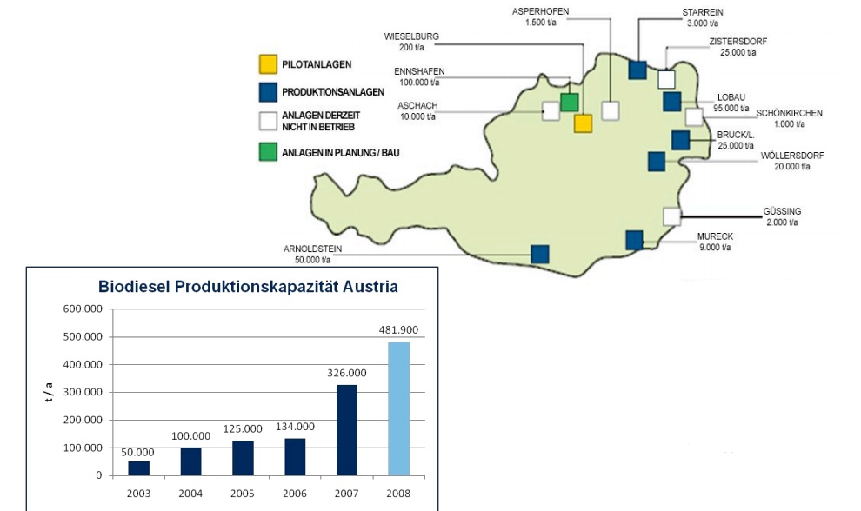
On the chart above you can see that the North American and the South American continents are more intent on producing bioethanol, because there conditions of producing bioethanol are much better and cheaper than in Europe.
Biodiesel is the biggest used biofuel in Austria. The reasons are on the one hand because Austria is a classic country of diesel vehicles and on the other hand biodiesel is produced in a big amount more than over 10 years. Also the whole Off-Road transport is diesel powered. Also most of the public transport is using biodiesel and were one of the pioneers using biofuels. Biodiesel is produced of every oleiferous plant, also known as FAME. In Austria biodiesel is mainly produced of rapeseed and sunflower. Biodiesel is produced since the mid-nineties and nowadays there are 15 plants which can produce more than 600.000 to biodiesel per year. For 2010 Austria produced 289.000 to biodiesel.
Image 2: Biodiesel plants and the production capacity of biodiesel in Austria
Source: http://www.fwf.ac.at/de/downloads/pdf/ampuls4-hilber.pdf

3.2.) Situation in Czech Republic
In the Czech Republic the most common biofuel is biodiesel used in transport. There are many reasons why the others are not so common. Firstly in the Czech Republic there is nearly no usage of biofuels as a heating, people are used to another kind of heating systems which are nowadays cheaper than this ecological one. Secondly the bioethanol business is still developing in the Czech Republic and there are bad distribution and promotional channel for biogas. But it represents a possibility for Czech producers and also consumers (especially in the situation of high level of petroleum price). Finally our climate conditions are quite good for rape production, so the Czech Republic could not only produce for own consumers, but also for export. That also knew the Ministry of Agriculture at the beginning of 90 when started “Oleoprogramme”. The programme supported the usage of rape oil as an alternative fuel and position of this fuel on the Czech market. Presently there is no longer state support of biofuels in the Czech Republic.
The situation with the rape in the Czech Republic illustrates the table below. The data are partly from internal materials and partly from the Czech-statistic office.
Year | Seed surface (ha) | Production (t) | Yield (t/ha)
2008/2009 | 356924 | 1048943 | 2,94
2009/2010 | 354826 | 1134857 | 3,2
2010/2011 | 368824 | 1036000 | 2,8

In comparison with the rest of the world there is a quite productivity. The world average yield is 1,9 ton. The European average yield is 3,3. There are no ecological problems in the Czech Republic such as cutting down forests. Some ecologists say that there is a “yellow avalanche”, but in fact all the oil plants are grown on the 18,7% of agriculture land, the rape on 15% of that. In comparison with for example grains, which are grown on 59% of agriculture land, is not so much.
Even if the productivity is good and the seed surface average, the problem is the lack of raw seeds. See table below. The data are from the internal materials.

Name of the factory | Day capacity (ton/day) | Used seeds
Setuza Ústí nad Labem | 1300 | Rape , sunflower
Preol Lovosice | 1200 | Rape
ADM Olomouc | 850 | Rape, sunflower
Total | 3350

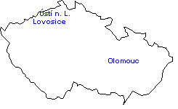
Image 3:

4.) Uncertainties about Biofuels and their Future Development

4.1.) Controversial points of View about Biofuels
The idea of the directive 2003/30/ES of the European Parliament and of the Council was that the biofuels are good of many reasons. Firstly they could help us with reduction of CO2 in the atmosphere, secondly they could make Europe more independent on Arabic petroleum and finally they could help European agriculture by creating new jobs in the countryside or just by using the overproductions. During the years of this European regulation there were lots of studies about biofuels and practically everyone was opposite to the previous one. There are some examples written down.
You can see lots of different opinions about reduction of CO2. There is the European Commission’s study from 2006 which told us that thanks to the first generation biofuels we can save up 60% of CO2 emissions. And thanks to the second generation of biofuels can we save even more – 80% of emissions which will be produce out of fossil fuels. The other studies (for example the one made by Paul J. Crutz, the Nobel Prize laureate) told that the biofuels produce 70% more emission than the fossil fuels. The problem is that in the time the directive and the studies were made most of the scientist thought that the bio-energy is carbon neutral. They compare only the amount of CO2 plant absorbs during the life-time with the amount of CO2 produced by biofuels burning. And that is not objective because some kinds of emission are also produced during the production of biofuels. The LSA method (life cycle assessment) counts with all of them and the new results are not positive for the biofuels. For example there is a table below which shows the emissions formed during the production of bio ingredient for the diesel. The data are from the 2010 from the Czech Union of biodiesel producers and the used method is LSA.
Production stage | Emission gCO2eq/kg | Emission g C02eq/MJ
Rape growing | 1073 | 29,0
Oil production | 203 | 5,5
MERO production | 367 | 9,9
Transport and distribution | 37 | 1,0
Total | 1680 | 45,4

The other results of study were: if you use 100% MERO the emissions are zero and the emissions produced by diesel production and usage are 83,6 gCO2eq/MJ. So the solution is that the CO2 balance depends of the kind of biofuel.
The other ecological problem often relate to biofuels is cutting down the rain forest. It happens in Asia or South America because there is shortage of land suitable for agriculture and the high prices of product used to make biofuels are inspired people to cut down the rain forests. Actually this is not the problem of Europe and both the Czech Republic and Austria do not need to deal with it. But still the European Commission tries to certificate biofuels and not import those destroying the rare ecosystems.
In the Czech Republic some people discuss the ecological problem with the rape growing. They call it “yellow avalanche”, which means that the amount of rape growing in the Czech Republic is increasing. And of course the surface on which we are growing the rape is also increasing. In fact it is not a problem. The rape is grown only on 15% of agriculture land. To compare the grain is grown on the 59% of agriculture land. The common argument is that the problem arises if we compare today’s data with the old one. And that is true; just compare the data in table below.
 | 1980 | 1990 | 1995 | 2000 | 2001 | 2002 | 2003 | 2004 | 2005 | 2006
Seed surface (thousands ha) | 65 | 105 | 252 | 325 | 344 | 313 | 251 | 261 | 268 | 292

The number is increasing, but in fact it is not possible to compare the data from 1980 with today’s situation. In the 1980 we had the different variety of rape plant. And that one was not able to grow in that part of Czech Republic where can be the new variety. And as we can see in the table, the surface was not extremely increasing in the past few years.
The same controversial questions are about our independency on Arabic oil or improvement of European countryside. The biofuels were suggested as an alternative to the Arabic oil. They were meant as a way to be more independent. This aim was not reached, because we are still dependent on the import of oil. And we probably will for the next years. We have not so many raw bio materials to satisfy all the customers who use the Arabic oil today and we have no infrastructure to distribute the bio solution. This problem could be solved only with the long time research which will cost a lot of money. But the possibility to use the biofuels only is there. Especially, if you considerer the hydrogen as a new fuel. The improvement of countryside is the goal we reached. The economic problem is that we don’t know if the new jobs were taken by the unemployed people or not. The possibility is that the new jobs were taken by the people from the other branch. There could be the “crowd out effect”.
The most discussed problem is the “food problem”. The usage of biofuels should protect Europe from the food surpluses. For some people it is even immoral to talk about food surpluses. For the others seems to be immoral to burn food as a biofuel if there are some people and children with malnutrition in Africa. Of course we know about the malnutrition problem. But the material we used as a biofuels is not able to solve food problems in Africa. And it is almost impossible to send these surpluses to other continent. The best solution is to teach people how to grown their own food, to give them education and technologies.

4.2.) Feasible Problems of Biofuels in the Future
Because our fossil fuel stock is strongly limited and more and more depleted, it is really important to switch to alternative fuel systems. If biofuels are going to substitute petrol for the long run is fraught with uncertainty. But the rise of oil price is an important factor to boost the competitiveness of alternative fuels. Because the increasing oil prices lead faster to find a substitution to work with. But there are a lot of pro and cons about biofuels. From a macro economical view biofuels are a good solution because they bring job opportunities and a big development for the countryside. But to substitute fossil fuels by biofuels utterly nowadays is quite impossible, because the capacities of producing biofuels are too low and too expensive and the usage of fuels is increasing rapidly. The main goal is to use the environmental benefits, including the potential to reduce emissions, such as greenhouse gases and CO2 and of course biofuels are a good solution for reducing them, but the problem is that the production of biofuels often produces more CO2 than the use of them actual is reducing. So the future role of biofuels in the long run depends on profitability and new technologies. We are heading in the right direction with the development of the second generation of biofuels but continuously technological progress is very important. Technological advances and efficiency gains such as higher biomass yields per acre or more gallons of biofuels per ton of biomass could steadily reduce the economic cost and could increase efficiency. Also a big problem for Europe is that a lot of producing technologies are more profitable in tropical areas where growing seasons are longer. For example Brazil is one of the biggest and cheapest producers of bioethanol in the world, because the sugar production is one of the main productions in Brazil.
But perhaps one of the biggest flaws of biofuels is that they represent a serious competition for food production. The competition of the production of biomaterials increases the demand and so the rise of food prices is increasing rapidly. Because of the increasing demand from biofuel production, between 2002 and 2007 world food prices increased by 140 per cent. Food prices will to rise dramatically if the biofuel production is increasing rapidly. Because of a rapidly increasing population, we are already running out of space to produce food to sustain the world’s population and if the prices are increasing more and more also poverty is growing.

5.) Conclusion and Résumé

5.1) Are Biofuels a good solution for the future in our opinion?

References
- Directive 2003/30/ES of the European Parliament and of the Council
- Voborníková, T. (2009). Biopaliva pro naftové motory. Bc., thesis, University of Economics Prague.
- Voborníková, T. (2011). Vývoj cen zemědělských komodit v letech 2008-2010 – analýza trhu olejnin. Ing., thesis, University of Economics Prague.
- Preol, a.s. (2009-2011). Personal communication and internal materials.
- Czech Union of biodiesel producers (2010). Personal communication and internal materials.
- Toepfer International (2008). Internal materials.
- Rollerová, A. (2009). Bruselská směrnice o biopalivech a její dopad na ekonomiku. IN: Gandalovič, P., Rovenský, J., Tajovský, L. (2009). Biopaliva – pomoc přírodě nebo zločin proti lidskosti? 1st edition. Prague CEP
- Hamplová, L. (2009). Biopaliva škodí klimatu víc než ropa tvrdí studie. [online]. Available from: http://ekonomika.ihned.cz/cl-23283305-biopaliva-skodi-klimatu-vic-nez-ropa-tvrdi-studie

This directive is really important for the biofuels problem because it order to member countries the obligation of minimum share of bio ingredient in the fuels.
Off-road transport are for instance all vehicles in agriculture like farm tractors or construction vehicles.
FAME is an abbreviation for Fatty Acid Methyl Esther.
The only support is the one from European Union which is paid to all the farmers no matter what they produce (SAPS and TOP-UP). It is paid for the agricultural land.
MERO = raps oil methylester

