Czech-Austrian Winter and Summer School Comparison of PV markets in Austria and the Czech Republic
)

Jakob Doubal
Lovorko Marić

Co-operating Universities



Financial support by

Prague and Vienna, 2012
Comparison of PV markets in Austria and the Czech Republic
(Jakub Doubal, Lovorko Marić)
Abstract
In the last decade, there have been intense developments occuring in the market of photovoltaics, a promising resource of renewable energy, that have led to dramatically different results in Austria and the Czech Republic. Due to socio-political and economic circumstances, the development of the photovoltaics market has been a controversial issue in the Czech Republic, although there have been progressions and improvements. Problems of other nature occur in Austria, in terms of a certain solar energy market stagnation that has plagued the Austrian market in comparison with other renewable energy sources for quite some time. In any case, there doesn’t seem to be a consensus within the countries of the European Union as to how the PV market will develop in the years to come, and how the balance between the economic and enviromental goals in regards to the usage of solar energy can be achieved and how these factors can co-exist. This Austrian-Czech cooperation hopes to do a research that will make it clear as to why the problems of huge taxation after a photovoltaics boom in the Czech Republic happened and how they can be solved. This research will answer the question of why has the development been so different in the two countries, what are the main obstacles for further long-term development and, on the basis of a qualitative and quantitative comparisons of market situation, feed-in tariff politics and licencing processes, how will this affect further PV-policies in the future. Suggestions as to how the problems of huge taxation after a photovoltaics boom in Czech Republic, and the incessant stagnation of the PV market and reduction of feed-in tariffs in Austria, can be alleviated follow in the conclusions of the paper.

Introduction
Photovoltaics utilization for power generation is a dynamic branch and it had as one of the renewable energy sources an interesting development in last years, when research for sustainable energy sources took place in energy strategies of all developed countries. It will be demonstrated in the work how the development of PV in two similar countries can go in such different directions. In the Czech Republic, the PV industry became extremely profitable business with no rational utilization compared to Austria, where PV was and still is only one of many ways how to cover electricity consumption form renewable energy sources. In this paper, the development of PV policies will be covered in these two countries, together with a detailed description of problems that appeared in Czech Republic with comments why any of these didn’t appear in Austria or if these had occured, would these affect Austria’s policies as extremely volatile as it happened in the Czech Republic.
The work will explore the differences between the countries, how these occurrences will change the policies of renewable energy and sustainability in both countries, would these affect the EU-given goals until the year 2020 in terms of renewable energy production and usage, what are the main problems that led to the problematic situation in both countries and what will the incentives and indicators be for future development and whether the fiscal and state-backed policies of renewable energy would actually lead to lucrative and sustainable results in the long-term.

History of PV in Czech Republic
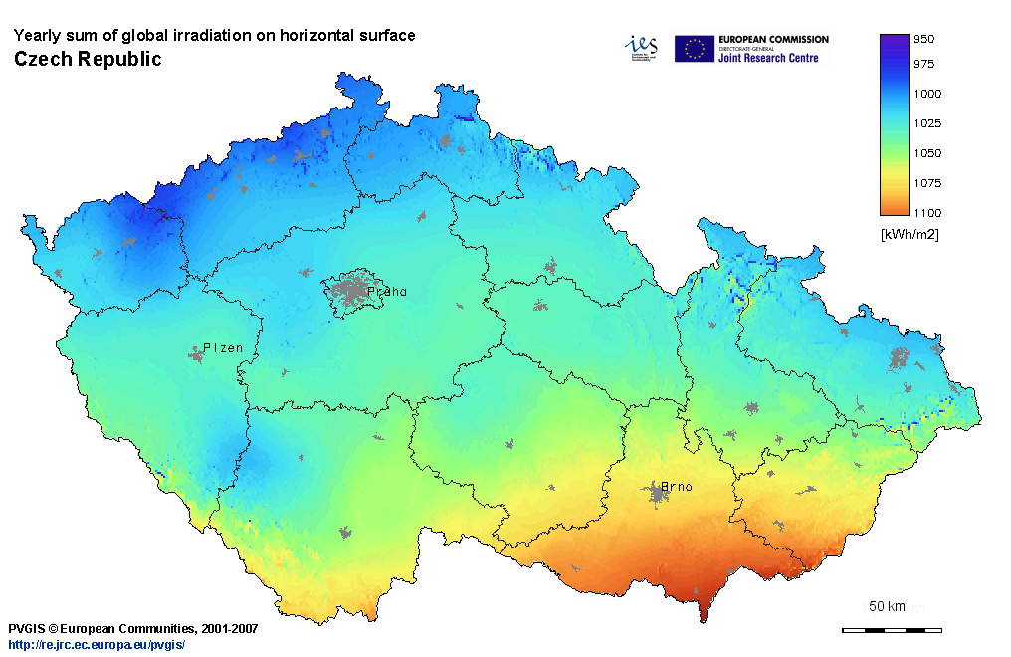
Figure 1: Yearly sum of global irradiation in Czech Republic Source: Institute for Energy and Transport, EC
Before 2002, when the first systematic support started, it was possible to find only a few PV generators. They were used mainly in areas with no possibility of connection to the grid or in areas where connecting to the main grid would be very expensive. In these times, the only subsidy the investor could get was an individual investment subsidy which typically covered 15-30% of the investment. At this time, the most effective renewable energy source (RES) was in the form of small hydro power plants, where the support was primary targeted.
Since the beginning of 2002, the Energy Regulatory Office (ERO) introduced a modified Feed-In Tariff (FIT) support scheme. Despite the fact that ERO guaranteed these tariffs for a technical lifetime, the investors found the situation too risky and the development of RES utilization stopped for a while.
Since the year 2006, systematic support of RES utilization for power generation started based on Act 180/2005 Col. which covers all kind of RES through assuring regulated rate of return and to minimize the risk for investors. The aim of this act was to boost utilization of RES, assure permanent growth of share of RES on Czech energy market and prepare conditions to follow the indicative target (covering 8% of total energy generation from RES till 2010) given by EU. A form of subsidy was also modified. Operator of RES power plant can choose from two forms of subsidies: feed-in-tariff(FIT) or green bonus. The operator can choose between the two every second year. Feed in tariffs are guaranteed for whole technical lifetime, which is 20 years for PV power. Feed in tariffs are derived from reference projects for particular kind of RES. Reference project are periodically updated, typically every 2 years, to follow current costs of technology and technical development.
Feed-in tariff scheme means that the energy producer has the right for obligatory purchase of generated electricity from distribution or transmission companies. These companies pay tariffs and bonuses and transfer extra cost to final electricity consumer via extra fee (fee for RES and cogeneration support – 89% of fee covers RES support) imposed on any MWh consumed. Fee is annually defined by Energy regulatory office (ERO). In case of overvaluation ERO considers it in next year fee making. FIT can be reduced by ERO annually by 5% at maximum. Feed-in tariffs are also annually modified by the inflation, measured with PPI index, by 2% at minimum, 4% at maximum.
Green bonus can be received if the producer uses or sells by himself part of generated electricity and the rest is sold to distributor. In this case the support is somewhat lower (9%-22% on MWh, depending on the year of putting into operation and installed capacity – less or more than 30kWh) , but compensated for all generated energy, including the used and sold part. GB can by changed every year without any limitation but should always reflect higher business risk connected to GB support scheme. GB had been included into support scheme to economically motivate investors to rational behavior – i.e. to optimize the RES power plant technical design and the power plant operation according to the needs of power system with the aim to minimize power deviations.
Due to imperfections of the Czech support scheme, installed capacity of PV power plants started to increase dramatically. Number of power plants (Figure 2, 4). 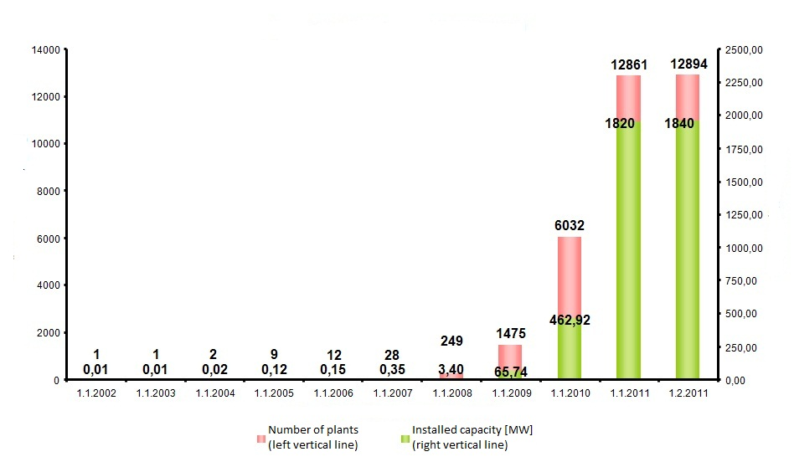
Figure 2: Development of installed capacity Source: czechRE agency
Because of massive development of RES utilization and rapidly increasing extra cost transferred to customer in 2010, 2011 (Figure 3), some essential changes had to been made.
Reaction of the Czech government on PV boom in 2010.
During 2010, the Czech parliament passed several changes, whose aim was to reduce impact on consumers and to make the profitability of PV project adequate to the risk. The regulated rate of return was reduced from 7% to 6,3%. Parliament authorized change in FIT value reducing that allows higher than 5% reduction (Figure 5), when payback time is less than 7 years. Licences for field applications were stopped. Licences are given only for roof and facade applications that are smaller than 30kW of installed capacity. Multiple finacing of extra cost started. This was the biggest challenge in meaning of finding extra sources of financing. Czech govenment came with these: for 2011, 640 mil EUR transferred to consumers and 480 mil EUR covered by the state budget. Sources were set as following: tax was imposed on gross revenues of plants bigger than 30kW in an amount of 26%, which was the most contentious of all changes. The fee for agriculture land utilization was increased. Gift tax imposed on emission allowances distributed free of change in an amount of 32%. No emission allowances were given free of charge since 2013.
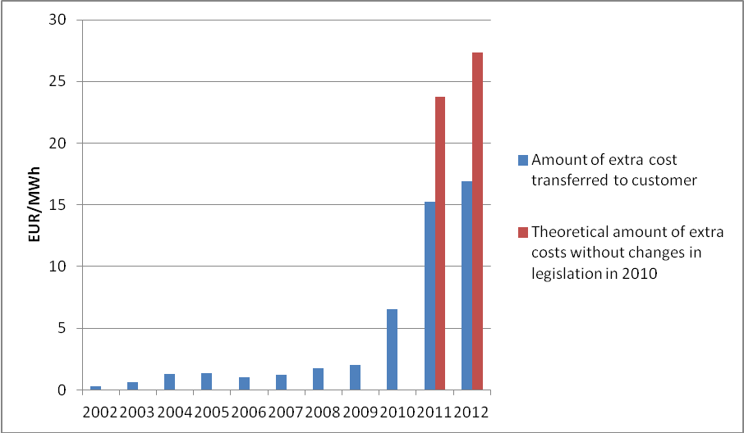
Figure 3: Development of extra cost transferred to customer Source: ERO

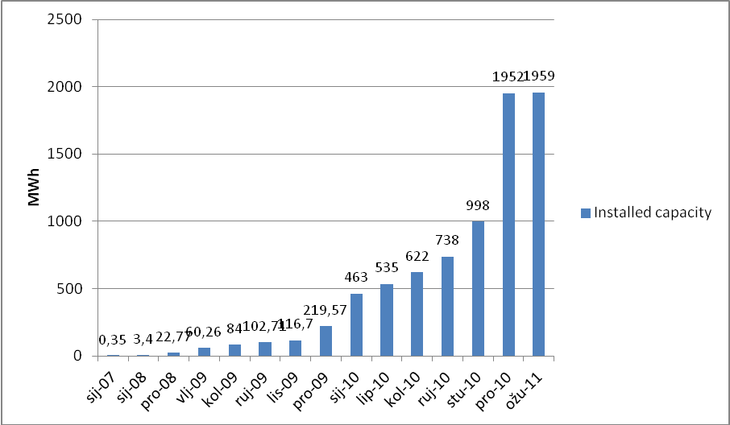
Figure 4: Development of installed capacity Source: ERO
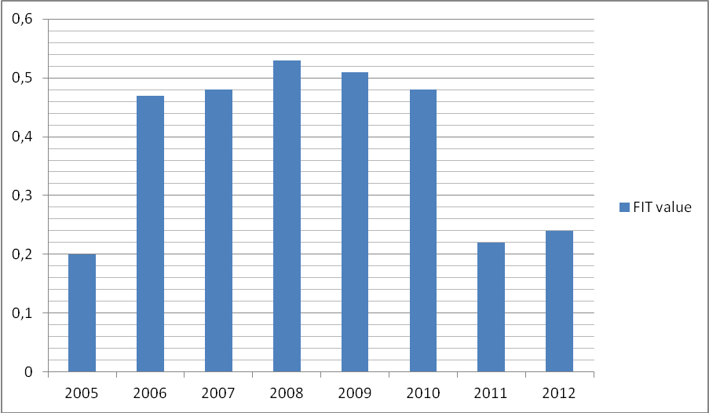
Figure 5: Development of FIT value Source: ERO
Methodology of feed in tariffs calculation
FITs and GBs were created to motivate investors to invest into RES utilization for power generation, set conditions interesting to investors but adequate to the rate of risk. So the regulated rate of return methodology was used. Feed-in tariff for given kind of RES should be set so that net present value (NPV) from the investor’s point of view would be equal to zero. In this case investor gets rate of return from his investment equal to the discount rate used for NPV calculation.
Proper value of feed-in tariff thus has meaning of so called minimum price, i.e. such price that assures required (adequate) rate of return from the investors’ perspective. Higher feed-in tariff value than minimum price would lead to the inadequate extra return and to the unnecessarily higher cost of support scheme, value of feed-in tariff lower than minimum price would cause rejecting of investment into RES projects by the investors.
Derivation of the minimum price p_{min} starts from condition that NPV (of given kind of project) should be equal to zero:
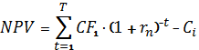
Where: CF_{t} project cash flow in the year t [EUR]
T project lifetime [years]
r_{n} nominal discount rate
Cash flow can be expressed as the difference between money inflow (revenues) and money outflow (expenditures)
Where: p_{min, t} minimum price in the year t [EUR]
Q_{t} power generated in the year t [MWh]
C_{t} project expeses (operational, financial, taxes, etc.) in the year t [EUR]
Minimum price in the year t can be expressed using the minimum price in the year 1 (operation start) and assumed long term inflation:
Then minimum price can be expressed as follows:
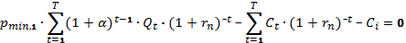
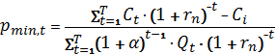
Minimum price calculation assumes current and expected conditions of entrepreneurial environment (income tax rate, income tax holidays for RES projects, average long term inflation, etc.). Investment subsidy reduces initial investment, operational subsidy creates additional source of operational revenues. Both types of support reduces minimum price:
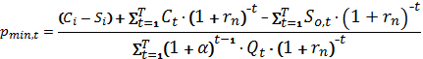
Where: S_{i} investment subsidy
S_{o, t} operational subsidy in the year t
Calculation of minimum price needs two crucial inputs:
- Basic technical and economic parameters of projects that will be realized in the next period. Typical combination of these parameters create reference project for given period (year). Reference projects should reflect not only cost of technology and project operation cost but also availability of suitable locations.
- Regulated rate of return that is represented by the value of nominal discount in the minimum price calculation.
Czech support scheme expected risk minimization for the investors and creating stable and transparent conditions. Also the scheme was supposed to reduce extra cost imposed to the final electricity consumers. Relatively low level of risk results in relatively low level of discount rate, i.e. regulated rate of return for investors – ERO used till 2010 discount rate 7% for minimum price calculation.
Projects are financed beside investment subsidies by the combination of equity and debt capital. It is very hard to predict any specific structure of financing - thus used rate (7%) has meaning of weighted cost of capital – WACC
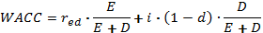
where: red rate of return on equity capital [%]
i cost of debt capital [%]
d income tax rate
E, D values of equity and debt capital [EUR]
Return of equity capital thus depends of E/D ratio, interest rate on bank loans income tax rate.

History of PV in Austria
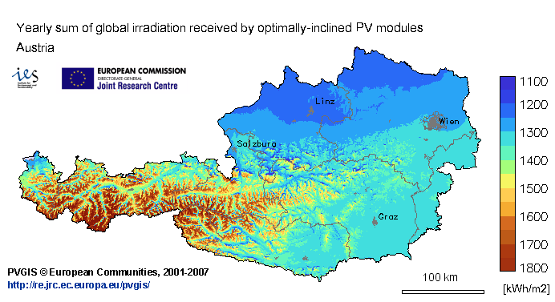
Figure 6: Yearly sum of global irradiation in Austria Source: Institute for Energy and Transport, EC
The history of PV in Austria since the year 2000 has been characterised through the implementation of the Renewable Energy Bill (dt.: Erneuerbare-Energien-Gesetz) and the Eco-Electricity Bill (dt.: Ökostromgesetz), where it was determined that the energy supplier is obliged to pay a compensation to the local renewable energy producer. If one would install PV moduls on 3% of Austria’s land area, this could cover 100% of Austria’s energy needs. The market expansion is shown in the following figure, between the years of 1993 and 2010, where the production peak has been in the final year of 2010. The left scale shows the newly installed capacity in Kw-peak, while the right scale shows the cumulated capacity. As shown in the diagram, the PV industry has blossomed with the increase in state and energy supplier subsidies. The capacity of the PV plants amounted to 95,5 MW in the year 2010, while the capacity of the newly built plants amounted to 42,9 MW (approximately 45% of the entire capacity and a 81,9% increase in overall capacity from the year 2009). The electricity prices produced from photovoltaics have been reduced by 15% and there has been a double increase sales growth, amounting to annual sales of 824 million Euros, with 4.414 workers being employed in the PV industry.
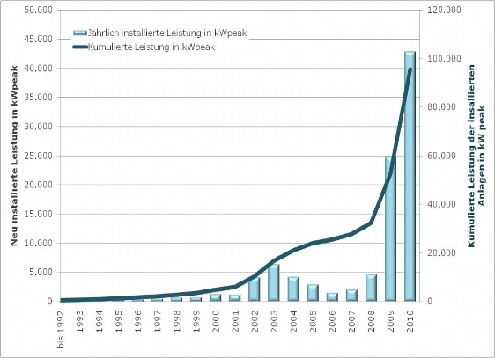
Figure 7: Yearly installed capacity in Austria (light blue, left side), the cumulated capacity (dark blue, right side) in kWpeak Source: PV Austria
In the year 2011, there have been policy changes by simplifying the FIT policy and procedures, with budget of 8 million Euros for photovoltaics technology and 2.1 million for solar subsidies. By the year 2020 photovoltaics are expected to account for a share of eight percent of the country’s total electricity with a capacity of 5.5 gigawatts installed, which is in accordance to the goal of 20% of country’s electricity being produced from renewable resources by the year 2020.
In the year 2012, following FIT prices were determined (for the roof-mounted installations and on the noise-proof fences):
5 kWp - 20 kWp............. 27,6 Cent/kWh
over 20 kWp .............. 23 Cent/kWh.
For the PV plants that are on open spaces, the following FITs were determined:
5 kWp - 20 kWp ........... 25 Cent/kWh
over 20 kWp.................... 19 Cent/kWh.
This presents a significant decrease (13%) from the FITs determined in the year 2011, which means that the PV industry might face a certain stagnation from its peak in 2010, although more projects on a smaller scale could be financed. Projects however are being planned, since Austria is investing into a smart grid project that will see new 120 PV systems built all over the country.
The Austrian federal parliament passed the 2012 Green Electricity Act on July 7, 2011, designed to support the production of green electricity via a feed-in tariff, financed by the Austrian electricity consumers through a clearance mechanism. Since its promulgation in 2002, the Green Energy Act has been amended three times in between 2006 and 2008, with some of the amendments taking effect or being further revised in 2009.
The following figure (EPIA, 2011) shows the 2010 EU market numbers in terms of PV capacity installed. Austria has 50 MW (although an increase is expected – the PV Austria is calculating a total of 175 MWp installed by the end of 2011), which is miniscule in comparison with the Czech Republic (1.490 MW or 11%, due to the aforementioned aggressive policy-making) and Germany, that has a 56% market share.
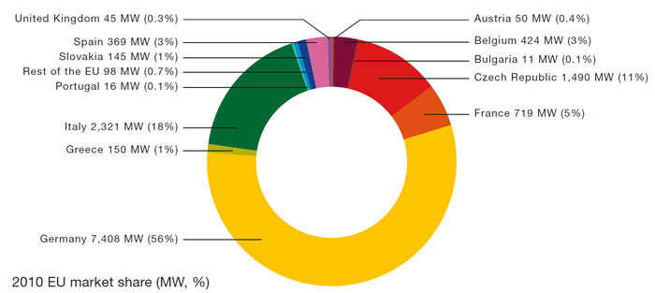
Figure 8: 2010 EU Market Share Source: European Photovoltaic Industry Association (EPIA)
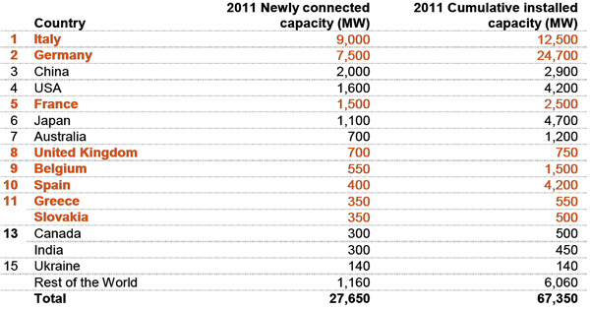
Figure 9: 2011 newly connected capacities Source: EPIA

The figure above shows the newly installed capacities in the year 2011. Austria oes not show a significant relative improvement in the installations, when compared to other EU countries, unlike the Czech Republic. Austria’s problems deal with the sudden decrease in FITs in the last two years, along with the fact that the lobbyism for renewable energy resources such as wind and biomass is stronger, along with the already long dominance of hydropower. Czech Republic has suffered a „PV recession“ due to the implementation of harsh taxes.
The problems that Austria is facing regarding the PV industry is that the incentives and the lobby is highly dependent on the usage of other renewable sources (namely wind and biomass), along with the development of the oil price on the global market. There is no independence to be found in the policy-making. The technologies of energy storage are being vastly ignored, have no subsidies from the government and, being that the investment costs for larger PV projects are still great, a modern PV system that includes energy storage (especially for winter time) is out of the question.
The FITs are reducing (up to 15 Ct) – the general word-of-mouth relates to the opinion that solar energy is still expensive and possibly does not provide the ROI necessary for the investors. With FITs being the only viable, but volatile, solution for the energy producers, it is to be expected that the future of PV in Austria is still dependent mostly on the policies of other energy carriers, whether those are renewable or non-renewable.

Ineffectiveness of Czech support scheme - Reality in Czech Republic
Basic principle of Czech RES support scheme was minimization of risk to the investors, which should result in minimization of extra cost transferred to customers. This was supposed to happen but reality turned out to be completely different. Thanks to the supported development of PV technology in the world, investment cost started to fall drammatically since 2008 and it went hand in hand with growing efficiency of PV panels. Thanks to rigid legislation, ERO was not able to react appropriately, most likely by the reduction of FIT value. Also other factors were involved. In 2009, the last year when changes had to be done to avoid enormous extra cost, Czech government fell, general election was postponed from 2009 to 2010. Therefore, major changes of legislation (Act. 180/2005) were made in 2010, so the changes came into operation since 2011 (for power plants with year of operation start 2011 and further). Furthermore, since 2004, the Czech krona is almost continually appreciating against the Euro and the US dollar, which also caused decrease in cost of technology for investors operating in crowns (figure 3). In the years 2006 to 2010, the investment cost decreased app. By 35%. Thus, the power plants that started in 2009 and 2010 were higly profitable (relative high FIT value, low cost of technology, high efectiveness of PV panels) as the support scheme failed. 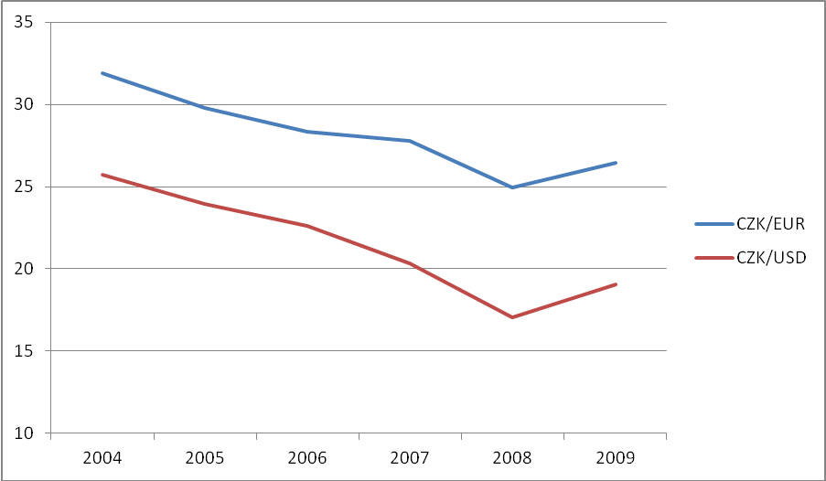
Figure 5: Development of Exchange rate of CZK to EUR and USD

Main disadvantages:
Limitation of FIT value reduction. Feed-in tariffs, set anually by ERO for power plant put into operation next year, can be reduced by 5% at maximum. It is obvious, that with changes in efficiency and cost of technology, 5% was not enough. Adequate reduction would be 30-40% instead of which investors realized extremely high rate of return on relatively low level risk investment.
Assumption of no other subsidy than FIT or green bonus. No other form of support was assumed in FIT calculation, but EU provides investment subsidy from structural funds through operational programmes.
No limitation of total installed capacity of RES power plants. The reason for not setting any roofs was to avoid prefering one kind od RES to another. In reality, this is one of reasons, that PV could grew out of limits while other renewable energy sources stagnated.
The use of WACC formula for FIT calculation which assumes some specific ratio of equity and debt capital while the ratio and cost of debt capital is different for small investors and big corporate investors. It created different conditions and led to higher economic motivation for big companies. These companies have easier access to bank loans and incomparably better interest rates. From small investor’s point of view, who usually needs higher share of debt capital with higher interest rate, it might cause zero or negative cash flows during the repayment period.
Strong influence of lobbyism on proces of creating reference projets. Reference project have been updated in two year period. Probably the biggest pitfall of this proces is relative unpredictability of future costs and conditions. As it use to be, in processes when no one can be blamed for a mistake, noticable ties to groups interested in RES.
Absence of any analysis on the future cost of the support scheme. No analysis of future costs were made before the problems appeared. The impact on final consumer was high and its reducing was much more expensive than the ex ante reducing would be.

Conclusion
It is important to note that the markets in Austria and in the Czech Republic are significantly different from each other, but there are similarities in the policies and in the way of thinking of investors and policy makers. The physiogeographical circumstances are quite similar and the climate challenges are being governed and shared by the same institution – namely the European Union, since both Austria and the Czech Republic have significant roles in achieving the EU renewable energy 2020 goal.
The fact is that the PV market is still a fresh territory that many failed to see as having potential, as in the case of Austria’s backing out of investments and further technological research, along with the fact that renewable energy sources like wind and biomass gained on the advantage. In the opposite case – in the Czech Republic - when the potential was realized, it was determined that the state-backed costs proved to be too big and that the fiscal economy was not prepared for such a case. Did Austria prove itself to having a realistic, both economic and environmental, overview of the renewable energy potential in the country, by not exaggerating with the incentives and policy-making that led to such economic losses that the Czech Republic had to endure? Will Czech Republic still in the following years have a positive environmental and economic development in its sustainability and renewable energy policy? The extremities that led to a failure in PV policies can still be remedied, if the FIT system is to be redesigned, with the prognoses of these more in hand with the long-term economic indicators, such as the currency exchange rate, the restructuring of the fiscal policy, the increase in the energy production supply (and demand), along with the introduction of smart metering and smart grid policies. It is very important that, before an environmentally friendly and sustainable policy is introduced, the cost-benefit analysis is being carefully analysed, all the economic indicators are clear, since the long-term implementation of PV projects should find the perfect balance between a social, environmental and economic rentability. This is something that has not yet been achieved in either of the countries.

References
epia.org
ERU.cz
Czrea.org
re.jrc.ec.europa.eu
cenyenergie.cz
chp-goes-green.info
pvaustria.net
pv-tech.org/tariff_watch/austria
Act of power generation 180/2005 Col.
Knápek, J - Vašíček, J. - Valentová, M.: Possible Pitfalls In Feed-In Tariff Support Scheme – A Lessons Learnt From PV Boom In the Czech Republic. In Proceedings of the 6th International Scientific Symposium on Electrical Power Engineering. Košice: Technická univerzita v Košiciach, 2011, p. 384-387. ISBN 978-80-553-0724-4.
Knápek, J.: Effectiveness of Feed-in Tariff Scheme - A Lessons Learnt in the Czech Republic. In Energy Economy, Policies and Supply Security: Surviving the Global Economic Crisis [CD-ROM]. Cleveland: IAEE, 2010, ISSN 1559-792X.
Zajíček, M – Zeman, K: Ekonomické Dopady Výstavby Fotovoltaických A Větrných Elektráren V ČR. Prague: Oeconomica, 2010, ISBN: 978-80-245-1687-5

Meaning of similar amount of solar radiation in reference ares of South Moravia in Czech Republic and Styria in Austria.

