Biomass energy production:
Analysis of biomass transport

Winter/Summer School 2008
By Sabrina Metz
and Marika Nachtigalová

Supervisor: Jaroslav Knápek

Introduction
Global energy consumption is continually growing and our society is facing urgent problems. The first serious problem is a vulnerable energy supply. Fossil fuels, main sources of energy, are limited. On the other side, using fossil fuels causes several environmental problems, such as rising greenhouse gases (GHG´s) concentration in air or local air pollution.
A possible solution to deal with these problems is to replace part of a traditional energy production by using renewable energy sources (RES). Biomass used for energy purposes seems to be an interesting option. Biomass is worldwide available and it is said to be CO₂ - neutral while producing and consuming. Some regions produce more biomass than others, which is caused by size of land area, percentage of arable land, population density etc. Existence of these regional differences requires biomass transportation and it is often transported long distances before use.
In our paper, we will take a look on a biomass energy production in Austrian and Czech context. We will focus on the process of supplying power plants with biomass, especially the way of transportation and the distance. Even though it is not possible to obtain precise data, we would like to point out this environmental problem. Also we would like to find out how important the role of biomass transportation is in the whole context of electricity generation.

General information
Austria and the Czech Republic are easy to compare – they have similar area size and almost similar population (Austria – 8,266 mil. inhabitants; Czech Republic - 10,251 mil. inhabitants (2006)). On the other hand, both countries have completely different natural conditions for using RES.

Energy consumption
Final energy consumption (includes all energy delivered to final customers for all energy use) was almost similar for both countries in 2006 (Fig. 1). Energy consumption was about 26 000 Mtoe (million tons of oil equivalent) at that time. At the beginning of viewed period (1996), Czech final energy consumption was much higher than Austrian, but since 1997 it started decreasing and it started increasing in 2003 again. In contrast to this trend, Austrian final energy consumption has been rising almost all the time (between 1997 and 2005).
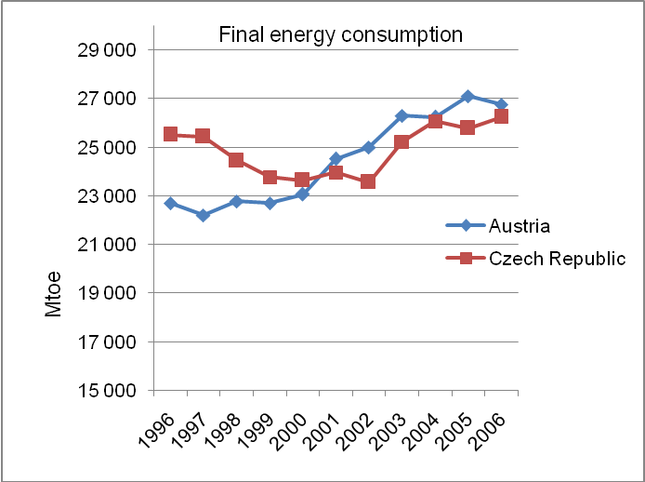
Country / Year | 1996 | 1997 | 1998 | 1999 | 2000 | 2001 | 2002 | 2003 | 2004 | 2005 | 2006
Austria | 22 695 | 22 211 | 22 778 | 22 702 | 23 057 | 24 525 | 24 995 | 26 300 | 26 241 | 27 107 | 26 753
Czech Republic | 25 514 | 25 435 | 24 455 | 23 781 | 23 636 | 23 970 | 23 571 | 25 234 | 26 078 | 25 776 | 26 251
Figure 1: Final energy consumption in Austria and the Czech Republic, EUROSTAT

Another important thing to take into account is CO₂ production (Fig. 2). If we take a look on the amount of CO₂ produced while energy generating in both countries, we can see that Austria has almost twice less CO₂ per capita emissions produced than the Czech Republic. This fact may be caused by using cleaner sources in process of energy generating.
These facts support percentage of energy produced from RES in both countries (Table 1). Austria produced about 56 % of gross energy consumption from RES, compared to the Czech Republic which produced only about 5 % in 2006.

Country / Year | 1996 | 1997 | 1998 | 1999 | 2000 | 2001 | 2002 | 2003 | 2004 | 2005 | 2006 | 2010
Austria | 63,90 | 67,50 | 67,90 | 71,30 | 72,40 | 67,20 | 66,10 | 53,10 | 58,70 | 57,40 | 56,60 | 78,10
Czech Republic | 3,50 | 3,50 | 3,20 | 2,70 | 3,60 | 4,00 | 4,60 | 2,80 | 4,00 | 4,50 | 4,90 | 8,00
EU - 25 | 12,50 | 12,80 | 13,10 | 13,10 | 13,70 | 14,20 | 12,70 | 12,70 | 13,70 | 13,60 | N/A | 21,00
Table 1: Electricity generated from RES - % gross energy consumption, EUROSTAT
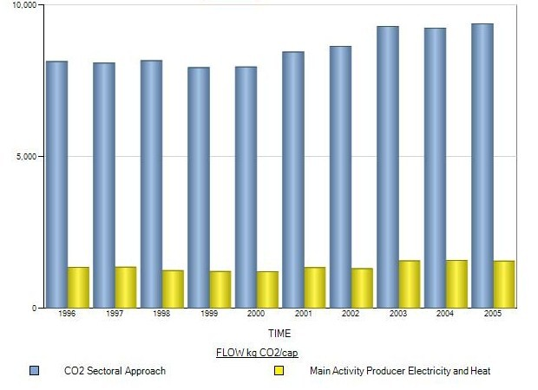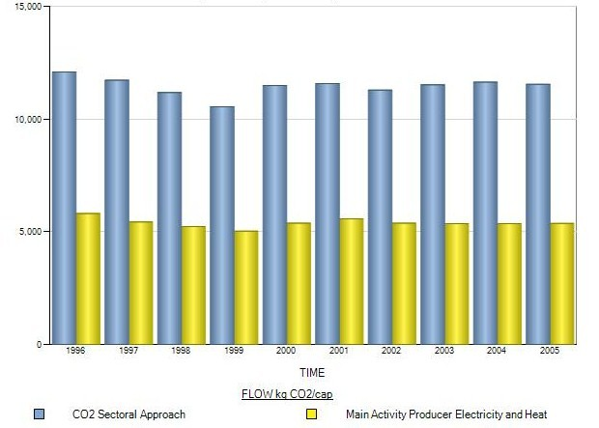
Figure 2: CO₂ per capita emissions in Austria and the Czech Republic, OECD
Austria
Austria
Czech Republic

Bioenergy production
In spite of having very similar climate, both countries dispose of different nature condition for using RES. The Czech Republic produces about 70 % of RES (Fig. 3) electricity production from hydro power plants (just 3 % of total electricity production), but this amount is a maximum to be reached. On the other hand, biomass has the largest potential from RES. Electricity production from biomass was almost 21 % of RES electricity in 2006. Gross electricity production from biomass in 2006 was almost double compared to biomass electricity production in 2003 (Table 2), but only about 39 % was supplied into the grid. The most frequent used type of biomass when electricity producing was cellulose leach; the second used were wood chips and waste from forests (Fig. 4).
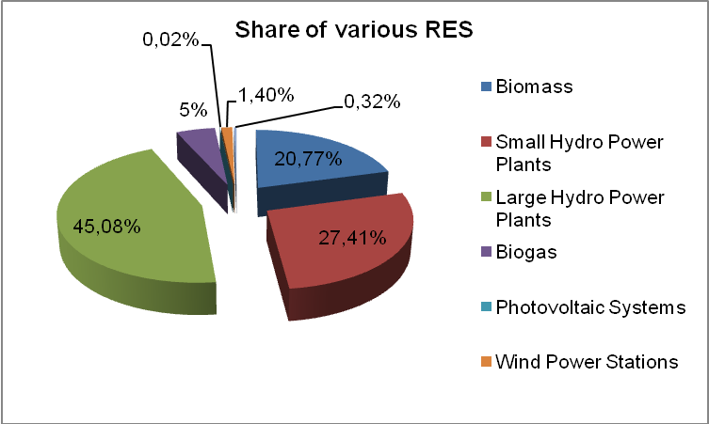
Figure 3: Share of various RES on the electricity production in
the Czech Republic in 2006, Ministry of Trade and Industry
If we compare electricity and heat and production, we can see that only about 20 % of biomass is used for electricity production and the rest is used for heat (Table 3).
Year | Gross electricity production | Grid Supply
Year | MWh | MWh
2003 | 372 972,40 | 17 383,30
2004 | 565 000,00 | 222 827,30
2005 | 560 251,90 | 210 379,20
2006 | 731 066,30 | 285 746,40
Table 2: Development trends of biomass-based electricity production in the Czech Republic, Ministry of Trade and Industry

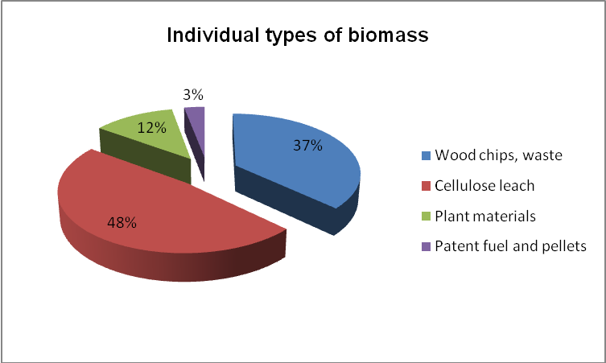
Figure 4: Share of individual types of biomass on the electricity production in the Czech Republic in 2006, Ministry of Trade and Industry

Fuel | Electricity generation (tons of biomass) | Heat production (tons of biomass) | Total
Wood waste, chips, sawdust etc. | 250 150 | 881 457 | 1 131 607
Fuel wood | – | 54 102 | 54 102
Plant materials | 62 146 | 12 307 | 74 453
Patent fuel and pellets | 15 519 | 8 134 | 23 653
Cellulose leach | 184 619 | 883 578 | 1 068 197
Total | 512 435 | 1 839 578 | 2 352 012
Estimated consumption of wood in households |  |  | 3 087 549
Biomass exports for energy generation |  |  | 516 455
Total biomass used or exported for energy generation |  |  | 5 956 016
Table 3: Energy use of biomass in the Czech Republic in 2006, Ministry of Trade and Industry

In 2005 63 % of gross electricity consumption of Austria was produced from RES. Most of it is produced by hydropower. As you can see in Fig. 5, 57 % total electricity produced is generated from water sources.
Only 3,4 % of energy production is produced from biomass and renewable wastes. As Austria has a big capacity of biomass, it is possible to produce more energy out of biomass.

Figure 5: Electricity Generation by Fuel of Austria in 2005, International Energy Agency, http://www.iea.org/textbase/pm/?mode=re&action=view&country=Austria

CO₂ - emissions of energy systems using biomass in other studies
There are some studies, which are dealing with the CO₂ - emissions of energy produced by biomass.
To compare our results and to see how a complete Life Cycle Inventory is made, we took a look at a study from the Swedish University of Agricultural Sciences, where a life cycle inventory has been used to find out if biomass that is used for energy production can be transported about 1200 km without loosing its environmental benefits.

Methodology: Life Cycle Inventory
The life cycle inventory (LCI) is a part of a complete life cycle assessment (LCA). LCA focuses on the environmental impacts throughout the full life- cycle of a product or system. In the life- cycle- inventory a model with certain system boundaries is created that contains all the amounts of the inputs and outputs of the processes during the life- time of the product, from resource extraction to final product use and disposal. Therefore data has to be collected for each process. It results into an inventory table that compares the output and input with a function unit.
If you take a look at the example of how much CO₂ is emitted per one MWh electricity produced, one MWh electricity is the function unit.
In a complete LCA an impact assessment is also conducted to interpret the results of the inventory study in terms of impact on human and ecological health and use of resources.

Emissions of biomass energy systems
When using biomass to produce energy, there are emissions during various steps, as you can see in Fig. 6, which shows the process tree of a biomass energy system using baling, which means that forest residues are compressed to bales.
In this case emissions are not only occurring during transportation but also during baling, which leads to higher CO₂- output compared to the use of forest residues without baling.
The CO₂- output in the combustion stage is not included in the life cycle inventory since there is a closed loop between growing and combustion of biomass.
Important for the specific CO₂- emissions is the efficiency of the power plant. In this study the power plants have an efficiency of about 44 %, which is quite high.
However this means that 66 % of the total amount of biomass, which had to be transported to the plant and processed to bales, can not be turned into electricity.
It also has to be considered that a specific amount of biomass gets lost along the way, which also leads to higher specific emissions.

Figure 6: Process tree of a biomass energy system based on baling technologies
Göran Forsberg, Biomass energy transport Analysis of bioenergy transport chains using life cycle inventory method, Biomass and Bioenergy 19 (2000), 22

Results of the study
In this study, a mass loss of the wood from the forest to the combustion of 20% was assumed. The wood is transported 50 km per truck, 200 km per railway and 1200 km per ship before it reaches the power plant. The power plant with a modern circulated fluidised bed has an electricity efficiency factor of 0.44, which means that 44% of the energy content of the biomass is transformed into electricity and the heat is not used.
In this study the “best available technology” is used which leads to smaller emissions than in our calculation.
In Fig. 7 you can see the amount of emissions during various stages of an energy system based on bales.
Figure 7: Emissions and energy expenditure in a system based on bales. fu stands for function unit, in this case MWh. Göran Forsberg, Biomass energy transport Analysis of bioenergy transport chains using life cycle inventory method, Biomass and Bioenergy 19 (2000), 25

In this case truck transport plays a minor role of the emission of CO₂. The main emissions occur during the ship transport, although ship transport has a smaller specific emission of CO₂ than truck transport. That is because the transport distance for ships is much bigger.
But also the baling with 7.3 kg CO₂/MWh plays an important role in emitting CO₂. In sum, 29 kg CO₂/MWh are produced in this case.
When using domestic biomass, which is transported for 200 km per truck and rail, we only have 17 kg CO₂/MWh.
If you take a look at the life-cycle emissions of coal, which are between 800 and 1000 kg CO₂equ/MWh, you can see that emissions from biomass, even in the case of long range transportation, are nearly negligible.

Emissions from biomass transport
To find out how ecological biomass as a RES is, should be take into account all the processes needed to power generation including transport. It is often neglected that biomass is transported for long distances. We use biomass as a source of energy in order to cut CO₂ emissions, on the other side a lot of emissions are produced on the way.

Data collecting
We gathered data from 3 bigger biomass power plants in each country. Data was collected from statistic databases on internet and by interviewing reliable employees in power plants.
In most cases, the system of supplying power plants with biomass is based on a contract between a power plant and a supplier. The power plant pays fixed sum for a ton of biomass delivered (including supplier´s transportation costs). This fact makes a data collecting more difficult, because the power plant is not interested in how long biomass is transported. On the other side, suppliers usually refuse to inform about these costs simply in order to harvest the fruit of their risky work.

Way of transport
In local dimension, biomass is usually transported by LKW trucks. These trucks satisfy emission standard Euro 3, they can carry 25 tons and a maximum size of cargo is 90 cubic meters. Unfortunately, attributes of biomass do not allow using railway for shorter distances. The first problem is loading biomass on to a truck – it is very rarely loaded at one place (when suppliers supply power plants with forest residues – wood logs, chips etc. – they usually are not able to gather 25 tons of biomass at one place). Trucks are more flexible than trains (railway tracks are not everywhere). The second problem when using railway freight is extra personal costs on reloading from a truck to a rail and thus higher price for a power plant (from a forest it must be transported by a truck and than it can be transported by a train).

Basic information about power plants
We collected information from 3 power plants in Austria and also in the Czech Republic. Power plants differ in capacity, annual electricity production and share of biomass used (Table 4).
Power plant | Technology | Capacity (Output installed) [Mwe] | Annual electricity production out of biomass (2006) in {MWh] | biomass per year in tonnes | Share of biomass (%) | Biomass transported [km] | Type of biomass
Czech Republic
Hodonín (ČEZ a.s.) | CHT* | 105 | 54 000 |  | 25 | 70 | forest residues, wood logs
Poříčí (ČEZ a.s.) | CHT | 165 | 49 500 | 90 000 | 0-25 | 40 - 100 | forest residues, wood chips
Tisová (ČEZ a.s. | CHT | 183 | 26 730 | 40 000 | 20 | 50 -100 | forest residues
Austria
Simmering | CHT | 66 | 167 000 | 190 000 | 100 | 100 | forest residues, bark
Leoben | CHT | 26,1 | 36 000 | 88 000 | 100 | 0 | bark
Timelkam | CHT | 49,7 | 183 000 | 115 000 | 100 | 50 | wood chips, bark, matured timber
Table 4: Data from chosen power plants, Authors´ own research
* CHT = combined heat and power

It is obvious that is not possible to figure out an average distance transported. According to interviewed employees, their idea is to get biomass from a power plant ´s neighbourhood, but they cannot influence it. The most common distance is between 50 and 100 kilometres. But often biomass is transported longer, especially when it is transported cross border. For example, a Czech power plant Poříčí in Trutnov (situated in north-east of Bohemia) used to transport biomass from Jeseníky area (north of Moravia). The distance between these two areas is about 180 kilometres.
A possible question may occur how this can be still economic? The answer is simple, the supplier had good organisation of supplies. On the way back, the truck was also loaded with other products. This example shows how logistics can save costs and also CO₂ emissions.

CO₂ emissions calculation
When calculating CO₂ emissions, we used methods invented by Czech Ministry of Transport. This method sets emission factors for different air pollutants produced from road transport. Emission factors are counted for each kind of vehicles.
An emission factor of CO₂ for trucks using oil (diesel) is 3138 grams per a kilo of fuel. An average fuel consumption of a loaded truck is about 30 litres of oil per 100 kilometres.
The density of diesel is 840 kg/m³. As one litre equals 1 dm³ we have 0,84 kg per litre, which leads us to a diesel consumption of 0,252 kg per kilometer.
If we multiply the above mentioned emission factor with the diesel consumption per km, we get the CO₂ emissions per km.
Our finding is that LKW trucks produce about 790 grams of CO₂ per kilometre. If one truck of biomass is transported for 50 kilometres, 39,5 kg of CO₂ is produced on one way.
We assumed that one truck can transport about 90 m³ of wood. From some power plants we knew how much m3 of wood are delivered per year, the so called stacked cubic metre of timber [stere].
From the rest of the power plants, we just had the tons delivered per year, we assumed that one tonne with a moisture of about 30 % equals four stacked cubic meter of timber.

Results
To compare the powerplants with each other we calculated the specific CO₂- emsissions from transportation per produced MWhel as you can see in Table 5.
Power plant | Annual electricity production from biomass (2006) [MWh] | Total annual electricity production [MWh] | Stacked cubic metre of timber [stere] | Biomass transported (km) | CO2- Emissions per produced Mwhel [kgCO2/MWhel]
Poříčí (ČEZ a.s.) | 49 500 | 573 000 | 360 000 | 70 | 4,473076364
Tisová (ČEZ a.s. | 26 730 | 763 000 | 160 000 | 75 | 3,944511785
Simmering (AUT) | 167 000 | 167 000 | 600 000 | 100 | 3,156790419
Timelkam (AUT) | 95 000 | 95 000 | 460 000 | 50 | 2,127233684
Table 5: CO2- Emissions per produced MWh_{el} of selected power plants, Author´s own calculations

The CO₂- emissions range from 2,14 kg/MWhel to 4,47 kg/MWhel. Timelkam, the power plant with the shortest transportation distance, has the smallest emissions.
It seems like the considered Austrian power plants have smaller specific emissions than the Czech power plants.
All of the Czech power plants use co- firing to burn the biomass together with coal in big coal power plants, therefore the efficiency of these power plants should be higher than the efficiency of the smaller Austrian power plants.
But according to our data the Austrian power plants have a higher efficiency in turning wood into energy, that´s why even Simmering, where the wood is transported about 100 km has lower specific emissions then the Czech power plants.
Porici seems to have the highest emissions of the plants we took a look at. It has to be considered that all of these power plants also produce heat, since they are combined heat and power plant, but we just took a look at the electrical energy produced per year.
Therefore the specific emissions would have been smaller if we would have taken the produced heat into account.

Conclusions
It seems like the specific emissions of CO₂ caused by biomass transport are quite small. But as already mentioned we don´t really know how far the biomass really is transported.
If the biomass for example is transported for 300 km per truck the emissions would rise to nearly 20 kg CO₂/kWh_{el}.
It is clear that the usage of domestic wood should be preferred or for longer distances railways or ships, which have a smaller specific CO₂-emission should be chosen.
But as mentioned earlier, in comparison with a coal- fired plant, the CO₂- emissions from transportation of biomass do not influence the fact that energy from biomass, as a renewable energy source, has lower specific CO2- emissions than energy from coal.

Literature
- Czech Energy Regulatory Office, Statistics “Electricity Industry in 2006”, http://www.eru.cz/rz_06/rz/index.htm, 24.5.2008
- Damen, K.; Faaij, A.: A life cycle inventory of existing biomass import chains for “green” electricity production(2003)
- Dufek, J.; Adamec, V.; Jedlička, J.: Metodické zásady výpočtu emisí z dopravy, Centrum dopravního výzkumu, Česká republika 2005 (Methodical principles for calculating emissions from transport, Transport Research Centre, Czech Republic 2005)
- EUROSTAT, “Environment and Energy Tables”, http://epp.eurostat.ec.europa.eu/portal/page?_pageid=0,1136239,0_45571450&_dad=portal&_schema=PORTAL, 24.5.2008
- Forsberg, G.: Biomass energy transport: Analysis of bioenergy transport chains using life cycle inventory method, Biomass and Bioenergy 19 (2000), 17 - 30
- Hameling, Carlo N.; Suurs, Roald A.A.; Faaij, André P.C.: International bioenergy transport costs and energy balance, Biomass and Bioenergy 29 (2005), 114 – 134
- International Energy Agency, www.iea.org, 27.5.2008
- OECD, www.oecd.org, 24.5.2008
- Report on the fulfilment of indicative targets for production of electricity from renewable resources for 2006, Ministry of Trade and Industry of the Czech Republic
- Weiser, D.: A guide to life-cycle greenhouse gas (GHG) emissions from electric supply technologies, Energy 32 (2007), 1543 - 1559
- International Energy Agency, www.iea.org, 27.5.2008
- OECD, www.oecd.org, 24.5.2008
- www.waldenergie.at/downloads/Masseinheiten_01-08.pdf, 27.5.2008

Hameling, Carlo N.; Suurs, Roald A.A.; Faaij, André P.C.: International bioenergy transport costs and energy balance, Biomass and Bioenergy 29 (2005), 114 - 134
International Energy Agency
Göran Forsberg, Biomass energy transport Analysis of bioenergy transport chains using life cycle inventory method, Biomass and Bioenergy 19 (2000), 19f
Kay Damen/André Faaij, A life cycle inventory of existing biomass import chains for “green” electricity production(2003), 4
Göran Forsberg, Biomass energy transport Analysis of bioenergy transport chains using life cycle inventory method, Biomass and Bioenergy 19 (2000), 20
Göran Forsberg, Biomass energy transport Analysis of bioenergy transport chains using life cycle inventory method, Biomass and Bioenergy 19 (2000), 22- 25
Göran Forsberg, Biomass energy transport Analysis of bioenergy transport chains using life cycle inventory method, Biomass and Bioenergy 19 (2000), 21- 26
Daniel Weiser, A guide to life-cycle greenhouse gas (GHG) emissions from electric supply technologies, Energy 32 (2007), 1550
www.waldenergie.at/downloads/Masseinheiten_01-08.pdf, 27.5.2008

