Interdisciplinary Bilateral Winter and Summer School on
Energy Innovations in Austria and the Czech Republic
10. bis 16. Februar in Graz und 29. Juni bis 7. Juli 2008 in Prag

From the solar power to the transport

Is in the transport sector a sustainable way with electric vehicles and solar energy a good solution for the future?

SUPERVISING PROFESSOR:

Jiri Louda
Wolfgang Streicher

STUDENTS:

(Julia Lyamzina)
Michael Schwingshackl 0330693

Graz, 28.07.2026

Abstract

This paper should give an answer to the potential and possibility to generate enough renewable electricity technically and how to use it as well for the transport sector.
The first part of this paper analyses the potential of generating renewable electricity out of solar power, according to an overview of renewable ways of generating electricity. The sun gives the answer.
The second part outlines the best way to implement electricity in the transportation technology. There is big challenge in future to change the general habits in the transport sector but also to alter the technology. The higher efficiency and lots of other advantages of an electrical vehicle should give us and our decision makers a better idea in which direction we should orientate our future technologies.

Table of Contents

Table of Contents 2
1 Renewable Energy and solar power 3
1.2 Current problems with photovoltaic technologies 3
1.3 Future of Photovoltaic 3
2 Transport 3
2.1 Current situation 3
2.2 Electrical vehicles and how they work? [IEAHEV, 04.2008] 3
2.2.1 Hybrid electric vehicles 3
2.2.2 Battery electric vehicle 3
2.3 Efficiency Potential and environmental effects 3
2.4 What are the current problems with the electrical vehicle technology and its implementation? 3
3 Summary and prospective 3
List of literature 3
List of figures 3

Renewable Energy and solar power

Renewable energy effectively uses natural resources such as sunlight, wind, rain, tides and geothermal heat, which may be naturally replenished. The part that solar power plays we can see indirectly for example in wind, biomass and hydropower and directly by solar heat and photovoltaic.

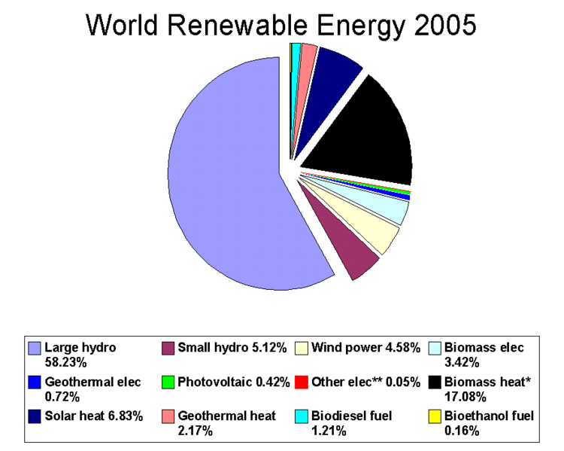
Figure 1: World renewable energy 2005 [EIA, access 05.2008]
The solar industry, especially the photovoltaics (PV) segment, has reduced product prices substantially in recent years. The industry has made major progress in all areas of performance, reliability, and costs, as well as consumer acceptance. [EIA, access 05.2008]
Statistic information shows us that there is a very small proportion of the whole electricity mix directly out of solar energy at the moment. The missing cost transparency leads to cheap recourses of coal, gas and nuclear energy and is the main reasons for nearly no development in the last years in renewable energy.

Due to the fact that the sun is able to deliver within the energy amount of one year about 7000 to 10000 times the amount we would need globally in primary energy, it is dolorous to see what problems we could avoid with changing our focus on this renewable resource. [WSW, access 05.2008]
Just a dessert area of 0,3% is necessary to support us with the needed energy for Europe, North Afrika and the Middle East. ‘With the technology of high-voltage direct current transmission it is even no problem to transport the needed electricity’, says Mr. Gerhard Knies in a Brand Eins report. [Brand Eins, 02.2008]
In combination with other renewable energy sources, there should be no doubt that the clean production of electricity as well for the transport sector is possible in future.

Current problems with photovoltaic technologies

Photovoltaic cells function only during daylight hours. Therefore, the electricity needs to be stored or combined with other renewable energy. The missing storage technology for this amount of electricity leads to a strategy use.
Before we reach a widespread use, improvements are needed in the photovoltaic cells to make them economically competitive. The rising oil price gives hope and we come closer to the historically missing cost and price honesty. Photovoltaic cells that consist of silicon solar cells are currently up to 17% efficient in converting sunlight into electricity. Compared to the other electricity generations this efficiency relatively is low; however the sun remains for free.
The most promising cells in terms of low cost, mass production, and relatively high efficiency are those being manufactured using silicon. This material makes the cells less expensive, with less toxic chemicals and environmentally safer than the heavy metal cells.

Future of Photovoltaic
All scenarios show that in a middle term perspective photovoltaic plays a major roll in the electricity production.
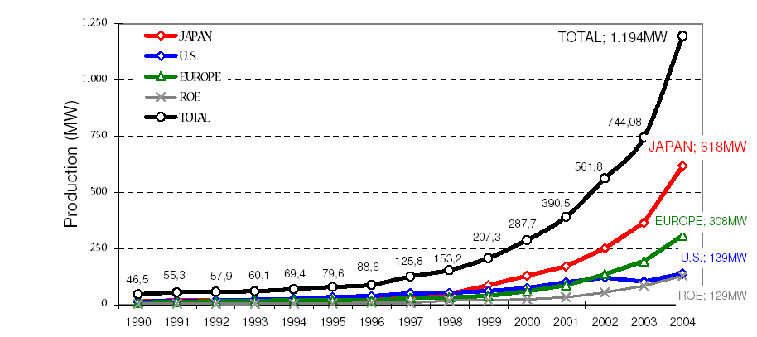
Figure 2: Energy in MW of past production [Photovoltaic Austria, 31.05.2008]
The generating cost factor will drive the development and should bring a break even at about 2020 if this economic system we have now, is still working by then. Subsidies could help immediately and push the energy market in a very clean direction.
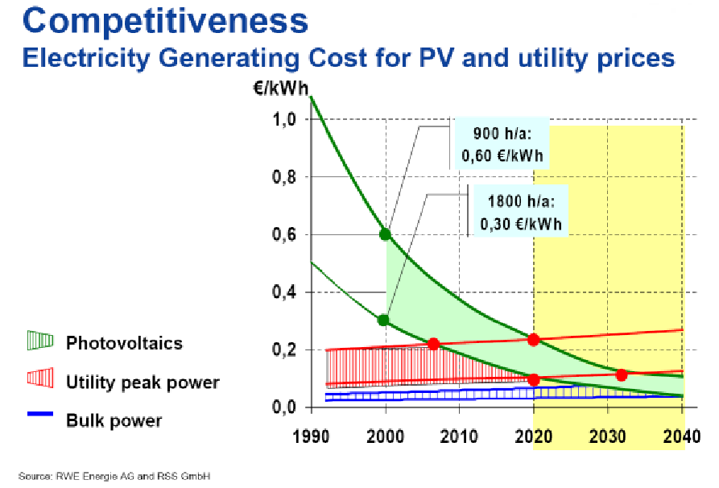
Figure 3: Competitiveness [RWE Energy AG and RSS GmbH]

Transport

Europe's road transport has made a clear contribution to economic growth, but its environmental performance is still unacceptable. Traffic congestion, poorer air quality, noise, tremendous production energy and in particular greenhouse gas emissions are some of the key challenges for our future. To reach intermediate and long-term climate change targets, transport demand in combination with a switch to high efficient transport technologies has to be addressed. [IEAHEV, 04.2008]
A future transport strategy should include a higher public transport proportion and a much lower individual transport proportion. Preferable based on electric powered public transportation such as train, subway, tram, trolley bus and a small proportion of battery electrical cars. A holistic solution needs to use the battery electrical vehicles for public transport as well with just the exception of some private vehicles. The lack of resources drives this very important change of the current system from private holding of cars to a car sharing possibility without any comfort losing for the individual.
This paper now tries to give an argumentation base for the shift from combustion engine to electrical engines as propulsion for passenger cars and its advantages for the transport sector and the climate issues.

Current situation

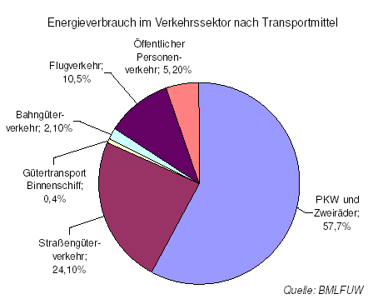
A study of the BMLFUW in Austria shows the CO2 emission in sectors and the emissions in the transport sector.
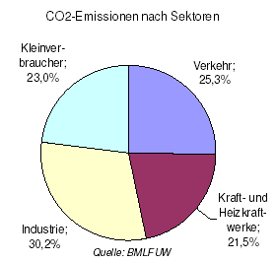
Figure 4: CO2- Emission in sectors and energy consumption in sectors [BMLFUW, 05.2008]

The transport sector with its 25,3% is the second largest emission sector as Abb. 4 shows. And in the transport sector the individual transport including cars and motorbikes is far the largest with 57,7%. This leads to 3,11 Mrd liters of petrol in the individual transport sector, witch is a tremendous part of end energy we need in Austria with 54 TWh. This shows us that especially in this sector the potential for improvement is very high.
Austria has a high percentage of motorized vehicles with about 500 cars per 1000 habitants. The number of EVs and HEVS in Different Countries [IEAHEV, 04.2008] shows us how little the amount of EVs and HEVS is and how big the potential.
At the moment there are about 3.5 Mio cars in Austria. Even if we reach a percentage of 5% EVs (150000) EVs the power requirement will rise only 0,5% of the total need of electricity in Austria. [Das Elektroauto, 2004]
Year | 2004 |  | 2005 |  | 2006 |  | 2007 thru Oct. 1
Vehicle Type | EV¹ | HEV | EV¹ | HEV | EV¹ | HEV | EV¹ | HEV
Austria | 515 | 0 | 517 | 75 | 1,300 | 75 | NA² | NA
Belgium | 60 | 131 | 50³ | 602 | 50³ | 1,493 | 0 | 2,665
Denmark | 5,300 | 15 | 5,650 | 35 | 5,650 | 60 | 10,650³ | 100
France | 11,013 | 650 | ~11,000 | 3,650³ | ~11,000 | 10,000³ | NA | NA
Italy | 113,201 | 720 | 132,491 | 1,110 | NA | 2,179 | NA | 2,295
Netherlands³ | 500 | 2,000 | 500 | 3,000 | 500 | 7,500 | NA | NA
Sweden | 400 | 1,355 | 360 | 3,300 | 335 | 6,100 | 324 | 9,500
Switzerland | 10,780 | 1,057 | 13,140 | 2,469 | 17,590 | 4,722 | 23,500³ | 7,760
United States | 55,852 | 196,293 | 68,000 | 404,400 | 76,200 | 656,300 | 120,000³ | 975,000
IA-HEV Members Total | 197,621 | 202,221 | 231,708 | 418,641 | 112,625 | 688,429 | 154,474 | 997,320
China³ | 13,000,000 | NA | 23,000,000 | NA | 33,000,000 | NA | 45,000,000³ | NA
Japan³ | NA | 120,000 | NA | 150,000 | NA | 260,000 | NA | NA
Taiwan³ | 75,000 | NA | 94,000 | NA | 100,000 | NA | 106,000³ | NA
GRAND TOTAL | 13,272,621 | 322,221 | 23,325,708 | 568,641 | 33,212,625 | 948,429 | 45,260,474 | 997,320
¹Includes e-bikes and e-scooters, where data available
² NA = not available
³ Estimate
⁴ Information exists, not released by government

Figure 5: Number of EV´s and HEV´s [IEAHEV, 04.2008]

Electrical vehicles and how they work? [IEAHEV, 04.2008]
There are currently three types of EVs: battery electric, hybrid electric, and fuel cell electric. Fuel cell electric vehicles are still in the prototype, testing, and demonstration phases. No further explanations.

2.2.1 Hybrid electric vehicles
Hybrid vehicles have a conventional engine (gasoline or diesel) as well as a large battery and an electric motor, so that the wheels of the car are driven by both an internal combustion engine and an electric motor. There are various arrangements for these two motors.
In a series hybrid vehicle, the internal combustion engine is not connected to the wheels of the car. It is used only to generate electricity, which powers the electric motor and is also fed into the battery at times when the car does not need all the energy produced. This internal combustion engine needs only to produce the average amount of power required by the car; it is much smaller than those in conventional cars, and it usually operates at its most efficient point and at constant speed.
In a plug-in or charge-depleting hybrid vehicle, the car battery can be charged from the electricity net, and this electricity can then be used for all or part of the next trip that the car makes. The distance that the car can drive on the electricity stored in the battery varies widely from model to model, anywhere from less than 20 km up to 80 km.
Hybrid electric vehicles (HEVs) are already on the market today. For example the Toyota Prius, Honda Insight, Honda Civic and many others are sold in many countries.
Advantages and disadvantages:
The only real practical and technical reason for this compromise mixing two technologies is the higher range the combustion engine brings with its petrol tank versus just a battery electric solution.
Another point is that automotive industry is able to sell the technology they researched on for decades and still get a high price for those vehicles even if they still pollute the environment. This kind of an environmental friendly step helps the most in an economic way of prospective. In a technological way of prospective this emission saving potential of about 5% to 25% compared to an conventional vehicle, (depending on the hybrid grade) could easily be reached with weight reductions as well (downsizing).
Hybrid vehicle technology is a "step-out" technology in that it modifies an existing and proven technology, rather than replacing it completely with something that is totally different. This is a major advantage from the market introduction perspective: the changes can be introduced gradually, and the risk of major technical problems and high warranty costs after a few years is reduced. Another advantage is that no new infrastructure is required.
Taking everything into consideration it is clear that the hybrid vehicle technology is just a good technological evolution with the goal to get closer in a clean electric vehicle direction. The biggest challenge is not the technology but the economy objectives and the economy system itself with makes it difficult to use existing better technology.

2.2.2 Battery electric vehicle
The battery electric vehicle, or BEV, is a vehicle that utilizes chemical energy stored in rechargeable battery packs, and electric motors and motor controllers instead of internal combustion engines (ICEs).
The distance Battery electric vehicles also known as Pure electric vehicles can drive before the batteries need recharging depends on the type and number of batteries installed in the vehicle and can range from 50 to 200 km with existing technologies and according to a sutable price that make sense. In the past decade, rapid progress has been made in battery technology. The lead-acid battery was surpassed in efficiency and power density by nickel-cadmium and then nickel-metal hydride batteries. These newer batteries are already important in commercially available hybrid vehicles. Advanced technologies, such as lithium-ion and lithium-polymer batteries show promise in vehicle propulsion applications. The costs of these newer technologies are still high, but they are decreasing steadily.
Electric motors have several advantages over internal combustion engines (ICEs):
- Energy efficient. Electric motors convert 75% of the chemical energy from the batteries to power the wheels—internal combustion engines (ICEs) only convert 20% of the energy stored in gasoline.
- Environmentally friendly. EVs emit no tailpipe pollutants, although the power plant producing the electricity may emit them. Electricity from nuclear-, hydro-, solar-, or wind-powered plants causes no air pollutants.
- Reduce energy dependence. Electricity is a domestic energy source.
- Performance benefits. Electric motors provide quiet, smooth operation and stronger acceleration and require less maintenance than ICEs.

EVs face significant battery-related challenges:
- Driving range. Most EVs can only go 150 miles (or less) before recharging—gasoline vehicles can go over 300 miles before refueling.
- Recharge time. Fully recharging the battery pack can take 4 to 8 hours.
- Battery cost: The large battery packs are expensive and usually must be replaced one or more times.
- Bulk & weight: Battery packs are heavy and take up considerable vehicle space.

Efficiency Potential and environmental effects

It is well known that the efficiency of a combustion engine starts at about 18 % ends at a maximum of 25%. Idling, brake and part load losses are the problems here. The electric motor reaches an efficiency higher than at least 65 - 70%. Battery losses and loss of load are the main problems here.
In-depth studies show that, all figures being equivalent, taking into account the energy efficiency at both production and distribution level, the consumption figures are as follows:
 | conventional cars |  | electric vehicles
 | fuel consumption / 100 km | electricity equivalent | electricity consumption
car | 8,5 l gasoline | 909 Wh / km | 488 Wh / km
van | 12 l gasoline | 1283 Wh / km | 600 Wh / km
small lorry | 16 l diesel | 1910 Wh / km | 1000 Wh / km
Figure 6: Average consumption of conventional cars and electric vehicles [CITELEC report]
These figures show that electric cars, vans or small lories, respectively consume 54%, 47% and 52% of the primary energy needed by internal combustion vehicles. It is clear that electric vehicles are much more energy efficient.
Taking into account an average mileage of 10000 km per year, which is the standard figure for vehicles in urban areas, the energy savings obtained by replacing conventional cars by electric vehicles are:
 | energy savings [kWh / year per vehicle] | energy savings converted into fuel volumes [l / year per vehicle]
car | 4210 | 438
van | 6380 | 709
small lorry | 9100 | 846
Figure 7: Energy and fuel savings due to electric vehicles [CITELEC report]
When regenerative braking is applied, kinetic energy can be recuperated and sent to the batteries. This can lead to an economy of about 10%.
A very simply calculation about how long a car is standing and not doing its job can show us easily what kind of problem we need to solve. A year has 8760 hours and if we assume a speed of 50 km/h and a mileage of 10000km per year the car is moving 200 hours and standing 8560 hours a year.
Probably the most inefficient tool we ever created for transportation if we only take the production energy and the costs into consideration for a vehicle that stands around most of its time, there is a big need to think of other solutions.

Still remember that the most efficient KWh is the one we don’t use.
In a long term prospective the only energy source will be the sun. There is no price rice assured from the sun for the next 5 billion years which should be advantage enough to use it. But this fact is very dangerous as well if we still believe that our existing way of economy is the only way for our future and needs to grow without compromise. Anyway we need to use Solar energy in future directly or indirectly with wind, hydro, geothermal or biomass. All other resources are not sustainable.
Environmental:
The introduction of EVs leads to a significant decrease of pollutants in the atmosphere. Taken into account indirect emissions from energy production, we can compare the emission values for each type of car.Figure 5 shows emission values as the total sum of operation-related emissions and emissions associated with final energy supply for Europe in the year 2000, for conventional cars (petrol, diesel and compressed natural gas) and electric cars. Figure 6 shows the CO 2 emissions from the engine and those associated with final energy supply, for European cities.
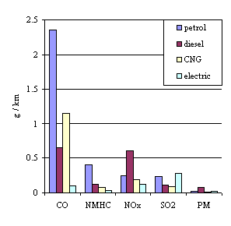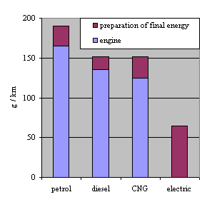
Figure 8: Vehicle emissions in Europe, 2002 [UNIPEDE, 1998] | Figure 9: Energy-related CO 2 emissions [UNIPEDE, 1998]
From these tables it is clear that EVs pollute less for almost all pollutants. Only for sulphur dioxide, the figure remains larger, because of the number of sulphurous coal plants. This is becoming more and more controlled, and the part associated with electric vehicles is actually rather marginal compared to other polluters. However, this figure should decrease substantially thanks to the improvement in emission control and the use of natural gas in the next few years. The global ecological impact is firmly positive.
In figure 8 we see EVs produce less than half as much CO 2 as the other drive variants.
Moreover, most of inner city movements are very short. So thermal engines remain in general rather cold, which means that emissions are higher and that efficiency is low. Catalyst converters only work properly at a sufficiently high temperature after some kilometres. But we want need the EV´s for cities anyway. The public transport is much more efficient as any individual transport.
In brief, low pollution by EVs is due to the higher efficiency of electric plants. Emissions from EVs are located outside the cities and it is easier to control emissions of one electricity plant than to control thousands of vehicles exhaust pipes.
Thermal engines are always rotating, even during a stop. EV motors, on the contrary, are stopped each time the vehicle stops. In traffic jams and at traffic lights EVs neither emit nor consume anything, except for auxiliaries such as lighting and radio.
Traffic noise is making the atmosphere of modern cities quite unbearable. Thousands of combustion-engined vehicles are generating an annoying background noise which degrades quality of life in cities. The electric vehicle is virtually silent and allows to rediscover the beauty of a moment of silence and quietness.
Electric vehicle stands for clean air as it is effectively zero-emission at its point of use. Furthermore, the emissions due to the generation of electricity are significantly lower than the corresponding vehicle emissions, due to the high efficiency of today's power stations.
The electric vehicle is ideally suited to be integrated in new traffic management concepts, such as automatic rent-a-car systems and goods distribution centres, which emphasise the complementarity of transport modes and which contribute to the relief of traffic congestion.

What are the current problems with the electrical vehicle technology and its implementation?
Surveys have shown that many people drive their cars 50% less than 5 km per go, and 80% less than 15 km per go. Battery electric cars available today can meet the mobility needs of many urban households, but they usually do not meet customer expectations when they are buying a car in the showroom. There are two broad responses to this challenge: one is to continue to improve battery technology and reduce costs, and the other is to address the customer expectation issue.
Improvements in battery technology are being driven by demand in cell phones and laptop computers, where customers are prepared to pay very high prices for high-performance batteries of a relatively small capacity (compared with vehicle batteries). Lithium-ion batteries are now widely available for laptop computers; this is a particularly promising technology because the material cost of lithium is relatively low compared with that of nickel. The current cost of lithium batteries would have to decrease significantly before they become practical for vehicles. This may well happen over the next 5-10 years. In addition, there are several other technologies based on zinc, sodium, and other metals that are not considered frontrunners at this time but that may yet emerge as competitors in the future.
The customer expectation issue may be addressed by designing different electrical cars than in the past and by cultivating different expectations among customers.

Summary and prospective

Photovoltaic:
The photovoltaic technology will play an important roll in the future, because all scenarios show that photovoltaic energy production with will rise.
There is no doubt that the amount of energy the sun delivers to the earth is more then enough to satisfy more than our basic needs. It is not the energy itself which is limited, but the resources to produce cells and its pollution which causes a need of limit in our wasteful human behaviour.
The problem is not the availability of renewable resources, or the technology to harness them, but the cost of doing so. Most of these technologies cost more, currently, than using fossil fuels. So another challenge is, supported by a rising oil price, to create the awareness of other values and other decision making processes than the just economic orientated ones.

Transport:
The individual motorised transport sector is the key sector for improvements according to the climate change issue in the transport sector. The main part of driven distances is under 15km which leads to a high potential of supporting this kind of mobilisation by public transport.
The battery electrical vehicles with the efficiency higher than 70% would bring the change in system we need for the targets that have been defined in the Kyoto Protocol. The technology already exists it remains a need of battery development.
It is clear that EVs have an important role to play in the reduction of CO2 emissions.
The big question is if the decision makers see the chance of a stronger European independence regarding energy supplies which brings the change of energy source from oil to electricity, in cooperation with renewable electricity producer.

List of literature

[IEAHEV, 04.2008]
www.ieahev.org

[EIA, access 05.2008], http://www.eia.doe.gov/cneaf/electricity/chg_str_fuel/html/chapter5.html

[WSW, access 05.2008]
http://www.wsw-online.de/energie/Pro_Umwelt/Klimafonds/Solaranlagen.htm

[Brand Eins, 02.2008]
Brand Eins Report 02/08, Gerhard Knies Physiker

[Photovoltaic Austria, 31.05.2008]
Photovoltaic Austria, Photovoltaik – Technologiestatus national und international , 31.05.2008

[Das Elektroauto, 2004]
Book: Das Elektroauto from Sonja und Konrad Metz, 2004

[CITELEC report]
G. Maggetto, P. Van den Bossche and J. Van Mierlo, CITELEC report "Force electrique en Wallonie: les vehicules electriques et hybrides en Wallonie, une solution ecologique durable pour la circulation urbaine"

[UNIPEDE, 1998]
UNIPEDE 1998 Report

Further reading for conclusions:

http://www.eurosolar.de
http://www.solarmobil.net/mobili.htm
http://www.elektromobil.com
http://www.oekonews.at

List of figures

Figure 1: World renewable energy 2005 [EIA, access 05.2008]
Figure 2: Energy in MW of past production [Photovoltaic Austria, 31.05.2008]
Figure 3: Competitiveness [RWE Energy AG and RSS GmbH]
Figure 4: CO2- Emission in sectors and energy consumption in sectors [BMLFUW, 05.2008]
Figure 5: Number of EV´s and HEV´s [IEAHEV, 04.2008]
Figure 6: Average consumption of conv. cars and electric vehicles
[CITELEC report]

Figure 7: Energy and fuel savings due to electric vehicles [CITELEC report]

Figure 8: Vehicle emissions in Europe, 2002 [UNIPEDE, 1998]
Figure 9: Energy-related CO 2 emissions [UNIPEDE, 1998]

