Comparison of the climate strategy of the Czech Republic and Austria

Ondrej Bores University of Prag
Gerald Senzenberger University of Graz
Content:
1 Introduction Kyoto protocol 3
1.1 Emission savings in Austria 4
1.2 Emission savings in the Czech Republic 5
2 Economy in a climate relevant approach 6
2.1 Brief economic overview of Austria 7
2.2 Brief economic overview of the Czech Republic 8
3 Austrian Policies 9
3.1 Ökostromgesetz 2002 9
3.1.1 Tarifs 9
3.1.2 Outlook 9
3.2 Energy taxation 9
3.3 Other important policies 10
4 Czech Policies 10
4.1 Subvention of renewable sources 10
5 General overview of emission structure - Austria 12
5.1 Energy 13
5.1.1 Renewable energy 13
5.2 Industry 14
5.3 Traffic 15
5.4 Households 17
5.5 Agriculture 18
5.6 Waste 18
5.7 F-gases 18
5.8 Other CO₂-, CH₄- and N₂O-Emissionen 18
6 eral overview of emission structure – Czech Republic 19
6.1 Energy 19
6.2 Industry 22
6.3 Households 22
6.4 Waste 22
6.5 Agriculture 23
7 Final Statement 23
8 Literature and weblinks 24
9 Appendix 25
9.1 Life cycle analyses - LCA 25

Introduction Kyoto protocol
Due to the man made climate change, the largest polluters except of USA and Australia have signed the Kyoto protocol to reduce Greenhouse gas emissions (GHG). Up to now 163 nations signed the treaty, which is equal to 61.6 % of the CO₂ equivalent emission of the year 1990. The treaty is binding since Russia ratified the protocol in 2005. The European Union set an ambitious goal to cut CO₂ emissions by additional 8% below the level of 1990 until 2010 to meet the EU-Kyoto targets. The target itself is a less drastic temperature rise and a lower peak temperature due to reduced GHG emissions which are responsible for the global warming. To meet these targets the members of the European Union have summarized national allocation plans (NAP´s) and climate strategies.
One of the most important instruments to reduce emission is the EU Emissions Trading Scheme. It is not Kyoto mechanism, but it shall help the EU to achieve mentioned target. The EU redistributed commitments of the EU-15, which resulted from Kyoto protocol. The EU targets are voluntary and the countries will not be sanctioned, if they do not meet these targets.

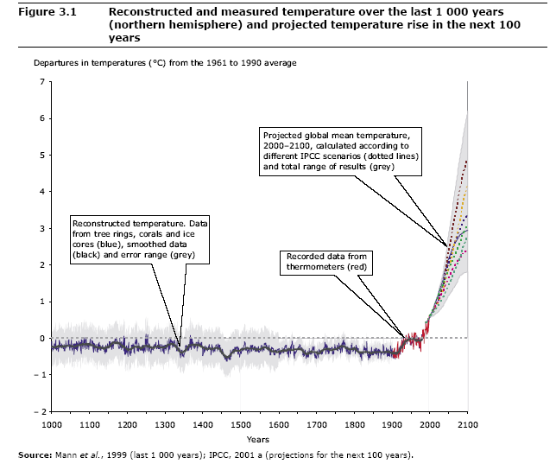
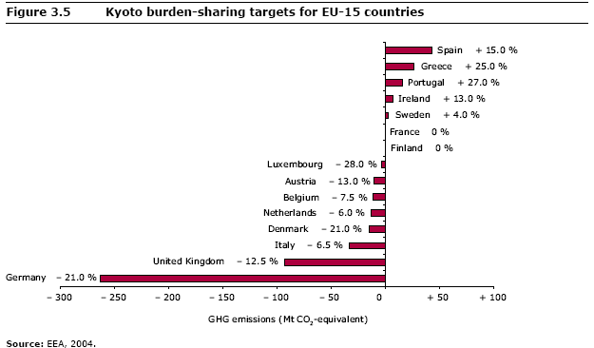

While Austria has signed to reduce by 13 %, the Czech Republic has to reduce by 8% below the level of 1990. Both targets are set above the average for OECD as well as for Eastern European countries.

Emission savings in Austria

At the moment Austria is about 30% above the emission level of 1990 (23 million tons CO₂ equivalent emissions). The strategy is to reduce emissions by 16.2 million tons and to buy pollution rights of the amount of 7 million tons via emission trading programs from other countries.
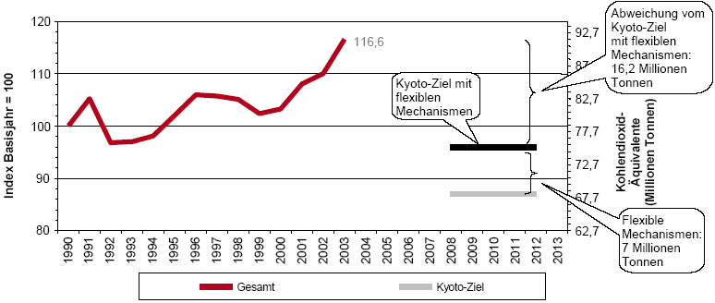

Sector | Emissions |  | Trend | Climate strategy 2002 |  | Outlook 2010
 | 1990 | 2003 | 1990-2003 | 2010 | Change in % | 2010 | Change in %
Room heating | 15,08 | 15,3 | 1,40% | 10,8 | -28,10% | 14,35 | -4,90%
Energy conversion | 13,67 | 16,11 | 17,80% | 11,7 | -14,10% | 16,69 | 22,10%
Waste | 4,5 | 3,41 | -24,20% | 2,7 | -40,90% | 2,78 | -38,20%
Traffic | 12,67 | 23,03 | 81,80% | 16,8 | 32,30% | 21,64 | 70,80%
Industry | 21,49 | 23,38 | 8,80% | 20,5 | -4,40% | 24,83 | 15,50%
Agriculture | 8,46 | 7,35 | -13,10% | 6,6 | -21,40% | 7,26 | -14,10%
F-Gases | 1,76 | 2 | 13,70% | 1,8 | 3,40% | 1,47 | -16,10%
Other | 0,89 | 0,98 | 9,50% | 0,6 | -27,80% | 0,92 | 2,80%
Sum | 78,54 | 91,57 | 16,60% | 71,4 | -9,10% | 89,93 | 14,50%
Kyoto Target |  |  |  |  | -13,00%
Source: Umweltbundesamt, 2006

The upper table shows that the Kyoto targets are far out of reach, instead of -13%, which already include emission trading, Austria might end up at +14,5%.

Emission savings in the Czech Republic

The amount of CO₂ emissions has dropped by 24 % during transition of economy (IEA, 2004). The following table shows progress of greenhouse gases in the Czech Republic.

Notes: blue line – real emissions
red dot – Kyoto target
Source: Ministry of Environment

The emission level is approximately on 75 % of referential year 1990 nowadays. Total emissions will probably slightly increase, mainly in branches, which are not comprehended in EU ETS (it means transport, agriculture, etc.). Reducing goal would not be threatened, because we can not expect giant economic growth.
However absolute values do not have sufficient predicative value. When comparing total emissions, the Czech Republic is on the same level as most of developed countries. But comparing emissions per capita as well as GDP the Czech Republic is above value, which is common in developed countries. It predicates of lower level of Czech energy efficiency (in production as well as in consumption).

Economy in a climate relevant approach

The Czech Republic, one of the faster growing economies within the Union and Austria, one of the most developed economies in the world today have a common problem, a lack of natural resources to cover there actual energy and material consumption in a sustainable way. Both countries are heavy dependent on fossil fuels. In order to elevate the living standards there is a big need to develop energy efficiency and renewable energy, also without the Kyoto incentive. 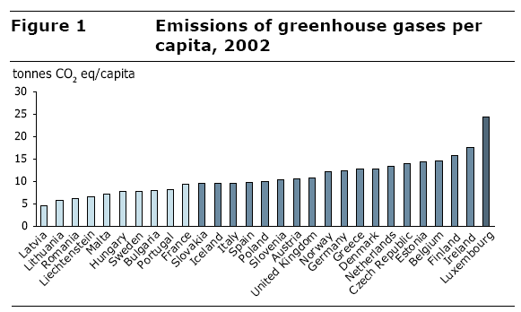
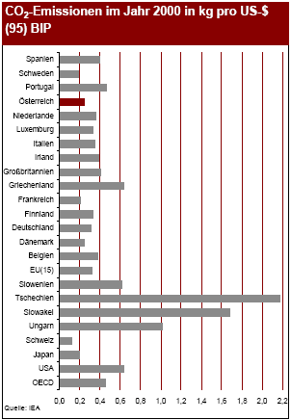
The NAP´s are not only designated to meet the Kyoto targets, they also give an outlook of economic development over a time span of more than 20 years. The plans are heavily influenced by sustainable development measures and resource related taxations schemes, some might say it could be the program of the environmentalist party.
The table to the left shows the Emission per unit of GDP in the year 2000. Since this time a strong economic growth has reduced the length of the bold lines of the 4 CEE countries included.

This paper will give an overview about the governmental activities and the successes of energy saving and renewable energy development. The comparison includes already the first effects, f.e. growth of renewable energy and an outlook for the Czech Republic and Austria. Both countries have similar energy problems and both are in a similar climatic region, except of the alpine climate in Austria.

Brief economic overview of Austria

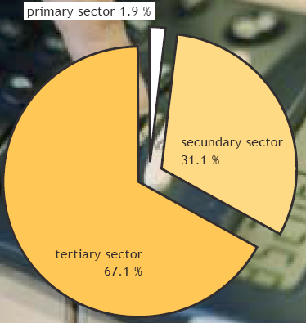
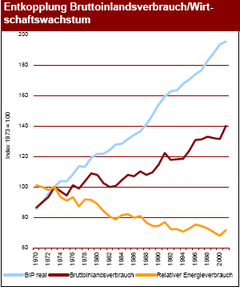
Austria has 8,22 Million inhabitants and generates a GDP of 246,5 Billion Euro, 29.960 Euro per capita. The area is 83.871 km²; about 47% of the area is covered by wood. The three sector model shows that Austria has a larger industrial share than most other developed countries, while the primary sector declined to 1,9%. Most of the GDP is generated by the tertiary sector. Despite the large industrial sector the emission per produced unit of GDP is much smaller than in countries with a comparable share of industry. This is due many market leaders in highly specialised niche products, many of them in the field of environmental related technologies. Andritz-VA TECH Hydro claims to have installed hydropower and gas fired plants to supply 100 million people with electricity. Other leading companies in environmental related sectors are Scheuch filter technology or KWB, small biomass boilers. Another important niche is wood industry and related technologies, large biomass heat boilers (Mawera, Kohlbach) most of the time used for wood drying kilns (Mühlböck) is an interesting option for decoupling some heat to large district heating systems after kilns, which would also improve the wood drying process to due better distributed heat within the kiln.
Since the first oil crisis started a decoupling of GDP and energy consumption, more efficient technologies have been introduced, most important Combined Cycle Power plants (CCGT) and district heating with heat losses of the power plants. Additionally inefficient industrial processes declined, like aluminium processing. BMWA, 2003

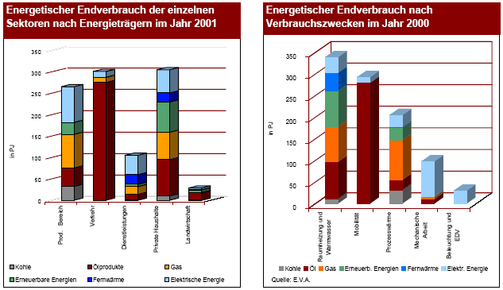
The left statistic shows what energy sources are used in the different parts of the economy, f. e. the high share of oil in traffic or the large share of electricity in the service sector. The right one shows for what the energy is used; by far the most energy is used for heating (process, water and home) and mobility.
A study made by the WIFO (Wirtschaftforschungsinstitut) shows that a sustainable development scenario will improve welfare and employment, while reducing imports of prime energy sources and emissions. At the moment the biggest problem might be the high subventions for farmers and workers to do nothing, which leads to a low incentive to cut wood, despite rising wood prices. A better subvention system could lead to much higher employment effects and an improvement of the terms of trade due to fossil fuel import substitutions.

 | unit | Baseline |  | Kyoto |  | Sustainability
 |  | 2010 | 2020 | 2010 | 2020 | 2010 | 2020
energy consumption | PJ | 1327,4 | 1444,7 | 1161,3 | 1207,2 | 1119,1 | 962,4
CO2 Emissions | mio. t | 66,2 | 69,3 | 53,5 | 51,9 | 51,5 | 38,2
additional GDP Growth | % | - | - | 1 | 0,6 | 1,4 | 1
costs/year | billion € | - | - | 1,2 |  | 1,85
investments/year | billion € | - | - | 1,9 |  | 2,75
employment change | # | - | - | 20000 up to 25000 |  | 30000 up to 40000
additional tax income | billion € | - | - | 1,38 |  | 1,45 up to 2,18

Brief economic overview of the Czech Republic

Since 1989 the Czech Republic has made significant economic progress and the country now has a functioning market economy. The Czech economy is performing solidly, with the country having attracted the most foreign investment per capita of any country in Central Europe.
The Czech Republic has 10 Million inhabitants and real GDP growth increased to 6 % in 2005, on the back of accelerated EU import demand growth and the recovery in personal consumption following the effects of large increases in indirect taxes in 2004. The tax increases, together with higher oil prices and economic growth, pushed up inflation in 2004, but price growth moderated in 2005, owing to increased retail competition and further strengthening in the crown's exchange rate. The current-account deficit fell to 4.0 per cent of GDP in 2005, down from 5.5 % in 2004. Unemployment is estimated at 8.6 %.
Most of the Czech economy is now in private hands after several waves of privatisation of formerly state-owned companies since 1989. Most major state-owned companies have been privatised with foreign participation. The government evaluates all investment offers for state enterprises.

Source: Czech Statistical Office

Austrian Policies

The climate strategy influences many fields of society. Starting with regulations for buildings, city design and subvention of public transport or street user fees, like the infamous “Vignette”. Some of these policies are regional, only a few are national, like the so called “Ökostromgesetz” – clean energy law. The impacts of regional policies are very different, as f. e. the Upper Austrian government supports solar panels and biomass boilers by 20% of the investment costs.

Ökostromgesetz 2002

This law includes the duty to buy the produced energy from renewable energy plants, except of electricity produced from large hydro power (>10 MW), sewage, animals and waste (with the additional exception of waste with a big part of biological waste) and the subvention for modernizing or building combined heat and power plants for public area heating. The main target is to raise renewable electricity production to 78,1% until 2010. The new suppliers have the same right to be connected to the grid than others.

Tarifs

Target 2010 | 78,1 % electricity from renewable resources
Subtarget 2008 | 59,5-60% large hydro | 9-  9,5% small hydro | 5,5-6% other renewable eco energy plants |  |  |  | 2-2,5%  other  renewables
Subtarget 2008 | 59,5-60% large hydro | 9-  9,5% small hydro | 3-3,5% wind | 1-2% biomass | 0,03% PV | others | 2-2,5%  other  renewables
Support C/kWh | 0 | 1,5-2 | 5 | 8 | 60 | 2 | 0
Support €/year | 0 | 88 Mill. | 80-90 Mill. | 45-90 Mill. | 10 Mill. | < 15 Mill. | 0
Source: E-Control

Outlook

During writing this paper the Austrian government implemented the fourth novel of this law. The Green Party said the new novel is disastrous, due to lower subventions and limits for installed power plants per year which get these subventions. Rumours also say that corrupt politicians from the pseudo leftist corner (SPÖ) wanted to support Russian gas imports due to higher subventions for decoupling of gas fired power plants heat to district heating.

Energy taxation
energy source | tax per unit (€)
 | 2003 | 2004
Diesel | 0,282/l | 0,317/l
Gasoline | 0,407/l | 0,432/l
Extra light oil | 0,069/l | 0,098/l
Heavy oil | 0,036/l | 0,060/l
Electricity | 0,015/kWh | 0,015/kWh
Gas | 0,04360/m3 | 0,066/m3
Coal | 0 | 0,05/kg

Other important policies

Most policies can be found in the fields of building of public awareness, due to educational programs, media and lighthouse projects and regional additional subventions, regulations and contracting programs. Austrian regional governments are responsible for the so called “Wohnbauförderung” – new buildings and renovation of old buildings, the necessary values of insulation to get “Passive house” or “Low energy house” subvention vary between the regions. Some effects of regional government regulation policies take a very long time, f. e. renovation of the house stock or regulation of area planning.

Czech Policies
Czech global-warming policy is particularly focused on industry thereby we can expect that it could work down an increase of industry production. Part of this decline should be neutralized by increase in other industry branches (mainly in renewable industry and services).
But greenhouse gases are emitted by transport and agriculture as well. It is necessary to reduce emissions in these sectors as well as to reduce energy consumption.
As mentioned above Czech policy is focused on industry and partial on renewable energy. Contrary to Austria the Czech Republic still has not initiated environmental taxation and wider subvention to energy savings.

Subvention of renewable sources

It can be seen, that there are really huge differences between Austria and Czech Republic in renewable energy production on next figure. It is caused by different natural conditions and economic situation.

The goal of Czech policy is to produce 15 % of energy from renewable sources in 2030. To obtain this goal many measures have been assumed.

Main measures are:
- investment subsidies – it shall reduce the entrance costs, you can obtain it from European as well as from Czech funds
- green bonuses – it increases market prices, a producer have to sell the electricity at first and after that he receive this bonus
- feed-in tariffs (minimum purchase prices) – a producer sell electricity for minimum prices, which is higher than market prices (profit is little bit lower than from green bonuses)
- tax allowance – in form of tax holidays, lower level of value added taxes
- emissions trading – emissions trading increases the prices of fossil fuels and that is why the prices of renewable sources relatively decrease and become more attractive for producers

Green bonuses and feed-in tariffs are set by Energy Regulatory Office for each sort of renewables every year.
There is illustrated share of particular renewables and the goal for 2010 on next picture.

Notes: green – biomass
dark blue – large hydropower plants
light blue – small hydropower plants
brown – windpower plants
Source: Ministry of Environment

General overview of emission structure - Austria
In comparison to most other countries the share of emission in the energy sector (incl. oil refineries) is smaller due to large hydropower and a successful implementation of other sources of renewable energy. The overall efficiency of the thermal power plants is quite high due to combined heat cycles. 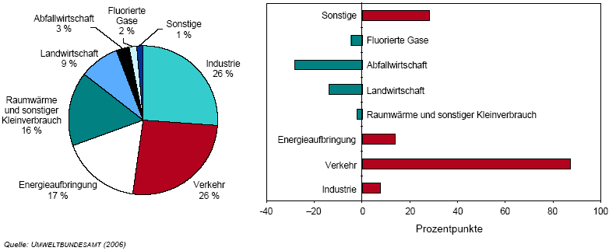
The thermal losses are used for district heating, due this the value of emissions from households are smaller than their fossil energy consumption. In the household sector, room heating due to lack of insulation is the driving factor. Still most of the Austrian households use gas or oil boilers, coal declined in the last 30 years. Biomass and solar thermal heating is rising with strong numbers per year. A strong 30% rise of the emission in the traffic sector was caused by tank tourism, due to lower prices than in neighbouring countries. The industrial sector has already shown strong improvements in energy efficiency, but the savings where less than the additional emission caused by higher production. Agriculture and waste sectors are responsible for methane and nitro dioxide, which are multiplied by the GWP factor to converse them into carbon dioxide equivalent emissions.

 | GWP | Emissions  in tonnes | CO2 equivalent  in tonnes | Share, in %
CO2 | 1 | 69.120 | 69.120 | 80,48%
CH4 | 21 | 432,11 | 9.074 | 10,56%
N2O | 310 | 19,2 | 5.951 | 6,93%
HFC | 1.290-1.330 | 1,12 | 1.033 | 1,2%
SF6 | 23.900 | 0,03 | 677 | 0,79%
PFC | 6.600-8.100 | 0,003 | 25 | 0,03%
 |  | total: | = 85.880 t | = 100%
Greenhouse gas emissions in Austria in 2001

Energy

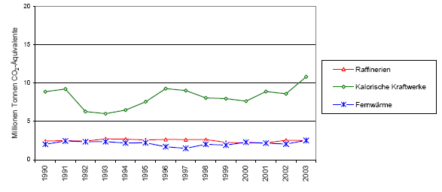

While the trend line below looks very stable, there have been big changes during these years. By dividing the electricity production and district heating into its components, there was a growth of demand by 34%, which would have raised the emission by 3,6 million tons and the declining share of hydro power, which would added 2,6 million tons, 0,9 million tons CO₂ from additional district heat demand and 0,7 million tons due a declining industrial generation. All these effects would have raised emissions by 7,8 million tons, a rising efficiency reduced emission by 2,2 million tons and followed by additional imports, co firing of biomass reduced a further 1 million ton of CO₂. The most important technology factor has been the change to high efficient CCGT and the shutdown of coal fired plants. In the next years will follow the closings of the rest of the low efficient power plants, f.e. Timelkam of the Energie AG. More co-firing of waste is planed to cover the rising demand for district heating, proposed savings are 265.500 tons.
The company Verbund estimates additional 16.000 GWh can be produced by new hydropower plants. This is approximately 10 times more than the actual production with renewable sources, except of small hydropower.
Included are also emissions from refineries, despite increasing demand, the outlook is stable due to efficiency increases. CCS (Carbon Capture & Storage) coal fired power plants close to the danube river are also in discussion because of lower fuel prices and a better supply security than for gas.

Renewable energy

Renewable energy is defined as energy from renewable sources, except of large hydro power (>10 MW). Since 2000 most renewable energy sources grew with 30-50% annually. Producer surpluses are rising, due to a very high demand for biogas and photovoltaic panels. In other markets, like wind power and small hydro power is a strong competition and fair prices. Small hydropower itself grew much slower and also declined during the beginning of the liberalisation due overcapacities in the electricity market. Included in the baseline are 360.000 tons of savings due small hydropower, equal to 540 GWh in the 2008, and in 2012 the number could be doubled to 1.000 GWh, approximately 90% from new plants and 10% from retrofitted plants.

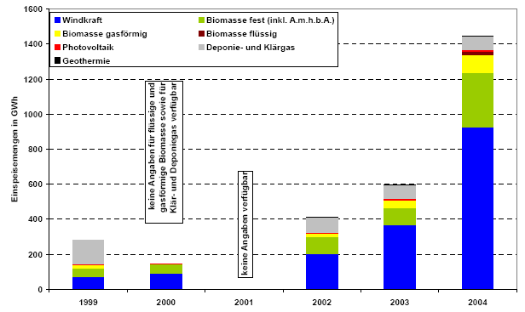
Source: E-control, 2005

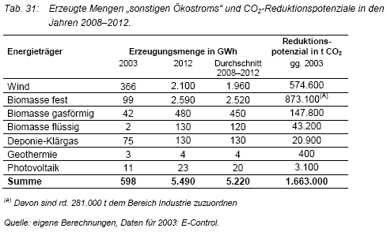

Industry

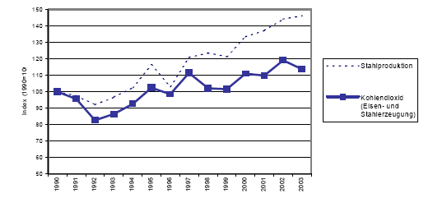
Due to an overall growth of industrial production it is not supposed that emissions will decline. As seen at the beginning of chapter 4, steel and iron demand on the world markets led to an increase of emissions, which were responsible for 43% of the total industrial emissions. While in the chemical industry process changes have reduced N₂O in saltpetre acid production (0,5 million tons). Further process optimization could reduce emission by 0.65 million tons. Savings in electricity consumption will get into effect in the electricity production (0.37 million tons).
Industrial processes need process heat and mechanical work, both can be optimized, but not substituted by the production of a certain good, f. e. ore can’t be melted without heat. To make this a climate neutral process, it would need lots of electrical energy generated by water power to generate the necessary heat for melting and the oxide has to be reduced by a non carbon reductant. The other option is closing down the production and substitute steel with a less climate polluting material. A reduction of demand due to extra taxes on heavy cars could also reduce the production level to a more useful level and help to increase economic efficiency due to a more intelligent use of gasoline. Of course the industry has no interest in selling less steel, cement, alloy, paper and other materials.

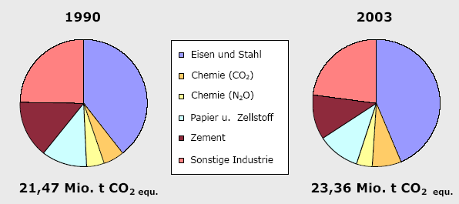

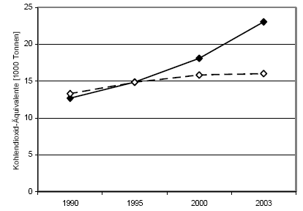
Most industrial optimization can be done by using the rest of the process heat for district heating. Many wood processing mills (pulp, paper and wood) have already created a district heating system around their wood chips boilers, which are normally used for wood drying kilns. This would not effect the emission of the industry, but those of the households. While households and electricity generation can change the whole process, f. e. from coal to hydro power to produce electricity, the industry does have fewer options to produce the same outputs. While the optimization of industrial process itself has a small potential for further reduction within the industrial sector, it has a larger effect on the households and the energy sector, due to district heating, cogeneration and electricity savings. As mentioned above as long as less polluting materials do not substitute metals or cement or in the case of paper by electronic storage there might not be any big improvements in this sector. Some process can already be seen in the housing industry which will effect the cement industry, due to a rising share of wood materials in housings.

Traffic

As mentioned in the introduction of chapter 4, traffic was the most important source of additional emission, including a rise from 12,67 million tons in 1990 to 23,03 million tons in 2003, a 81,8% growth in 13 years. A closer look at the traffic sector shows, that CO₂/km went down, due higher efficient cars (minus 1 million tons), while the passengers per car (1.3) stayed at nearly the same level. The emission of individual traffic rose by 45%, or 4 million tons, 2 millions are caused by tank tourism.
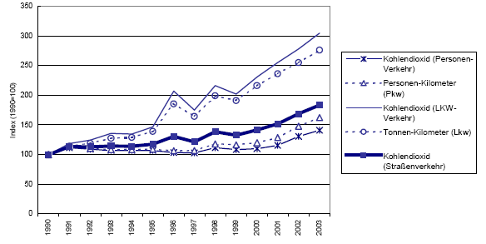
The transport sector rose by 250%, from 2.7 million tons to 9 million tons. 60% or 5.3 million are caused by tank tourism. Another 2 million tons are due to more transports. It is expected that rising energy taxation will reduce tank tourism and so the emission.
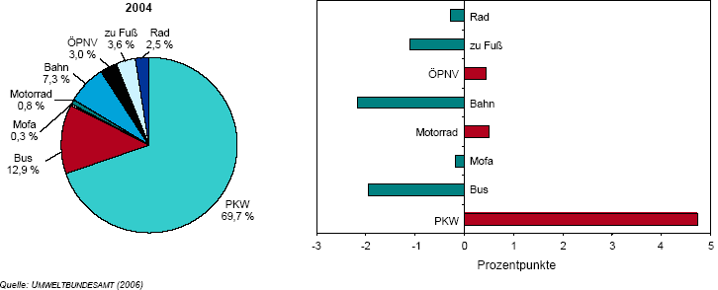
The proposed effect of bio fuels 1.39 million emission savings, until 2008 5.75% of bio fuel shall be sold in a mixture with the standard gasoline. This regulation is in accordance with the EU bio fuel regulation to promote non fossil fuels. The car manufacturers are also supposed to produce cars which are adapted to bio fuels. It is still unclear if the use of fertilizers will raise emissions in the agriculture sector. Long term effects are due area planning, taxation, true costs. Today most emissions are caused by short ways to shopping malls by car. As shown in the upper graphic, the most inefficient transport system has the highest share. A more intelligent planning can reduce these emissions. Local authorities have already been informed create adequate plans for new settlements and supermarkets.
Not included are the emissions caused by aeroplanes, approximately 10% of the total CO₂ emissions. The EU might introduce emission a trading scheme to the aeroplane lines. One long distance flight causes approximately 3-4 t CO₂ emissions per person, which equals to the world wide average emissions per person in one year.

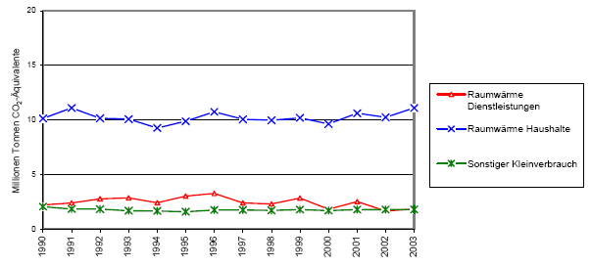
Households

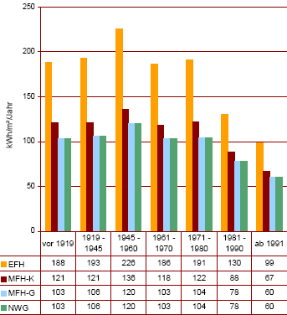
The CO₂ emissions were stable over the last 13 years, while the population rose by 5% over the same period of time, emission rose only by 1,4%. While rooms got bigger and more, more efficient heating, f. e. change from coal to gas or the change from heating value to burning value boilers reduced the emissions. Households were mentioned as the sector with the highest potential for savings in the climate strategy paper, 4.3 million tons. So far we haven’t had any progress, mostly due to the long life span of houses and heating systems, but also due cheap oil and gas prices until the Iraq invasion. Since 2002 a rise in renovation of building has been observed. Despite the progress in the last years, the target of minus 4.3 million tons was reduced to minus 1 million tons.
On the left graphic we see that energy consumption per square meter was reduced by nearly 50% within 20 years. Most non single family houses are already low energy consuming houses, while single family houses are still by far more inefficient. Today it is technically possible to build houses with less than 20 kWh per m². In 2005, 950 housings have been built with passive house technology, the growth has been nearly 30 to 50% per year. For both types of houses it is possible to get different subventions from regional governments.
A similar strong growth has been observed by pellets and heat pump market, while solar heating market is stable since some years. All technologies combined could lead to a zero CO₂ emission water and heat production in households, but it will take time. It also would make less sense to build lots of new houses, because the emissions which are made by producing a house are equal to the emissions of 50 years running an older house. The heating material composition itself has not changed a lot, gas and district heating substituted coal. Within the wood heating is an ongoing change to pellets. In 2005 the number of new pellet heating installation was for the first time higher than new oil boiler installations. Some people could not afford to change their heating system, for some of these people the last winter has been quite hard, when they ran out oil.

Quelle: Statistik Austria, (2005)

Agriculture

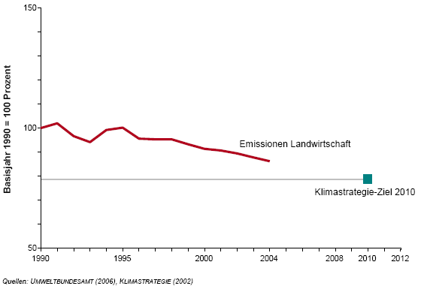
Due to that farm machinery and energy consumption are not included in this sector; there are only two factors left, fertilizer use by minus 29% and digestion of animals. Both declined over the observed period, CH₄ mainly due more milk output per cow and therefore a reduced animal stock, approximately -15%. While N₂O emissions decreased due to less fertilizer in use.
In the table below are the numbers in CO₂ equivalent emissions.

 | 1990 | 2004 | Change in % | Share of total emission
digestion (CH4) | 3,561 | 3,072 | -14% | 3,4%
fertilizer (N2O) | 3,287 | 2,812 | -14% | 3,1%
liquid manure (CH4) | 1,060 | 0,88 | -17% | 1,0%
liquid manure (N2O) | 1,005 | 0,886 | -12% | 1,0%

Waste
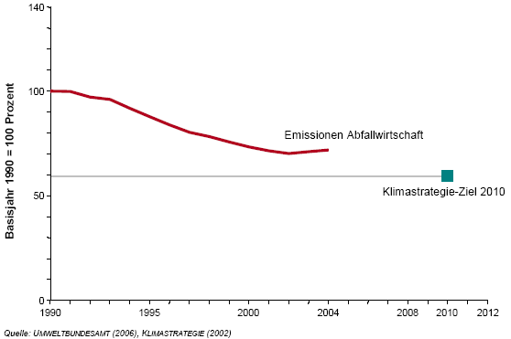
The emission from waste dumps are 2,7% of the total CO₂ emissions. 87% of the waste dump emissions are CH₄. The emission have been reduced from 3,375 million tons to 2,219 until 2004, a reduction of 34,4% or 1,156 millions tons of CO₂ equivalent emissions. Most of the reduction has been done by waste separation and the subsequent burning of some separated materials.

F-gases

F-Gases are highly reactive in the atmosphere, SF6 which is now forbidden to use as filling gas has a GWP of 22.600. The amount of F-gases is 1,7%. Most important was the closing of aluminium production in Ranshofen, Upper Austria in the 1993.

Other CO₂-, CH₄- and N₂O-Emissionen

Are responsible for 1,4% of the total emissions. Since 1990 these emissions rose by 28,3%. The main reason is the higher upstream of natural gas in Austria.

eral overview of emission structure – Czech Republic

We can see on the following picture, that the biggest share on greenhouse gases has CO₂ in the Czech Republic. Most of it is produced by energy sector, which is quite common in developed countries (the exception is f.e. Austria). Thereby Czech policy is centred on this sector and other industry (it results from EU ETS as well).
Source: Ministry of Environment

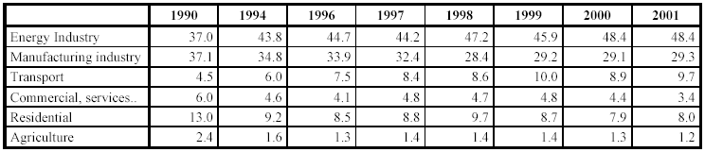
Share of individual categories on the CO2 emissions in 1990, 1994 and in 1996-2001
Source: National GHG Emission Inventory Report of the Czech Republic 2001

Energy

For future progress of energy sector the State Energy Concept is very important in The Czech Republic. It was made by the year 2030 and we can see there trends leading to lower energy consumption, lower exploitation of fossil fuels, higher share of renewable sources and higher share of fissionable fuels (see next figure)

Estimated structure of electricity production
TWh | 2000 | 2005 | 2010 | 2015 | 2020 | 2025 | 2030
Total | 73,73 | 78,20 | 82,37 | 80,85 | 84,95 | 87,49 | 89,17
 | 2000 | 2005 | 2010 | 2015 | 2020 | 2025 | 2030
Brown coal | 43,06 | 38,27 | 37,30 | 32,76 | 31,72 | 28,86 | 28,46
Hard coal | 8,94 | 5,18 | 5,58 | 5,26 | 7,79 | 6,36 | 4,34
Other fossil fuels | 0,14 | 0,06 | 0,10 | 0,10 | 0,07 | 0,06 | 0,06
Gas | 4,69 | 3,66 | 4,56 | 6,25 | 7,27 | 7,37 | 6,46
Liquid fuels | 1,59 | 0,84 | 0,62 | 0,60 | 0,48 | 0,41 | 0,34
Fissionable fuels | 13,59 | 26,04 | 26,04 | 26,04 | 26,04 | 30,24 | 34,44
Renewables | 1,71 | 4,16 | 8,17 | 9,84 | 11,58 | 14,20 | 15,06

Source: State Energy Concept

High share of fissionable fuels is quite interesting. High share of fissionable fuels is inscribed as goal with high priority in the Concept. The reasons are firstly lower grenhousegases emissions and secondly maximalization of energy independence of the Czech Republic.

As I mentioned above, energy sector is the biggest producer of CO₂ emissions the Czech Republic. EU ETS shall help to reduce these emissions with as low cost as possible.
Emission trading should influence main measures conducing to cut emissions:
- changing of fuels
- energy savings
- energy efficiency

Emissions trading is stimulus to conversion of fuels – from coal to gas, from gas to biomass (etc).

General Emission Factors of CO₂
Fuel | Emission Factor
Brown coal | 0,36 t /MWh heating power of fuel
Hard coal | 0,33 t CO₂ /MWh heating power of fuel
Gas | 0,20 t CO₂ /MWh heating power of fuel
Biomass | 0 t CO₂ /MWh heating power of fuel
Electricity | 1,17 t CO₂ /MWh heating power of fuel
Source: Ministry of Industry and Trade

Key element is extra costs for CO₂ producers, which is connected with higher energy prices. It should influence energy consumption (it should lead to decreasing) as well as energy efficiency. But now higher energy prices leads only to lower increase in consumption in the Czech Republic. Increasing consumption is awaiting till 2025, how can we see in next picture.

Note: Awaiting energy consumption in the Czech Republic
Source: State Energy Concept

While the costs are put to fuels prices, this system should persuade the producers of energy to utilize combinated heat and power. Thanks to combinated heat and power the producers can save up to 40 % of fuel, which means lower costs and extra money for sold out allowences. A lot of energy producers do so in the Czech Republic, but not all of them.

Price of energy depends on three basic factors:
- price of fuels
- operating and maintenance costs (variable and fixed)
- price of fixed capital

The Structure of Marginal Costs of Power Plants
Price of fuels
SRMC Variable operating and maintenance costs
Fixed operating and maintenance costs LRMC
Price of fixed capital
Source: IEA

The energy prices are given by short run marginal costs in perfect competition (see picture above), but in the Czech republic these price depend on negotiation between energy the producers and the Czech Regulatory Office.
Emission trading should increase SRMC, but Czech energy producers have surplus of allowences, that is why this system meanwhile does not increase energy prices.

For the first year of emissions trading Czech firms covered in the system save approximately 15 % of allowances.

Industry

This category includes only emissions from actual processes and not from fuel combustion
used to supply energy for carrying out these processes. For example, in the production of
cement, consideration is given only to emissions derived from the thermal decomposition of
mineral raw materials (specifically CO2 emissions from the decomposition of limestone) and
not from fuel used to heat the rotary kiln.

Source: National GHG Emission Inventory Report of the Czech Republic 2001

In respect to emissions of direct greenhouse gases, these consist only in emissions of CO₂ in
the production of mineral products (cement, glass).
Other sources of direct greenhouse gases are minor, except of CO2 emissions from iron and
steel production.
Industry is included in EU ETS and it is most significant measure to reducing GHG emissions in the Czech Republic. Whole sectors are at the moment not covered, including transport, which alone accounts for a not small part of CO2 emissions. Industries currently covered are electricity, iron & steel, glass, cement, pottery and bricks

Households

Most significant activity of Czech government is motivation of households to change fuels of heating (from coal to gas or biomass). Households could obtain subsidies, which cut costs of these processes. It caused decrease in emissions from small sources. But when the prices of gas increased, a lot of households reverted to coal.

Waste

Emissions of greenhouse gases from waste in the Czech Republic consist mainly of methane emissions from municipal waste landfills and methane emissions from wastewater treatment (industrial and municipal). This category also includes CO2 emissions from waste incineration and nitrous oxide emissions from wastewater. Greenhouse gases from waste are on really low level, how can we see in following figure.

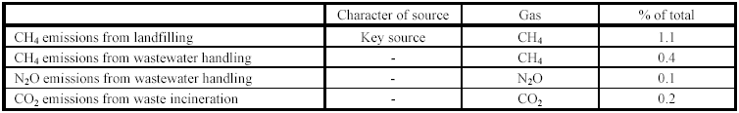
Source: National GHG Emission Inventory Report of the Czech Republic 2001

Agriculture

Agriculture has really low share on greenhouse gases emissions in the Czech Republic, thereby it was not worth do mention it here.

Final Statement

The driving factor as we have seen in many examples (f. e. 25% rise in public near distance traffic, new pellets boilers installations are overtaking oil boilers for the first time) is not the climate strategy, it is the hike in energy prices. 10 years ago most of the public didn’t even cared about energy, environment or efficiency, some even laughed about the environmentalist. Today it might be the most discussed theme in Austrian pubs, but as every theme it will phase out and new will come up. Now is the best time to make the big changes. Members of most parties, nationalist, environmentalist and the farmers are putting heads together and vote for a less on oil and gas depending economy. Of course their real reasons are different, but the common goal is very similar.
Due to the fact the plans are driven by politics there are some black zones, mostly in the field of “consumer liberty” (kerosene tax, transport, domestic consumption), but also in agriculture, f.e. imports of bio fuel from former rain forests. When it comes to LCA’s (life cycle analyses) things often look different, then in the national approach. This counterattacks the proposed CO₂ emission savings and might run the plan in a global context ad absurdum. Some investments also would have higher effects on emissions if they are done where they are most efficient. One example might be the “Ökostromgesetz” and other subventions from regional governments, which helped to build up a big wind power generation industry in Austria. To build them in north coast regions would have been better investments, due to higher and more constant wind velocity. Similar for photovoltaic panels, some regional subventions (up to 3700 €/kW) were even higher than the investment itself.
After some years of discussion, raising public awareness and policymaking, we can observe strong influences on the market nowadays, f. e. the exponential rise of pellet heating system with a growth of 50% per year. This is a sign that politically influenced market economies react very well after the information lack has been solved. While other market economies, just react on the change of fossil fuel prices and in some cases too late for the environment.
Austria and the Czech Republic have quite different global-warming policies. Austria has the highest share of renewable sources in EU. Thereby Austrian policy is focused on other problems, than Czech one.
Starting situation of both countries is different. The amount of CO₂ emissions has dropped by 24 % during transition of economy in the Czech Republic and does not have problems with achieving the Kyoto targets, despite of the Czech Republic wants to reduce GHG emissions.
The biggest producer of CO₂ emissions is energy sector in the Czech Republic. The share of renewable sources is low and on account of natural conditions and economic situation it is only slowly changing. Consciousness of Czech people about renewable sources is lower than in Austria and it is often considered to waste of money.

Literature and weblinks

EU:
- EU Emissions Trading, January 2005, http://europa.eu.int/comm/environment/climat/pdf/emission_trading2_en.pdf
- EU Green Paper on Renewable Energy, EEA, 2006
- Report of the EEA, EEA, 2005

Czech Republic:
- CO 2 Emissions from fuel combustion- 2003, IEA
- Czech Republic 2004, IEA
- Czech Statistical Office, www.czso.cz
- Ministry of Environment of the Czech Republic, www.env.cz
- Ministry of Industry and Trade of the Czech Republic, www.mpo.cz
- National Allocation Plan of Czech Republic, 2005
- National GHG Emission Inventory Report of the Czech Republic 2001
- State Energy Concept, 2004

Austria:
- National allocation plan of Austria, BMLFUW, 2004
- Klimawandel, August Raggam, 2004
- Das Jahrhundertprojekt, Heinz Kopetz, 2002
- Strategie Österreichs zur Erreichung des Kyotoziels, BMLFUW, 2002
- Evaluierungsbericht zur Klimastrategie, Umweltbundesamt, 2006
- Energiebericht 2003, BMWA, 2003
- Ökostromgesetz 2002, Bundesgesetzblatt
- Statistik Austria, www.statistik.at
- Energieagentur, www.eva.ac.at
- IG Windkraft, www.igwindkraft.at
- VCÖ, www.vcoe.at

Appendix

Life cycle analyses - LCA

Effects of climate change are widespread and will cause various damages due to flooding, drought, heat waves, storms and sea level rise. The socioeconomic impact might be in the worst cases climatic refugees, due reduced ability to survive in their native countries.
CO₂ equivalent emission include CO₂ itself plus CH₄, N₂O and F-gases emissions multiplied by the global warming potential factor (GWP), which ranges from 23 for Methane up to 22.200 for SF₆
The general Kyoto target is equal emission than in the year 1990, the EU target is 8% below this level.
Emission trading due to JI (Joint Implementation) and CDM (Clean development mechanism). Countries which are below their emission level can sell to their emission rights to other countries. JI and CDM projects are projects which reduce the CO₂ emission in other countries. For more information please read www.ji-cdm.at.
Please see Prof. Dr. DI August Raggams Publication on the effects of biomass heating.
Taxation of fossil fuels is done by excise duty which main reason is fiscal, not environmental.
Additional 6 million t CO₂ emissions per year are caused by tank tourism, BMLFUW, 2006
LCA is a complete analyse of the product, how many non CO₂ neutral emissions are produced during growing f. e. a crop by fertilizers, tractors, later during transport and refining, and at the end by the end consumer. Please see attached information, chapter 7 Appendix.

